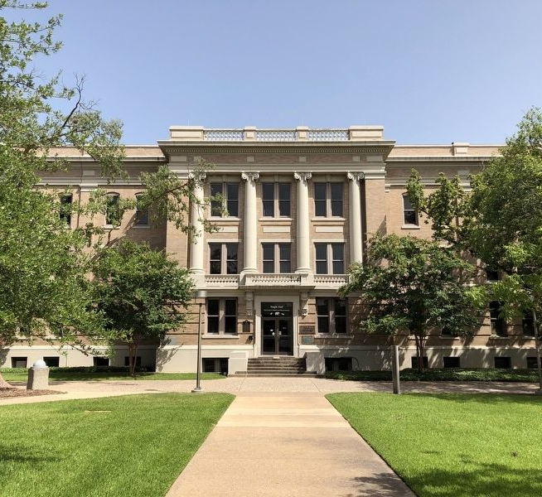

2023

Graduate

Advisor

Handbook

THE GRADUATE AND PROFESSIONAL SCHOOL

August 2023 Version

Contents
1 Graduate and Professional School 11
1.1 Expectations for Graduate Study 11
1.2 Directory Summary 11
1.3 Associate Provost and Dean and Leadership Team 12
1.4 Graduate and Professional School Services 13
1.4.1 Data and Survey Coordination 13
1.4.2 Dual Enrollment Graduate Student Special Support 14
1.4.3 Graduate Student Awards 14
1.4.4 Graduate Student Professional Development 14
1.4.5 New Graduate Student Orientation 14
1.4.6 Graduate Student Ombuds Services 15
1.4.7 Administrative and Programmatic Support 16
1.4.8 Graduate Records Processing 16
1.4.9 Interdisciplinary Degree Graduate Student Special Support 17
1.4.10 Thesis and Dissertation Services 17
1.4.11 General Contacts 17
2 Graduate Administrative Services 19
2.1 Student Recruitment and New Students 19
2.1.1 Graduate Student Recruiting Best Practices 19
2.1.2 Suggestions for the Successful Graduate Recruitment 19
2.1.3 Recruiting Services from the Graduate and Professional School 20
2.2 Graduate and Professional Student Government 20
2.3 Graduate and Professional Council 21
2.4 Graduate Operations Committee 21
2.5 Authorized Signers for Colleges or Schools, Departments, and Interdisciplinary Degree Programs (IDPs) 22
2.5.1 Authorized Signers Form Access 22
2.5.2 Authorized Signers for the Graduate Committee Faculty Portal 22
2.5.3 Authorized Signers for the Document Processing Submission System 23
2.5.4 Authorized Signers on InfoReady for Fellowships and Awards 23
2.5.5 Graduate Student Records Access 23
2.5.6 Authorized Signers for Non-Resident Tuition Waivers 23
2.6 Access to Graduate and Professional School Documents in TAMUDocs 24
2.7 Guidelines for Graduate Faculty Membership 25
2.7.1 Graduate Teaching Faculty 26
2.7.2 Graduate Committee Faculty 26
2.8 Graduate Committee Faculty Nominations 28
2.8.1 Graduate Committee Faculty Nomination Entry 28
2.8.2 Nominating Faculty and Professional Staff Employed by Other Institutions and Organizations 28
2.8.3 Nominating Special Appointments 29
2.8.4 Graduate Committee Faculty Membership Change Requests 29
2.9 Interdisciplinary Degree Programs (IDPs) 30
2.10 New 689 (Special Topics) Courses 31
2.11 GradAdvisors LISTSERV 31
2.11.1 Some examples of LISTSERV appropriate information: 31
2.11.2 Submitting Information to the LISTSERV 31
2.11.3 Subscribing/Unsubscribing from the LISTSERV 32
2.12 Compass Use 32
2.12.1 Access 32
2.12.2 Compass Training 33
2.13 Compass Reports 33
2.13.1 Access 33
2.13.2 Graduate and Professional School Use of Compass Reports 33
3 Graduate Student Funding And Development 35
3.1 Graduate Student Funding Offers Guidelines 35
3.2 Graduate Fellowships and Awards 35
3.2.1 The Dr. Dionel Avilés ’53 and Dr. James Johnson ’67 Fellowship Program 35
3.2.2 Award Information 36
3.3 National Fellowships 37
3.3.1 NSF GRFP 37
3.3.2 The National GEM Consortium | GEM Fellowship Program 37
3.3.3 Ford Foundation Dissertation Fellowship 38
3.3.4 Graduate Fellowships for STEM Diversity (GFSD) 38
3.3.5 Fulbright U.S. Student Program 39
3.3.6 Graduate Recruitment, Enhancement, and Travel (GREAT) Program 40
3.4 Graduate Student Awards 41
3.4.1 U.S. Senator Phil Gramm Doctoral Fellowship Award ($5,000) 41
3.4.2 The Texas A&M Distinguished Dissertation Award ($1,000) 41
3.4.3 Montgomery Award ($1,000) 41
3.4.4 Distinguished Graduate Student Awards (certificate and watch value at $500) 42
3.5 Other Grants 42
3.5.1 Graduate Student Research and Presentation Travel Award 42
3.6 TAMU Graduate Fellowship Nominations and Processing 42
3.6.1 Call for Nominations/Applications 42
3.6.2 Nomination Submission Process 43
3.6.3 Review and Award Process 43
3.6.4 Reviewer Selection Process 43
3.6.5 Award Letters 43
3.6.6 Acceptance Forms 43
3.6.7 Follow-up and Welcome Letters 44
3.6.8 Welcome Social 44
3.7 Retention Techniques 44
3.8 Professional Development Opportunities 45
4 Graduate Student Matriculation Processing 47
4.1 Departmental Role in Document Processing 47
4.1.1 Document Processing Submission System (DPSS) 47
4.1.2 Additional Processing Notes 47
4.2 Graduate and Professional School Signature and Approval Requirements for Graduate and Professional Student Documents 48
4.3 Standardized Test Scores 49
4.3.1 Standardized Test Score is Required for Fall 2024 and Beyond Admissions 50
4.4 English Language Proficiency Requirements 51
4.4.1 English Language Proficiency Requirement Waivers for Admissions 52
4.4.2 English Language Proficiency Verification 52
4.4.3 English Language Proficiency Certification 53
4.4.4 Non-Degree Status International Students 56
4.4.5 English Language Proficiency Certification Compliance Procedures 56
4.5 English Language Proficiency Examination 57
4.5.1 ELPE for International Graduate Students Serving in Teaching Positions 58
4.5.2 Testing During the Semester 58
4.5.3 ELPE Results 58
4.5.4 ELPE Retesting 58
4.6 Center for Teaching Excellence-English Language Proficiency (CTE-ELP) Instruction and English Language Certification 58
4.6.1 English Language Certification and Teaching-Assistant Eligibility 58
4.6.2 English Language Proficiency Certification Process 60
4.6.3 The CTE-ELP Program 60
4.6.4 CTE-ELP Progress Assessment and ELPE Re-Testing for ELP Certification 63
4.7 TA Training Requirements 64
4.7.1 Purpose of TATEP 64
4.7.2 TA Evaluation 65
4.8 Graduate Classifications 65
4.8.1 G6 Postbaccalaureate Non-degree 66
4.8.2 G7 Graduate, Master’s 66
4.8.3 G8 66
4.8.4 G9 Graduate, Master’s/Doctoral Admitted 66
4.9 Degree Level Change Information 66
4.9.1 Domestic Students 66
4.9.2 International Students 67
4.9.3 Changing from G7 PhD to G8 PhD 67
4.9.4 Semester Change for Late Classification Changes 67
4.10 Subvention Funding 67
4.11 99-Hour Doctoral Cap 67
4.12 Separation of a Graduate Student for Scholastic Deficiency 68
4.13 Registration 69
4.13.1 Full-Time Status 69
4.13.2 Half-Time Status 69
4.13.3 Continuous Enrollment 70
4.13.4 Excess Hours 70
4.13.5 Examinations 70
4.13.6 Not Registering for Courses in Graduating Semester 70
4.13.7 Certification of Full-Time Enrollment 70
4.13.8 Residence Requirement 71
4.13.9 Undergraduates Registering for Graduate Courses 71
4.13.10 Leave of Absence 71
4.14 Grade Point Average (GPA) Requirements 72
4.14.1 Scholastic Requirements 72
4.14.2 GPA on the Degree Evaluation 74
4.14.3 Calculating GPAs 74
4.14.4 Checking GPA without a Degree Plan on File 74
4.15 Degree Plan Information and Filing Degree Plans and Petitions 74
4.15.1 Online Document Processing Submission System (DPSS) 74
4.15.2 Staff/Committee/Departmental Approvers 75
4.15.3 Proxy Approvers 77
4.15.4 Aquiring DPSS Accounts for New Faculty and Staff 77
4.15.5 Special Appointments and Degree Plans 78
4.15.6 Miscellaneous DPSS Tips 78
4.15.7 Transfer Course Work 79
4.15.8 Verifying Outdated Standardized Test Scores as Official 79
4.15.9 Petitions 80
4.15.10 Degree Plan Blocking Criteria 80
4.16 Viewing Degree Evaluations – Graduate Advisors 82
4.17 Viewing Degree Evaluations – Committee Chairs 83
4.18 Research Proposal 89
4.19 Preliminary Examinations 89
4.19.1 Preliminary Examination for Doctoral Students 89
4.19.2 Preliminary Examination Format 89
4.19.3 Preliminary Examination Scheduling 90
4.19.4 Grading of the Preliminary Exam 90
4.19.5 Failure and Expiration of Preliminary Examination 91
4.20 Final Examination/Final Defense 92
4.20.1 Final Examination for Doctoral Students 92
4.20.2 Grading of Final Exam 93
4.21 Theses, Dissertations, and Records of Study 94
5 Financial Processing 96
5.1 Fellowship Payments 96
5.1.1 Fellowship Payment 96
5.1.2 NSF GRFP Fellowship and Other National Fellowship Payments 96
5.2 Payment of Tuition and University Required Fees for Graduate Assistants 96
5.3 Standard Operating Procedure (SOP) for Assistantship Non-Resident Tuition Waivers for Graduate Students 97
5.3.1 Enrollment Issues 101
5.3.2 Registration Requirements Graduate Assistantships 101
5.3.3 Maximum Allowed Graduate Assistant Work Hours Per Term 102
5.4 Graduate Student Health Insurance 104
5.4.1 Student Insurance 104
5.4.2 Avilés ’53 and Dr. James Johnson ’67 Fellowship Students 104
5.4.3 Dissertation Fellowship Students 105
5.4.4 National Science Foundation – Graduate Research Fellowship Program Students 105
5.5 Graduate Assistantship Titles and Checklist 105
6 Graduate Admissions Processing 107
6.1 Directory 107
6.2 Items Required by Admissions Office 107
6.2.1 Applicants Who Are Citizens of the Following Countries Do Not Need to Submit Proof of English Proficiency: 108
6.3 Graduate Confirmation Process 108
6.4 Evaluation and Admission Tools 110
6.4.1 WebAdMIT 110
6.4.2 Graduate Tracking Report and Decision Codes 110
6.4.3 TAMUDocs (http://tamudocs.tamu.edu) 110
6.4.4 Uploaded Transcripts 111
6.4.5 Applicant Information System (AIS) 111
6.5 Special Circumstances 111
6.5.1 TAMU Undergraduates Admitted to Graduate and Professional School 111
6.5.2 Admission without Final Transcript or Diploma 111
6.5.3 Readmission to Graduate and Professional School 111
6.5.4 Admission Deferrals 112
6.6 Graduate Admissions Compass Forms Guide 112
6.6.1 SPAIDEN- General Person Identification 112
6.6.2 SOAIDEN – Name search form 112
6.6.3 SAASUMI – Admissions Application Summary 113
6.6.4 SAAACKL - Admission Application/Checklist Summary 114
6.6.5 SOAPCOQ- Prior College and Degree 114
6.6.6 SOATEST- Test Score Information 115
6.6.7 SOAHOLD/WOAHOLD- Hold Information 116
6.6.8 SPACMNT- Person Comment 116
SOASUPL- Application Supplemental Information 117
6.6.9 SUAMAIL- Student Mail 118
6.6.10 GOAINTL- International Information 119
7 International Student and Scholar Services 120
7.1 Directory 120
7.2 Overview of International Student and Scholar Services 120
7.3 Information about F-1 and J-1 status 121
7.4 Academic Departments and ISSS 122
7.5 Financially Sponsored Students 124
7.5.1 Identifying a Sponsored International Student 124
7.5.2 Restrictions 125
7.5.3 Sponsor Visits 125
8 Resources And Services For A&M Students Going Abroad 126
8.1 Directory 126
8.2 Passport Services 126
8.3 International Medical Insurance 126
8.4 Texas A&M Education Abroad Programs 127
8.4.1 Texas A&M Faculty-Led Programs 127
8.4.2 Exchange Programs 127
8.4.3 Non-Degree Programs 127
8.4.4 Independent Research Abroad 127
8.4.5 Internships 128
8.5 Scholarships Available for Students 128
8.5.1 Junior Fulbright 128
8.5.2 British Marshall 128
8.5.3 Rhodes 128
8.5.4 Rotary Foundation Ambassadorial Scholarship 128
8.5.5 National Security Education Program (NSEP) – Boren Fellowship 128
8.5.6 Study Abroad Fellowship 129
8.5.7 International Education Fee Scholarship – Graduate and Professional 129
8.5.8 International Education Fee Study Grant – Graduate and Professional 129
8.5.9 Patti and Weldon Kruger ’53 scholarship 129
9 Office Of The Registrar - Records Administration & Archives 130
9.1 Directory 130
9.2 Registration Information 130
9.3 Grade Changes 134
9.4 Full-Time Classification for Internships/Co-Op Experience 136
9.5 Graduate Certificates (Degree Audit) 136
9.6 Graduation Application (Degree Audit) 138
10 Graduate and Professional School - Student Milestones and Forms 140
10.1 Special Request Letter 141
10.2 Research Proposal, Preliminary Examination, and Final Examination ARCS guides 143
10.3 Request for Exemption from the Final Examination 143
10.4 Request for Letter of Completion 143
10.5 Letter of Intent 146
10.6 Graduate Student Graduation Cancellation Form 148
10.7 Non-Resident Tuition Waivers 151
10.8 Thesis / Dissertation – Approval of Written Thesis Form 156
10.9 Thesis / Dissertation – Copyright and Availability Form 156
10.10 Graduate Student Research and Presentation Travel Award Application Form 159
10.11 Graduate Student Research and Presentation Travel Award Reimbursement Form 159
10.12 Request for Fellowship Deferment 160
10.13 Request for fellowship reinstatement 162
11 Graduate and Professional School - Faculty/Staff Forms 164
11.1 689 (Special Topics) Course Requests 165
11.2 Authorized Signers Forms 165
11.2.1 College/School Authorized Signers Form 167
11.2.2 Department Authorized Signers Form 168
11.2.3 Interdisciplinary Degree Program Authorized Signers Form 169
11.3 English Language Proficiency – Alternative Verification Form 170
11.4 English Language Proficiency – Alternative Certification Form 172
11.5 English Language Proficiency – Emergency Deferral Request Form 174
11.6 Academic Department Approval For Graduate Assistant To Work >50% Effort 178
11.7 Request for Doctoral Student to Add a Secondary Master’s Degree Program 180

Graduate and Professional School

Expectations for Graduate Study
The major goals of graduate and professional education at Texas A&M University include instilling in each student an understanding of and a capacity for scholarship, independent judgment, academic rigor, and intellectual honesty. Faculty and graduate students have a shared obligation to work together to foster these goals through relationships that advance freedom of inquiry, demonstrate individual and professional integrity, and encourage common respect.
Both the committee chair/co-chair and a graduate committee guide and evaluate student progress. These individuals give direction and support for the appropriate developmental and learning goals of graduate students. The committee chair/co-chair and the graduate committee also evaluate a graduate student’s academic performance. The graduate student, committee chair/co-chair, and graduate committee constitute the basic core of graduate education. The quality, scope, and extent of interaction among this group determines the significance of the graduate experience.
High quality graduate education requires professional and ethical conduct of all participants. Faculty and graduate students have mutual responsibilities to ensure high academic standards and quality graduate programs. Excellence in graduate education is achieved when faculty and students are inspired, have the academic and professional backgrounds essential to function at the highest level, and are genuine in their mutual desire to see one another succeed. Any action that negatively affects this interaction––from either faculty member or student––destroys the whole relationship. Mutual respect is critical to the successful process.

Directory Summary

204 Nagle Hall  1113 TAMU  College Station, TX 77843-1113  http://grad.tamu.edu  grad@tamu.edu | Dr. Fuhui Tong  Interim Associate Provost and Dean  fuhuitong@tamu.edu | Dr. Shannon Walton  Assistant Dean  shannon@tamu.edu
Dr. Julie Harlin  Associate Dean  j-harlin@tamu.edu | Dr. Charles Criscione  Associate Dean  ccriscione@bio.tamu.edu | Trent Smith  Assistant Director  smitht@tamu.edu
Amy Fritcher  Chief of Staff  afritcher@exchange.tamu.edu | Jackie Perez  Director  jackieperez@tamu.edu | Dr. Rob Dixon  Director  rdixon@tamu.edu

Name | Title | E-mail
Erika Brigham | Assistant to Associate Provost and Dean | Erika.brigham@tamu.edu
Cory Raney | Assistant to Leadership Team | corylynne@tamu.edu
Dr. Stephen Caster | IT Business Analyst | scaster@tamu.edu
Dr. Linda Castillo | Ombuds Officer | lcastillo@exchange.tamu.edu
Savanah Sanchez | Graduate Student Specialist | sdsanchez@tamu.edu
Aimee Lay | Senior Graduate Student Specialist | alay@tamu.edu
Cori Eckert | Communications Specialist | corirutheckert@tamu.edu
Mark Gleason | Graduate Program Specialist | mark.gleason@tamu.edu
Victor Gongora | AGEP Coordinator | vgongora@tamu.edu
Vacant | Special Projects Coordinator
Kourtney Hennigan | Business Services Coordinator | Kourtney.hennigan@tamu.edu
Isah Juranek | Student Success Coordinator | ijuranek@tamu.edu
Dr. Jamie Saucier | Thesis and Dissertation Specialist | Jamie.saucier@tamu.edu
Jane Brewer | Thesis and Dissertation Specialist | ejbrewer@tamu.edu
Amy Motquin | Thesis and Dissertation Specialist (Part-Time) | acmotquin@tamu.edu
Vacant | Technology Specialist
Melissa Easley | SLATE Coordinator | melissaeasley@tamu.edu
Dr. Jessica Connor | Fellowships Specialist | jconnor@tamu.edu
Danielle Pacheco | Business Services Specialist | daniellepacheco@tamu.edu
Dr. Morgan Schweller | Professional Development Coordinator | mschweller@tamu.edu
Karen Seago | Graduate Records Specialist (Part-Time) | kseago@tamu.edu
Kim Widdison | Graduate Records Coordinator | k-widdison@tamu.edu
Raiden Sawyer | Graduate Records Processor | Raiden.sawyer@tamu.edu
Layne Wells | Graduate Records Processor | Layne4@tamu.edu
Vacant | Graduate Records Processor
Julia Williams | Thesis and Dissertation Specialist (Part-Time) | julia-williams@tamu.edu
Dr. Yu-Chen Yeh | Data Analyst | yuchen188@tamu.edu

Associate Provost and Dean and Leadership Team
The Graduate and Professional School advocates for continual improvement in graduate education at Texas A&M University. The Graduate and Professional School aims to provide customer-friendly, accurate, and timely support services to graduate and professional students, faculty, and staff.
The Leadership Team also works to create and nurture an office climate that leads to excellent performance and collegiality among staff.
Dr. Fuhui Tong, Interim Associate Provost and Dean, Graduate and Professional School
Erika Brigham, Executive Assistant to the Associate Provost and Dean, Graduate and Professional School
Dr. Julie Harlin, Associate Dean
Dr. Charles Criscione, Associate Dean
Dr. Shannon Walton, Assistant Dean, Student Development Success
Amy Fritcher, Chief of Staff
Jackie Perez, Director, Business Services
Trent Smith, Assistant Director, Graduate Records Processing
Dr. Rob Dixon, Director of Graduate Marketing and Communications
Cory Raney, Executive Assistant, Graduate and Professional School

Graduate and Professional School Services

Data and Survey Coordination
The Graduate and Professional School Data Services Team provides external and internal data collection, analysis, and reporting across a variety of graduate and professional student activities. The team supports participation in national-level research projects; required reporting to the Texas Higher Education Coordinating Board (THECB); and many adhoc needs within the university, unit, and the academic colleges.
Please use this table to help determine where different types of data may be available at Texas A&M University:
 | DARS | Accountability | EIS Compass Reports | EIS CWR | EIS ARGOS | OIEE
Reported externally; aggregate counts on student populations. | X | X |  | X
Individual student level to be used for internal tracking and performance monitoring. |  |  | X | X | X
Feed/file of individual student data to be shared with a vendor or used in an internal system. |  |  |  | X
Student survey responses. |  |  |  |  |  | X
Notes. DARS: Data and Research Services, https://dars.tamu.edu. Accountability: https://accountability.tamu.edu/ . EIS: Enterprise Information Systems: https://eis.tamu.edu/compass. CWR: Compass Work Request. OIEE: Office of Institutional Effectiveness and Evaluation, https://assessment.tamu.edu. ARGOS: Adhoc Report Generation Output Solution.
graddata@tamu.edu – Data Services team email.
Vacant, Director
Dr. Stephen Caster, IT Business Analyst
Dr. Yu-Chen Yeh, Data Analyst

Dual Enrollment Graduate Student Special Support
This area addresses the specialized questions and needs of students dually enrolled at Texas A&M University and another institution of higher education, including branch campuses in Galveston and Doha, Qatar. Common questions include those related to registration, enrollment, funding, and financial aid.
Trent Smith, Assistant Director

Graduate Student Awards
The Graduate and Professional School offers the Graduate Student Research and Presentation Travel Award Program, which is supported by the George Bush Presidential Library Foundation. The purpose of the program is to reimburse travel expenses associated with graduate students’ domestic and international travel related to conferences, academic presentations, and research projects. Students may receive only one (1) of these travel awards during their degree program. Additionally, up to 15 graduate students receive Distinguished Graduate Student Awards for Research or Teaching annually. The students are nominated by their committee chair/co-chairs in the spring semester with strenuous eligibility requirements.
For other awards opportunities, please see Section 3: Student Funding and Development.
grad-award-admin@tamu.edu – Graduate and Professional School awards administrator’s email address
grad-travel-award@tamu.edu – Graduate and Professional School Travel Award email address

Graduate Student Professional Development
Professional Development refers to training outside one’s discipline-based graduate coursework and research. It is the continuous process of acquiring new knowledge and transferable skills related to one’s career goals. Engaging in professional development programs can help master’s and doctoral student progress to degree completion and prepare for a wider range of employment opportunities, and bridge the gap between graduate education and the workforce. The Graduate Resources and Development for Aggies (G.R.A.D. Aggies) professional development program, facilitated by the Graduate and Professional School, includes a comprehensive curriculum of workshops and activities covering 7 different skill areas (see Section 3.9). In addition, the Graduate and Professional School maintains several professional development resources and services for graduate and professional students, including the Professional Development Portal, a searchable inventory of professional development workshops, seminars, and courses offered by individual departments and colleges across campus.
G.R.A.D. Aggies Program – http://grad.tamu.edu/academics/professional-development/grad-aggies
Professional Development Opportunities – http://grad.tamu.edu/academics/professional-development
Dr. Morgan Schweller, Professional Development Coordinator

New Graduate Student Orientation
Coordinated by the Graduate and Professional School, the New Graduate Student Orientation provides an overview of graduate education and services at Texas A&M University – including information on financial aid, procedures and processes, campus safety and security, the English Language Proficiency Program, and additional campus services. New graduate students will get the chance to meet campus leaders, administrators, and fellow graduate and professional students. Experienced graduate students will be present to answer questions and provide insight about thriving in graduate school, balancing work and personal life, and making the most of living in Bryan/College Station. Designed to get new graduate students off to a good start in their experiences, students will also have the opportunity to mingle and explore the resource fair and meet representatives of campus services and organizations who serve the graduate and professional student community.
Vacant, Graduate Recruitment Coordinator

Graduate Student Ombuds Services
The Ombuds Officer serves as an informal and neutral resource for graduate students to discuss questions and concerns related to their graduate experience. The university is a large and complex institution, and graduate students often play multiple roles (e.g., student, research collaborator, teacher, technician, and peer). Misunderstandings and conflicts can arise in any one of these roles. Having a safe, off-the-record conversation with an Ombuds Officer can be a first step if students do not know where to turn. The Ombuds Officer is here to help graduate students identify options for addressing concerns and promote a fair and impartial process for all parties involved. The Ombuds officer is also a resource for faculty and administrators who have questions about the institutional policies and procedures as they relate to graduate students.
The Graduate and Professional Student Ombuds Officer is guided and informed by the Code of Ethics and Standards of Practice of the International Ombudsman Association.
The Ombuds Officer Can:
- Listen and help you achieve a greater understanding of the problem.
- Help you find information applicable to your situation and identify possible solutions to your problem.
- Explain University policies and procedures and how they apply to your specific case.
- Help you identify options for resolving conflicts with colleagues, staff, faculty, and advisors.
- Help you achieve fair and equitable solutions to problems.
- Facilitate communication among people in conflict.
- Provide other types of assistance to help you resolve a problem informally.
- Refer you to formal grievance or appeal procedures if you wish to engage in a formal process.
- Offer recommendations for changes to policies/procedures that appear outdated or problematic, while maintaining confidentiality.

The Ombuds Officer Cannot:
- Advocate for the University or the student, or any particular point of view.
- Make or change University decisions, rules, or policies.
- Set aside a decision or supersede the authority of another University official.
- Participate in formal grievance procedures.
- Provide legal advice.
- Conduct formal investigations.
- Testify in in formal proceedings with respect to confidential communication.

If a student is unable to resolve a problem within the student’s department (most often by working with the student’s Committee Chair/Co-Chair, the department’s Graduate Advisor, and /or the Graduate Program Chair), the student can request a meeting with a Graduate Ombuds Officer. These are private, informal meetings in which to explore potential solutions to the dilemma.
The Ombuds Office values and protects the privacy and identity of students seeking assistance. We do not disclose confidential communications unless required by state law such as in situations of child abuse or neglect; imminent risk of serious harm to the visitor or another person; or a court order with appropriate authority.
According to Texas A&M System Regulation 08.01.01, Ombuds Officers are considered Mandatory Reporters and are required to report any alleged sexual harassment, sexual assault, dating violence, stalking, discrimination, or any other prohibited conducted committed by or against a person who was a student or employee at the time of the incident. Ombuds Officers are also obligated to report discrimination based on a protected status.
Appointments can be requested by emailing ombuds@tamu.edu or calling 845-3631.
Dr. Linda Castillo, Graduate Ombuds Officer

Administrative and Programmatic Support
Administrative and Programmatic Support Services fields all incoming phone and walk-in inquiries to the Graduate and Professional School, connects students and other stakeholders with resources and information to assist the mission of graduate studies, supports internal HR needs, coordinates internal and external fiscal-related transactions, and works with campus stakeholders to disseminate best practices related to graduate student employment benefits. The team manages the retention of graduate student records.
Jackie Perez, Director
Erika Brigham
Kourtney Hennigan
Theresa Reyes

Graduate Records Processing
The Graduate and Professional School is responsible for maintaining all University graduate degree requirements and records, and receiving proper documentation for each major milestone in a graduate student’s degree program. In addition, we offer training and guidance for graduate advising staff related to university requirements and resources.
Trent Smith, Assistant Director
Kim Widdison
Raiden Sawyer
Layne Wells
Karen Seago
Mark Gleason

Records Processing: gradprocessing@tamu.edu

Interdisciplinary Degree Graduate Student Special Support
The Graduate and Professional School addresses the specialized questions and needs of students participating in TAMU’s interdisciplinary degree programs (IDPs). Because these programs are not housed in the traditional department model, certain matters related to IDP graduate students are structured in unique ways.
More information related to master’s, doctoral, and certificate programs is available here.
Dr. Charles Criscione, Associate Dean

Thesis and Dissertation Services
Thesis and Dissertation Services reviews each electronic thesis, dissertation, and record of study (ETD) for uniformity, consistency, and adherence to university formatting guidelines. In addition, we provide a wide range of preparation support and coordinate the timely release of the ETD for public access.
Our goal is to help each student produce a professional document that meets the quality standards of Texas A&M University. Students are encouraged to use the resources available from our website (including Word and LaTeX templates and Overleaf technical support) and to participate in a pre-submittal conference prior to their final defense.
The thesis, dissertation, or record of study must be submitted in electronic form as a single PDF file, while the Approval Form must be routed by the posted deadline for each term. Thesis and Dissertation Services deadlines are published in the Graduate and Professional School calendar.
Dr. Charles Criscione, Associate Dean (administrative oversight)
Dr. Jamie Saucier, Senior Graduate Student Specialist II (Team Lead)
Jane Brewer, Graduate Student Specialist
Amy Motquin, Editorial Assistant (part time)
Julia Williams, Editorial Assistant (part time)

General Contacts
G.R.A.D. Aggies –
grad-aggies@tamu.edu
Graduate and Professional School – grad@tamu.edu
Thesis and Dissertation Services – thesis@tamu.edu
Graduate Records Processing Team – gradprocessing@tamu.edu
Data Team – graddata@tamu.edu
Graduate Ombuds Officer – ombuds@tamu.edu
Graduate Student Employment and Benefits – grad-employment@tamu.edu
Graduate and Professional School awards administrator – grad-award-admin@tamu.edu
Graduate and Professional School fellowship administrator – grad-fellowship-admin@tamu.edu
Graduate and Professional School travel award – grad-travel-award@tamu.edu
Graduate and Professional School Council Administrator – GPCAdmin@tamu.edu
Responsible Conduct of Research – rcr.grad@tamu.edu
For Graduate Operations Committee (GOC) Deans to request that the Graduate and Professional School lift degree plan holds – dpblocks@tamu.edu
Non-Resident Tuition Waivers – gradbusinessservices@tamu.edu

Graduate Administrative Services

Student Recruitment and New Students
The Graduate and Professional School at Texas A&M University performs targeted recruitment for graduate and professional students in collaboration with colleges, departments, and interdisciplinary graduate programs. The marketing and communications team works with the the Student Development and Success area to create general communications campaigns to market Texas A&M to prospective students and to provide materials to departments for recruiting. Student Development and Success also encourages and welcomes questions from prospective students, attends graduate fairs around the country, and supports the presentation of information to undergraduate research scholars who may be interested in early graduate enrollment at Texas A&M University.
Vacant, Graduate Recruitment Coordinator
grad-recruit@tamu.edu Graduate and Professional School recruiting email address

Graduate Student Recruiting Best Practices
- Use regional and national databases to identify top students in your discipline. The Graduate and Professional School has databases with strong students who participate in the McNair Scholars, National Name Exchange, California Diversity Forum, and SACNAS, among other programs.
- Meet with recruiters across the state and around the country to discuss best practices in recruiting and retention.
- Advertise in professional conference proceedings. You may also purchase listings of top applicants in your field from sources such as the Educational Testing Service (ETS).
- Review conference proceedings for your professional associations (national and regional) to identify student presenters. These are likely to be strong students who are already socialized into the profession.
- Electronic Prospective Request Forms: These provide a quick means for students to provide relevant information, in person or online, allowing you to match potential students with faculty and current graduate students.
- Branding: Be consistent in all publications.
- Develop a PowerPoint presentation about your program that your faculty and students can show at conferences and when visiting other universities. Doing so will help them to be effective recruiters.

Suggestions for the Successful Graduate Recruitment
- Provide timely responses to prospective students. Appropriate follow-up after your first communication is imperative.
- Develop a tracking database system (CRM) to keep records of where successful applicants are from, how they found out about your program, and who their mentors and/or major professors were.
- Keep in touch with your former students, and recruit them to assist in speaking to prospective students in their hometowns.
- Keep a former student profile page available for prospective students to access.
- Fund campus visits, send personal letters from the department chair or college dean, and provide competitive assistantships and/or fellowships.
- Provide information about appropriate community resources.
- Invite students you have been communicating with, or have identified through contact cards or colleagues, to visit campus.
- Host an informational/recruitment weekend.
- Use campus events to interest prospective students in coming to campus, such as Graduate Research Week or during the Undergraduate Research Summer Program.
- Develop a group of reliable, trained, and advanced student ambassadors to help with recruiting.
- Make use of your department web page and/or department newsletter to highlight student/faculty accomplishments and collaborations, faculty research interest and successful grants, professional development activities and other things that help the prospective student identify you as a department dedicated to cutting-edge research, student success, diversity and the development of graduate students as colleagues and professionals.
- Encourage current graduate students to assist at recruiting fairs.

Recruiting Services from the Graduate and Professional School
- The recruitment of graduate students is conducted by the various departments and by the Graduate and Professional School. The Graduate and Professional School provides services to departments to assist in their recruiting efforts.
  - Materials for recruitment fairs and contacts include PowerPoint presentations for domestic and international students, brochures, handbills, flyers, and table covers.
  - Promotional materials for recruitment include pens, highlighters, and key chains, among other items.
  - Assistance with the development of departmental recruiting plans and presentations.
  - Graduate school information to local, national, and international institutions and organizations.
  - Support for the recording of information Slate (CRM) and disseminating the information to appropriate departments.
  - Names of prospective graduate students from national lists (e.g., National Name Exchange, California Diversity Forum, McNair Conference) to departmental representatives.
  - Presentations and workshops each semester to students involving various aspects of graduate school processes and resources.
  - Fellowship opportunities for prospective students to include the Avilés-Johnson Fellowship Program.
  - Representation of Texas A&M University at various local and national Graduate and Professional School Day Programs.

Graduate and Professional Student Government
The Graduate and Professional Student Government (GPSG) works in cooperation with the Texas A&M University administration to ensure that the needs of graduate and professional students are understood and considered when campus policies concerning academic excellence, tuition and finance, and research are made.
Specific goals of the GPSG include: to represent all graduate and professional students by identifying and advocating their interests on graduate issues; to be recognized as representing a unique population within the University system; to facilitate communication on graduate issues within the University community; and to enhance the graduate experience through social service opportunities. The Senate is comprised of elected/appointed Senators representing different departments or recognized student organizations across campus and the Governance Board. Officer elections are held in the spring. GPSG also works closely with the Student Government Association to assure graduate and professional student issues are represented and addressed through student legislation and on University committees. Additional information can be obtained by visiting the GPSG website at the GPSG website.

Graduate and Professional Council
The Graduate and Professional Council is composed of representatives from the graduate faculty at Texas A&M University. The Graduate and Professional Council reviews all curricular requests pertaining to graduate and professional academic courses and programs, maintains the quality and development of graduate instruction and programs, and advises the Associate Provost and Dean of the Graduate and Professional School on all graduate and professional program and policy matters.
Membership consists of the following:
- One (1) representative from each college, school, and off-campus academic unit who shall be selected by the Faculty Senate Executive Committee after consultation with the college and school deans and caucuses (chairs of the college and school Committees for Graduate Instruction shall be considered for appointment)
- Two (2) representatives of the Graduate Faculty
- Two (2) graduate students
- Associate Provost and Dean of the Graduate and Professional School (Ex-Officio)
The Graduate and Professional School offers administrative support to the Graduate and Professional Council. All curricular requests submitted for Graduate and Professional Council review and/or approval should be submitted through the Curricular Approval Request System (CARS).
Dr. Fuhui Tong, Chair
Contact: Graduate and Professional Council Administrative Assistant – gpcadmin@tamu.edu or 979-845-3631

Graduate Operations Committee
The Graduate Operations Committee (GOC) serves as an advisory body to the Associate Provost and Dean of the Graduate and Professional School. It focuses primarily on operations and procedures regarding administration of graduate education throughout the University. The GOC serves as a forum for the Associate/Assistant Deans in each College/School to discuss issues and concerns of an operational nature, and to recommend procedures, which are as uniform as possible across Colleges/Schools, to resolve these issues/concerns. The GOC works closely with the Graduate and Professional Council to coordinate all curriculum and policy issues. It also works closely with the Academic Operations Committee to consider recommendations concerning undergraduate operations and procedures. Each academic College is represented on the GOC by the Associate Dean (or other named individual) responsible for graduate studies in that college/school.
Contact: Erika Brigham, Executive Assistant to Associate Provost and Dean

Authorized Signers for Colleges or Schools, Departments, and Interdisciplinary Degree Programs (IDPs)
Each college or school, department, and interdisciplinary degree program (IDP) is required to have an Authorized Signers Form on file with the Graduate and Professional School. These forms identify and designate faculty and staff authorized to approve graduate and professional student documents and access certain university platforms.
This form (managed through a secure Google Drive) should be updated when there are are changes in unit roles. The Graduate and Professional School may also request updates from all units if changes in university procedures occur.

Authorized Signers Form Access
The Authorized Signers Form is managed through a secure Google Drive. Ability to access and edit the Authorized Signers Form requires a TAMU email address and the Google Apps Account setting enabled in the “Email Settings” section on Aggie Account Gateway (https://gateway.tamu.edu/settings/email/).
Each college/school, department, and IDP must designate a point of contact/editor with the Graduate and Professional School. Should the unit’s point of contact change, please notify GradCom@tamu.edu for a transfer of access. The Graduate and Professional School will also provide vierwer access to all Deans, Department Heads, and IDP Chairs.

Authorized Signers for the Graduate Committee Faculty Portal
The faculty member(s) designated as the College/School, Department, or Program Approver will be notified to approve Graduate Committee Faculty nominations submitted for their unit The Graduate and Professional School requires at least one designated approver for each college/school, department, and IDP).
Faculty designated as Proxy Approvers on the forms will be able,but not required, to approve Graduate Committee Faculty nominations in the event the College/School, Department, or Program Approvers are unable to do so. The Graduate and Professional School recommends each unit designate at least one Proxy Approver. Proxy Approvers will not receive notifications when nominations are submitted for approval.
Please note: Only members of the Graduate Committee Faculty may be listed as faculty approvers.
Faculty and staff members may have access to enter and view nominations for their unit. Individuals with this access will be able to create, but not approve, nominations to the Graduate Committee Faculty. Users will also be able to see the status of all nominations for their unit.

Authorized Signers for the Document Processing Submission System
The Pre-Committee Staff Approver in DPSS is the departmental “pre-check” to ensure that all degree plans and petitions submitted by students follow the program’s rules and requirements before submission to the students’ advisory committee members.
The faculty member(s) designated as the College/School, Department, or Program Approver will be required to approve all degree plans and petitions for all students submitted in DPSS for their unit or program. The Graduate and Professional School strongly recommends only one approver for each college/ school, department, and IDP.
The faculty member(s) designated as a Proxy Approver will be able, but not required, to approve degree plans and petitions in the event a College/ School, Department, or Program Approver, or advisory committee member is unable to do so. The Graduate and Professional School recommends at least one Proxy Approvers for each college/ school, department, and IDP; however, this is not mandatory.

Authorized Signers on InfoReady for Fellowships and Awards
Nominations for fellowships and awards are submitted through the InfoReady website managed by the Student Development and Success and the Graduate Technology Management teams. The submission system is used for
- the Dr. Dionel E. Avilés ’53 and Dr. James E. Johnson ’67 Graduate Fellowship Program, and
- the Association of Former Students Distinguished Graduate Student Award.
Faculty and/or staff authorized to enter and view nominations on the Authorized Signers Form will be able to submit, but not approve, nominations in the InfoReady website and view the academic unit’s active and approved nominations. If a staff member is designated to enter nominations, no faculty member is required to be marked for that role.
Faculty authorized to approve nominations will receive notifications and have access to approve nominations in the InfoReady website.

Graduate Student Records Access
Academic units should indicate the faculty and/or staff member(s) authorized to provide their e-signatures on documents processed through DocuSign. Those designated as a Staff Pre-Approver are responsible for ensuring the accuracy of documents and contacts submitted through DocuSign before approval. The faculty member(s) designated as a an Approver will be authorized to approve all documents for the program sugmitted through DocuSign.
Indicate the faculty and/or staff who should have access to student documents uploaded to ImageNow
Faculty and/or staff members with access to the Doctoral Student Profile and Feedback System will be responsible for creating students’ review cases in the system and have access to view the status of cases. Those who are designated will have the ability to create reports in the system and review the information submitted by students and their committees.

Authorized Signers for Non-Resident Tuition Waivers
Indicate the faculty and/or staff members able to submit non-resident tuition waivers to the Graduate and Professional School and serve as a designated contact person regarding waivers. Designate any faculty members authorized to approve non-resident tuition waivers.
Contact: Graduate Committee Faculty Administrative Coordinator – gradcom@tamu.edu or 979-845-3631

Access to Graduate and Professional School Documents in TAMUDocs
TAMUDocs, also referred to as Perceptive Content or ImageNow, houses student documents submitted to the Graduate and Professional School. Academic units must indicate on their Authorized Signers Form who should have access to view documents that have been submitted to the Graduate and Professional School. This access will allow faculty and staff to confirm that documents have been received by the Graduate and Professional School and allow users to see what has been processed and approved or returned.
To view the student documents submitted by your unit in TAMUDocs,
- Log in at https://tamudocs.tamu.edu/ or use the Perceptive Content client (if it is already installed on your desktop) with your NetID and Password.

- Select the “Documents” drop-down and select the “OGAPS – Department View” option.
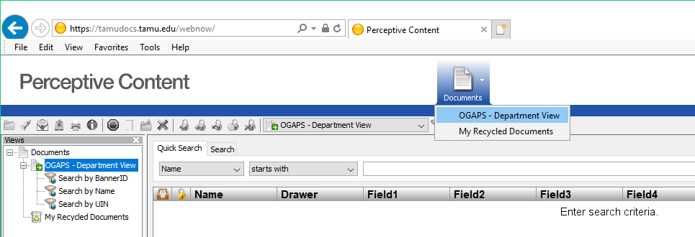

- Click once on the respective “Search by …” filters on the left of the screen.
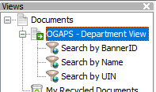
For example, to search by UIN, click on the filter labeled, “Search by UIN”. A prompt will pop-up for you to enter a UIN.
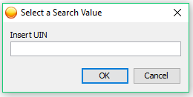

- Double click any document to open/view it. (You will only be able to view documents linked to your specific department. You will not have access to route the document or add any stamps or annotations for the Graduate and Professional School.)

- To perform another search after you have already completed one, click on the green “Go” button in the top right to open the prompt again.
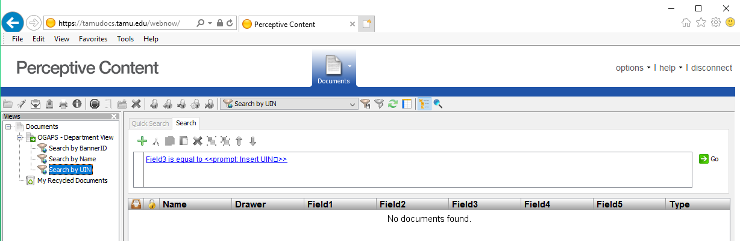

Contact: Graduate Records Processing – gradprocessing@tamu.edu or 979-845-3631

Guidelines for Graduate Faculty Membership
The Graduate Faculty at Texas A&M University consists of the President, the Provost and Executive Vice President, the Associate Provosts, the Deans of all subject-matter colleges/schools, selected Directors, and properly qualified academic groups.
The Graduate Faculty Guidelines (https://grad.tamu.edu/academics/graduate-faculty) explains university policies and practices which Deans, Department Heads, and intercollegiate faculty Chairs should follow in nominating members to the Graduate Committee Faculty of Texas A&M University for participation on graduate student advisory committees. This document also discusses the various roles of Graduate Committee Faculty and describes the credentialing requirements for the Graduate Teaching Faculty. Colleges/schools, departments, and interdisciplinary degree programs may require additional requirements that must be satisfied for appointment to the Graduate Committee Faculty. Additional requirements are subject to review and approval by the Associate Provost for Graduate and Professional School.

Graduate Teaching Faculty
According to SACSCOC guidelines, faculty teaching graduate and post-baccalaureate coursework should have an earned doctorate or terminal degree in the teaching discipline or a related discipline. Other credentials that may be considered include possessing a master’s degree or at least 18 semester credit hours of graduate-level coursework in the same or closely related field, professional licensure or certification in a related field or profession, or significant professional, research or teaching experience in the same or closely related field. Faculty members meeting these credentialing requirements are automatically members of the Graduate Teaching Faculty.
The Office of Faculty Affairs assumes responsibility for verifying the teaching qualifications for faculty. Colleges/schools, and departments oversee hiring of Graduate Assistants who serve as instructors of record for undergraduate courses. The guidelines for all instructional faculty, including Graduate Teaching Assistants, who are instructors of record for graduate and undergraduate courses at Texas A&M University and its two branch campuses – Texas A&M University at Galveston and Texas A&M University at Qatar – are available on the Faculty Affairs website (https://facultyaffairs.tamu.edu/Faculty-Affairs/Faculty-Credentialing).
In addition to meeting the credentialing requirements for teaching graduate courses, faculty teaching research courses such as 691 (Research) and other designated courses must also be members of the Graduate Committee Faculty.

Graduate Committee Faculty
Appointees to the Graduate Committee Faculty participate in the graduate degree programs of Texas A&M University by serving on graduate student advisory committees.

General Terms of Membership
Members of the Graduate Committee Faculty are selected from qualified individuals of the faculty and professional staff of Texas A&M University; from employees of Texas A&M University System agencies; from employees of affiliated research organizations located near Texas A&M campus sites, and from affiliated hospitals and clinical organizations.
Nomination for membership on the Graduate Committee Faculty is always initiated by the head of the appropriate academic department, intercollegiate faculty chair, or dean of a college/school (under special circumstances) of Texas A&M University.
Membership on the Graduate Committee Faculty is maintained only by participating in graduate programs by directing or administering graduate work, by doing research and publishing, or by other direct and substantial contributions to the graduate programs of the University, such as through service on a Graduate Instruction Committee or with administrative assignments in graduate education. A member of the graduate committee faculty may not serve on the graduate committee faculty of an academic program in which the member is pursuing a graduate degree or certificate. Individuals who have not been appointed to the Graduate Committee Faculty may not serve on student advisory committees unless special approval is granted by the Associate Provost and Dean of the Graduate and Professional School.
The Graduate and Professional Council expects that all Deans, Department Heads, and intercollegiate faculty Chairs will regularly review the Graduate Committee Faculty under their direction and will recommend withdrawal of the appointments of any members who no longer merit membership on the Graduate Committee Faculty on the basis of their lack of contribution to graduate education.
If the chair of a student’s advisory committee voluntarily leaves the University and the student is near completion of the degree and wants the chair to continue to serve in this role, the student is responsible for securing a current member of the University Graduate Committee Faculty, from the student’s academic program and located near the Texas A&M University campus site, to serve as the co-chair of the committee. The Department Head or intercollegiate faculty Chair may request in writing to the Associate Provost and Dean of the Graduate and Professional School that a faculty member who is on an approved leave of absence or has voluntarily separated from the University, be allowed to continue to serve in the role of chair of a student’s advisory committee without a co-chair for up to one (1) year. The student should be near completion of the degree. Extensions beyond the one-year period can be granted with additional approval of the Associate Provost and Dean.
The Department Head or intercollegiate faculty Chair must provide notification to any faculty member who is non-voluntarily removed from the roles of the Graduate Committee Faculty. Faculty members have the right to appeal their removal through University Rule 12.99.99.M2 (Faculty Grievances Procedures; https://rules-saps.tamu.edu/PDFs/12.99.99.M0.01.pdf). Before removal, the academic unit should verify the faculty member is no longer active on any student committees. Current faculty participation on student advisory committees can be found via the Committee/Service Member Inquiry (SHICMBQ) screen in Compass.
The two categories of membership are: 1) Member, and 2) Special Appointment.

Members of Graduate Committee Faculty
There are five member category types defined in the Graduate Committee Faculty Guidelines:
- Tenured and Tenure-Track Faculty (TTF) at Texas A&M University
- Academic Professional Track (APT) Faculty at Texas A&M University at Qatar
- Academic Professional Track (APT) Faculty at Texas A&M University, TAMU System Agencies, and Affiliated Hospitals and Clinical Organizations
- Professional Staff (PS) at Texas A&M University, TAMU System Agencies, and Affiliated Hospitals and Clinical Organizations
- Faculty and Professional Staff Employed by Other Institutions and Organizations (OtherFPS)
The GCF Guidelines outline the nomination process and minimum qualifications which must be met for eligibility to serve in each of three member roles: Chair, Co-Chair, and/or Member.

Special Appointments
There may be times where the head of an academic department or intercollegiate faculty chair wishes to have qualified individuals (such as those from government, industry, or another university) serve on a student’s advisory committee without being permanent members on the Graduate Committee Faculty.
An individual serving as a Special Appointment on a student’s advisory committee does not count toward the minimum number of Graduate Committee Faculty necessary to form the committee, does not appear on the student’s degree plan, and does not approve student documents. Special Appointments, however, may be listed on the title page of a thesis, dissertation, or record of study.
Contact: Graduate Committee Faculty Administrative Coordinator – gradcom@tamu.edu or 979-845-3631

Graduate Committee Faculty Nominations
Authorized users may submit Graduate Committee Faculty nominations through the Graduate Committee Faculty Portal (http://gradcom.tamu.edu/). To enter or approve in GradCom, the user must be listed on a college/school, department, or interdisciplinary degree program’s Authorized Signers Form (see section 2.5 above). Any issues with access or notifications should be directed to the Graduate Committee Faculty Administrative Coordinator.

Graduate Committee Faculty Nomination Entry
After logging in to GradCom (http://gradcom.tamu.edu/), select the “Nominations” tab. To create a new nomination, click “Create New Nomination”.
Complete the form in its entirety. Please enter the nominee’s location, category, primary department, academic rank, and details of degrees earned; upload the appropriate documents – Curriculum Vitate for all nominees and Letter of Support for APT, PS, and OtherFPS nominees (TTF nominations do not require a letter of support); select the appropriate membership roles; and submit the nomination for approval through the workflow.
If a unit no longer intends to pursue an incomplete or returned nomination, it can be cleared from the system by selecting “Delete Nomination.”
For more information on entering and approving graduate committee faculty nominations, please see the Graduate Committee Faculty Portal User’s Guide available on the GradCom home page.

Nominating Faculty and Professional Staff Employed by Other Institutions and Organizations
Faculty and Professionals who are not employed by TAMU, TAMUQ, TAMUS agencies listed in section C, or affiliated hospitals and clinical organizations are eligible to participate as a member of the Graduate Committee Faculty (if permitted by college/school, department, or interdisciplinary degree program guidelines). Prior to nomination, the nominating college/school, department, or interdisciplinary degree program must
- Sponsor an account for the prospective nominee through the university’s Technology Services (https://it.tamu.edu/services/accounts-and-id-management/uin-netid-and-passwords/guest-accounts/)
- Once a University Identification Number (UIN) has been assigned, the prospective nominee must claim a NetID and create a TAMU email address through Aggie Account Gateway (https://gateway.tamu.edu/)
- The prospective nominee must then publish the TAMU email address to the University Directory (also through Aggie Account Gateway)
- Prospective nominees must also complete mandatory online trainings (EIS and FERPA) before the academic unit can complete the nomination approval process
Once all the above steps have been completed, the academic unit may submit nominations through the Graduate Committee Faculty Nomination Portal for approval.
Contact information: Technology Services, Identity Management – identity@tamu.edu or 979-862-4300

Nominating Special Appointments
Nominations for non-voting Special Appointments do not require the academic unit to sponsor credentials or for the prospective nominee to be assigned a University Identification Number (UIN).
Complete the nomination form in its entirety. Please enter the nominee’s location, email address, employer, position or title, and details of degrees earned; upload a current Curriculum Vitate (Special Appointment nominations do not require a letter of support); enter the UIN of the student for whom the Special Appointment will advise; and submit the nomination for approval through the workflow.

Graduate Committee Faculty Membership Change Requests
Academic units may adjust their Graduate Committee Faculty members’ roles through the Change Request process. After logging into GradCom, select the “Committee Faculty” tab,search by first or last name, or see all members with a specific unit affiliation (the affiliation in bold is the member’s primary/home department). Select a specific member by clicking “View.” Under “Memberships”, select your unit from the drop-down menu and click “Start Change Request.” The request will move to the “Change Request List” page. To initiate, click the “Update” button. The change request will than move the the same approval process as the equivalent regular nomination.
Please note: users can make change requests only for departments in which they are authorized to submit Graduate Committee Faculty nominations.
For more information on entering and approving change requests, please see the Graduate Committee Faculty Portal User’s Guide available on the GradCom home page.
Contact: Graduate Committee Faculty Administrative Coordinator – gradcom@tamu.edu or 979-845-3631

Interdisciplinary Degree Programs (IDPs)
The Graduate and Professional Catalog provides a list of approved interdisciplinary degree programs at the master’s and doctoral levels.
All Graduate and Professional School documents for students in the following programs require the signature of the Chair of the appropriate interdisciplinary program. Students who have not filed a degree plan are listed as members of the IDP’s administrative home department. Once a degree plan is filed, the student will count as a member of the advisory committee chair’s home department.
Students in IDPs graduate with the college/school as determined by the program below.

Program/Major | Degree | Commencement Ceremony
Agribusiness (AGBU) | MAB | with College of Agriculture and Life Sciences
Agribusiness and Managerial Economics (ABME) | PhD | with College of Agriculture and Life Sciences
Biotechnology (BIOT) | MBIOT | with College of Engineering
Data Science (DATA) | MS | with College or school where chair of advisory committee resides*
Ecology and Evolutionary Biology (EEBL) | PhD | with college or school where chair of advisory committee resides*
Energy (ENGY) | MS | with College of Engineering
Genetics (GENE) | MS | with college or school where chair of advisory committee resides*
Genetics and Genomics (GGEN) | PhD | with college or school where chair of advisory committee resides*
Molecular and Environmental Plan Sciences (MEPS) | MS | with College of Agriculture and Life Sciences
Molecular and Environmental Plan Sciences (MEPS) | PhD | with College of Agriculture and Life Sciences
Neuroscience (NRSC) | MS | with college or school where chair of advisory committee resides*
Neuroscience (NRSC) | PhD | with college or school where chair of advisory committee resides*
Toxicology (TOXI) | MS | with college or school where chair of advisory committee resides*
Toxicology (TOXI) | PhD | with college or school where chair of advisory committee resides*
Water Management and Hydrological Sciences (WMHS) | MS | with College of Arts and Sciences
Water Management and Hydrological Sciences (WMHS) | MWM | with College of Arts and Sciences
Water Management and Hydrological Sciences (WMHS) | PhD | with college or school where chair of advisory committee resides*

New 689 (Special Topics) Courses
689 (Special Topics) courses may be taught, temporarily, with approval from the Graduate and Professional School. According to the Rule FS.15.013 for Special Topics Courses (https://u.tamu.edu/FS-15-013), a new graduate course may be taught under the designtation of 689 (Special Topics) two times. After the second offering, the course should then be given a regular, permanent course number and submitted for approval as a new course. The Special Topics course may receive approval for a third time only if a permanent course request has been created and submitted in the Curricular Approvals Request System (CARS) for consideration. This process will be monitored by the Graduate and Professional School.
Note: If extenuating circumstances exist to prevent submission of a new course request, and the course must be approved a third time, please contact the Graduate and Professional School excplaining the situation.
689 requests must be submitted through the Registrar’s Section Request System (SRS) at https://sectionrequest.tamu.edu/. For information on the SRS and submission of 689 requests, see the Regstrar’s User Guide (https://sectionrequest.tamu.edu/UserGuide/SRSUserGuide.pdf). Additional information regarding Special Topics courses can be found on the Office of the Registrar’s Course Inventory Approvals webpage at https://u.tamu.edu/Course-Inventory-Approvals.

Contact: Graduate and Professional School – grad@tamu.edu or 979-845-3631
Office of the Registrar, Scheduling Office – scheduling@tamu.edu or 979-458-4950

GradAdvisors LISTSERV
The LISTSERV is a mailing service through which the Graduate and Professional School, as well as other entities around campus, disperse information relevant to graduate and professional students, advisors, and programs at Texas A&M University.

Some examples of LISTSERV appropriate information:
- Scholarship/Grant/Fellowship information
- Information for graduate and professional students and advisors related to programming, events, and professional development
- Updates/changes to graduate academic requirements
- Student rule information relevant to graduate students or programs
Note: All content submitted to the listserv should be applicable to the campus community as a whole, rather than one specific college or department.

Submitting Information to the LISTSERV
Messages should be sent to gradadvisors@listserv.tamu.edu for approval and should be addressed to the intended recipients: “Grad Advisors.”. The moderator acts only as a filter for unnecessary information and does not edit or tailor individual emails for submission. Each email should be carefully crafted, meticulously proofread and edited, and have contact information clearly listed.

Subscribing/Unsubscribing from the LISTSERV
To subscribe to the Grad Advisor LISTSERV, send an email to listserv@listserv.tamu.edu with the following commands as a single line in the body of the message:
- Subscribe GRADADVISORS Firstname Lastname
where “Firstname” and “Lastname” is your real name.
- No “Subject” is required. You do not need to include your email address in your message. LISTSERV automatically uses the address from your email.
To unsubscribe or sign off from the Grad Advisors LISTSERV, send an email to listserv@listserv.tamu.edu with the following command as a single line in the body of your message:
- SIGNOFF GRADADVISORS
- Your email must come from the account you used when you subscribed to the list.
grad@tamu.edu – More information pertaining to the GradAdvisorS Listserv.
grad@tamu.edu – More information pertaining to the GradAdvisorS Listserv.

Compass Use
Compass, the student information system, provides critical support to the administrative and academic operations of Texas A&M University by maintaining an electronic database of student records. It is accessible online to authorized users. Compass support is divided into six functional areas: admissions processing, registration, student records, student accounts and billing, student financial aid, and degree evaluation.

Access
If your job duties require you to use Compass, you will need a Compass Account Request form initiated by the Primary Authorizing Agent (PAA) within the employee tab of Howdy. After you complete the Basic Navigation training, you will receive your Compass account. You will then be notified to take additional training if needed. Prerequisites for acquiring Compass access include knowing your NetID and password, acquainting yourself with the Howdy web portal, completing the EIS Application Security Statement of Acknowledgement, and completing FERPA training.
More information on Compass may be found online at https://eis.tamu.edu/Compass.
The following Compass security groups are necessary to obtain Compass forms which display items associated with graduate student progress and provide access to generate a graduate degree evaluation:
G_REGI_CAPP_DEG_AUDIT_VIEW
Grants access to the Advisor Menu Channel on the Instructor/Howdy Dashboard in the Howdy Portal. With this security group, advisors can generate degree evaluations and access the advisor functions in self-service. Includes Compass forms: SMARQCM, SMACACT, SMAPRLE.
G_REGI_CAPP_ADJUSTMENT_VIEW
Provides query level access to Compass forms which display archived degree audit data. Includes Compass forms: SMASARA, SMASLIB.
G_CLGR_GRAD_STU_INFO_VIEW
Provides query level access to Compass forms which display graduate GPA, graduate student advisory committees, faculty committee assignments, non-course requirements, thesis/dissertation information and accumulated doctoral hours and terms. This group also provides Compass Reports access to all Graduate and Professional School reports which are used by department and college graduate advisors. Includes Compass forms: SOAGPAT, SHICMID, SHICMBQ, SHANCRS, SHAQPNO.

Compass Training
Compass training is currently completed in the Introductory Training available through Enterprise Information Systems (EIS) at the beginning of the Compass account setup process. Additional information is available through the Employee tab on the Howdy Portal. Under this tab, there is a channel entitled “Compass User Training” that contains various electronic presentations on Compass topics.

Compass Reports
Compass Reports is a repository of Compass-based reports which allows approved users to display, download, and print documents created by a variety of TAMU offices. Compass Reports is accessed via the Compass Reports link in the Compass Channel on the Employee tab in the Howdy Portal or via the Compass Reports Icon in the Howdy Portal.

Access
Following the same process used to request or update a Compass account, PAAs request access to reports for their Compass users by completing the ‘Compass Account Request Form’ In Howdy. The security group which contains the desired report is listed on the request. The completed form is sent to EIS for approval.

Graduate and Professional School Use of Compass Reports
The Graduate and Professional School will include all Graduate and Professional School reports used by departments and colleges in specific security groups available by college and department. Please have your PAA contact Trent Smith at smitht@tamu.edu or Stephen Caster at scaster@tamu.edu for the specific group that needs to be requested.
The following lists some common graduate student-related reports available through COMPASS Reports:
Report Name | Description
PWS_CURR_STD_COMM_XX | All students in the college with a committee. Lists all the student’s committee members, member UIN, member type and member affiliated department(s) in Compass.
PWS_GR_COMMITTEE_XX | Ad hoc report. This report only exists if it has been requested by a department or faculty member through the eis-reports team. It will list all committees a specific faculty member has ever served on including historic committees from SIMS. The report has the option to also include the student’s thesis/dissertation title.
PWS_GRAD_GPR_XX | College specific report that lists whether the graduate student has an approved degree plan, completed degree plan hours, degree plan GPR, cumulative GPR, incompletes, completed S/U hours, and committee chair.
PWS_ELP_CERTIFICATION_XX | English Language Proficiency levels, as they relate to English Language Certification for international students.
SRC_AL_FINAL_GRAD_AL  SRC_AL_FINAL_GRAD_AL_CSV  SRC_AL_FINAL_GRAD_GR  SRC_AL_FINAL_GRAD_GR_CSV  SRC_AL_FINAL_GRAD_XX  SRC_AL_FINAL_GRAD_XX_CSV | Final graduation report. The SRC_AL_FINAL_GRAD_AL reports list all students who graduated (UG, GR, professional). The “_GR” reports only list graduate students.
SRC_AL_GRAD_COMM_XX  SRC_AL_GRAD_COMM_XX_CSV | Faculty affiliated in Compass with the college who serve on graduate advisory committees. Lists all committees (enrolled students only) on which they serve. Includes member type, student UIN and student program. Intended to be used for Faculty load.
SRC_CS_ACCUM_DOC_HRS_XX | Accumulated doctoral hours and terms of G8 doctoral students.
SRC_CS_GRAD_GPR_XX  SRC_CS_GRAD_GPR_XX_CSV | Cumulative graduate GPR and degree plan GPR of enrolled students.
SRC_CS_GRAD_STU_ENROLL_XX | Graduate students enrolled for the semester or term.
SRC_CS_NO_DEGPLAN_XX  SRC_CS_NO_DEGPLAN_XX_CSV | Students who will be blocked for missing degree plan, includes TAMU email address for contact.

Graduate Student Funding And Development

Graduate Student Funding Offers Guidelines
April 15 Resolution - Resolution Regarding Graduate Scholars, Fellows, Trainees, and Assistants
Acceptance of an offer of financial support* (i.e., graduate scholarship, fellowship, traineeship, or assistantship) for the next academic year by a prospective or enrolled graduate student completes an agreement that both the student and graduate school are expected to honor. In that context, the conditions affecting such offers and their acceptance must be defined carefully and understood by all parties.
Students are under no obligation to respond to offers of financial support prior to April 15. Earlier deadlines for acceptance of such offers violate the intent of this Resolution. When a student accepts an offer before April 15 and subsequently desires to withdraw that acceptance, the student may submit in writing a resignation of the appointment at any time through April 15. However, an acceptance given or left in force after April 15 commits the student not to accept another offer without first obtaining a written release from the institution to which a commitment has been made. Similarly, an offer by an institution after April 15 is conditional on presentation by the student of the written release from any previously accepted offer. It is further agreed by the institutions and organizations subscribing to the above Resolution that a copy of this Resolution or a link to the URL should accompany every scholarship, fellowship, traineeship, and assistantship offer.
The Council of Graduate Schools (CGS) has prepared a shareable PDF of the Resolution, which includes a list of CGS member institutions that have expressed support for the agreement.
This Resolution was renewed October 2019.
* This Resolution applies to offers of financial support only, not offers of admission.
For more information, please see the following information page: https://cgsnet.org/resources/for-current-prospective-graduate-students/april-15-resolution/

Graduate Fellowships and Awards

The Dr. Dionel Avilés ’53 and Dr. James Johnson ’67 Fellowship Program
These fellowships provide a monthly stipend amounting to $20,000 per year for three (3) years for doctoral students and $15,000 for two (2) years for master’s students. In addition, the student receives tuition and fee payments at full-time enrollment (9 hours fall & spring, 6 hours summer, if applicable) for two (2) years for master’s students or three (3) years for doctoral students.
It is essential that the Avilés-Johnson Fellowship Program recipients be given ample opportunities for success and integration into the culture of their respective department early in their campus residence. Therefore, along with a fellowship award from the Graduate and Professional School, the nominating department is required to provide an assistantship of a minimum of 25% FTE at the department’s standard assistantship rate. If the department provided assistantship is 50% FTE, the student is eligible for graduate student employee benefits. Master’s students are to receive support for two (2) years, and doctoral students are to receive support for three (3) years.
In year 4 (doctoral students), matching funding at a minimum equivalent to the standard assistantship level for the nominating department, and tuition payment are required from the department and/or faculty.
Reviewers will consider all aspects of the applicant’s experiences in the evaluation process with a focus on excellence and how the applicant will contribute to diversity at Texas A&M. Only U.S. citizens or permanent residents are eligible for this award.
As part of the nomination process, nominators must complete a nomination application and a nomination letter. The nomination letter should clearly describe the nominee’s (1) superior academic performance, (2) relevant experiences outside of the classroom, and (3) other indicators of future success.
Dr. Shannon Walton, Assistant Dean
For more detailed information regarding the Avilés-Johnson Fellowship Program: https://grad.tamu.edu/knowledge-center/funding-and-benefits/what-is-the-aviles-johnson-fellowship.

Award Information
The Texas A&M University Graduate and Professional School offers a Dissertation Fellowship to support students in the dissertation phase of their degree program during the 2023-2024 academic year. This fellowship is intended to support doctoral students in the final analysis of the research topic and the final writing of the dissertation. This fellowship is NOT intended to finance data collection or the completion of doctoral coursework. Priority goes to doctoral students whose primary financial support for the upcoming academic year is NOT related to their research (e.g. GANT, GAL, GAT, Self-funded). Students who have funding related to their dissertation research will be least likely to receive this fellowship. Students who anticipate graduating by December 2023 (Round 1) or May 2024 (Round 2) of the current academic year will be least likely to receive this fellowship.
Requirements
- Must be admitted to candidacy by May 12, 2023 for Round 1 and October 27, 2023 for Round 2. To be admitted to candidacy for a doctoral degree, a student must have:
  - Completed all formal coursework on the degree plan with the exception of any remaining 681, 684, 690, and 691 credit hours,
  - Demonstrated a 3.0 Graduate GPA and a Degree Plan GPA of at least 3.0 with no grade lower than C in any course on the degree plan,
  - Passed the preliminary examination (written and oral portions),
  - Submitted an approved dissertation proposal, and
  - Met the degree residency requirements (see Graduate Catalog).
- The Dissertation Fellowship will not be authorized for any doctoral student who has not been admitted to candidacy by the dates listed above for each round.
- The student must reside in Bryan/College Station and conduct the work described in the Disseration Fellowship application on campus, during the fellowship year (Round 1: August 2023 to August 2024 and Round 2: January 2024 to December 2024), except for TAMU doctoral students whose committee chair resides on the TAMU-Galveston campus. In the latter case, those students should be working on site in Galveston.
For more detailed information regarding the Dissertation fellowship: https://grad.tamu.edu/knowledge-center/funding-and-benefits/dissertation-fellowships

National Fellowships

NSF GRFP
The National Science Foundation (NSF) Graduate Research Fellowship program (GRFP) recognizes and supports outstanding graduate students in NSF-supported science, technology, engineering, and mathematics disciplines who are pursuing research-based master’s and doctoral degrees at accredited US institutions.
Students apply directly to and are awarded by NSF. Texas A&M receives the funding directly from NSF and the Graduate and Professional School administers the awards to the NSF GRFP fellows. NSF GRFP fellows receive a three-year annual stipend of $37,000, payment of 100% tuition and required fees, as well as access to opportunities for professional development available to NSF-supported graduate students. Each recipient is eligible to participate in a Texas A&M University System (TAMUS) insurance program as a graduate student fellow.
NSF Fellows are NOT eligible for the graduate assistant tuition payment program.
https://www.nsfgrfp.org/

The National GEM Consortium | GEM Fellowship Program
The National GEM Consortium (GEM) offers Master’s and Doctoral level students an outstanding opportunity and access to dozens of the top Engineering and Science firms and Universities in the nation. The GEM Fellowship was designed to focus on promoting opportunities for individuals to enter industry at the graduate level in areas such as research and development, product development, and other high-level technical careers. GEM also offers exposure to a number of opportunities in academia.
Eligibility
Under-representation: Candidates are targeted for participation who are members of the following under-represented groups in science and engineering as defined by the United States Bureau of Labor Statistics:
- American Indian/Native
- African American/Black
- Hispanic American/Latino
Citizenship: Applicants must be a U.S. citizen or U.S. permanent resident at time of application.
GRE: Applicants are strongly encouraged to take the GRE to qualify for multiple GEM Member University programs. Applicants will be asked to provide test dates and/or GRE scores when available.
University Graduate Program: Applicants must directly apply to a minimum of three (3) GEM Member Universities STEM graduate departments. The deadline to apply to three GEM Member Universities is January 15th OR the relevant STEM graduate department deadline, whichever is earlier. Applicants must be admitted into a GEM Member University graduate program with confirmed department funding support before the GEM Fellowship is awarded.
www.gemfellowship.org/students/gem-fellowship-program

Ford Foundation Dissertation Fellowship
Eligibility to apply for a dissertation fellowship is limited to:
- All U.S. citizens, U.S. nationals, and U.S. permanent residents (holders of a Permanent Resident Card); individuals granted deferred action status under the Deferred Action for Childhood Arrivals Program; Indigenous individuals exercising rights associated with the Jay Treaty of 1794; individuals granted Temporary Protected Status; asylees; and refugees, regardless of race, national origin, religion, gender, age, disability, or sexual orientation;Individuals with evidence of superior academic achievement (such as grade point average, class rank, honors, or other designations),
- Individuals committed to a career in teaching and research at the college or university level in the U.S.,
- Ph.D. or Sc.D. degree candidates studying in an eligible research-based discipline in a dissertation-required program at a non-proprietary (not for profit) U.S. institution of higher education who will complete the dissertation in a period of 9-12 months during the 2023-2024 academic year;,
- Individuals who, by December 8, 2022*, have completed all departmental and institutional requirements for their degree, except for writing and defense of the dissertation, and
- Individuals who have not earned a doctoral degree at any time, in any field
*Deadline from the 2022 competition. The 2023 application deadline will be announced at a later time.
Stipend and Benefits
- One-year stipend of $28,000
- An invitation to attend the Conference of Ford FellowsAccess to Ford Fellow Regional Liaisons, a network of former Ford Fellows who have volunteered to provide mentoring and support to current Fellows, and access to other networking resources
https://sites.nationalacademies.org/PGA/FordFellowships/PGA_047959

Graduate Fellowships for STEM Diversity (GFSD)
Duration: Initial support may be for two or three years, or for a full six years, depending on the employer-sponsor. Fellowship renewal will be reviewed in partnership with employer-sponsor on an annual basis.
Amount: The charge to the employer for each student supported is $27,000 annually, of which $20,000 is the fellow's expense allowance and $7,000 is GFSD's fee to support its operations. (The charge is subject to change at the discretion of the GFSD Board of Directors.)
Fields of Study: Though the fields supported can vary annually depending on employer needs, in general, GFSD covers the following: Astronomy, Biomedical Engineering, Chemistry, Computer Science, Geology, Materials Science, Mathematical Sciences, Physics, and their sub disciplines, and related engineering fields: Chemical, Computer, Electrical, Environmental, Mechanical.
Location or Type of Institution: Any participating GFSD University or College
Eligibility: GFSD welcomes applications from any qualified U.S. citizen who has the ability to pursue graduate work at a GFSD university partner. Applicants at any stage of their graduate program may apply, as long as they will be available to accept two summers of paid internship. Those who already possess a doctoral degree are ineligible.
https://stemfellowships.org/applicants

Fulbright U.S. Student Program
The Fulbright U.S. Student Program expands perspectives through academic and professional advancement and cross-cultural dialogue. Fulbright creates connections in a complex and changing world. In partnership with more than 140 countries worldwide, the Fulbright U.S. Student Program offers unparalleled opportunities in all academic disciplines to passionate and accomplished graduating college seniors, graduate students, and young professionals from all backgrounds. Program participants pursue graduate study, conduct research, or teach English abroad. During their grants, Fulbright students will meet, work, live with, and learn from the people of the host country, sharing daily experiences. The program facilitates cultural exchange through direct interaction on an individual basis in the classroom, field, home, and in routine tasks, allowing the grantee to gain an appreciation of others’ viewpoints and beliefs, the way they do things, and the way they think. Through engagement in the community, individuals will interact with their hosts on a one-on-one basis in an atmosphere of openness, academic integrity, and intellectual freedom, thereby promoting mutual understanding.
Grant lengths and dates vary by award. Please consult the specific award description for details.
Eligibility Requirements:
- Applicants must be citizens or nationals of the United States of America at the time of the application deadline. Permanent residents are not eligible. Please review the Award Description in relation to the eligibility of dual citizens.
- Applicants must have a conferred bachelor's degree or equivalent before the start of the grant period.
  - In the creative and performing arts, four years of professional training and/or experience meets the basic eligibility requirement. If you are an Arts applicant and do not hold a BA, please email fbstudent@iie.org with your professional experience and educational history to confirm eligibility before beginning an application.
- Applicants must meet the language requirements of the award to which they are applying and demonstrate sufficient competency to complete their project and adjust to life in the host country.
- Applicants may hold a J.D. at the time of application.
- Doctors of Medicine may receive grants for advanced academic study, but not for internships or residencies. Scholars with an M.D. degree who have completed their formal postgraduate training and propose attachment to a hospital or clinic for the purpose of independent or collaborative research should apply to the Fulbright U.S. Scholar Program. Grants shall not authorize activity for which a license to practice medicine or nursing is required. The Fulbright Program cannot authorize proposals for medical research that involves clinical training, patient care or patient contact.

Preferred Qualifications:
- Strong preference for those who have not previously held a Fulbright grant. For the 2024-2025 competition, 2023-2024, 2022-2023, and 2021-2022 grantees will be at a competitive disadvantage, but are still eligible to apply, provided they continue to meet all other eligibility requirements of the program and their chosen award.
- Preference will be given to applicants whose higher education was undertaken primarily at educational institutions in the United States. Undergraduate study abroad experiences, either in the chosen host country or elsewhere, will not be considered a disadvantage.
- Candidates who have not resided or studied in the country to which they are applying for more than six months, not counting undergraduate study abroad, are preferred. Duty abroad in the Armed Forces of the United States is not considered disqualifying within the meaning of this section.
- Candidates who have served in the Armed Forces of the United States will be given preference, provided their qualifications are approximately equivalent to those of other candidates.
- For most programs, applicants who have had extensive, recent previous experience in the host country are at a competitive disadvantage but are still eligible to apply.

Past and upcoming events: https://us.fulbrightonline.org/applicants/information-sessions

Graduate Recruitment, Enhancement, and Travel (GREAT) Program
The Graduate Recruitment, Enhancement, and Travel (GREAT) Program provides supplemental funding to eligible: (i) nationally competitive external fellowships awarded to students, (ii) federal training grant fellowships awarded to faculty or departments, and (iii) federal research grant supplements awarded to faculty to promote diversity.

The goal of the supplements is to provide a full funding package for eligible nationally competitive dissertation and multi-year external fellowships, federal training grants, and federal research grant supplements promoting diversity. An annual full funding package includes a monthly stipend of at least $3,000 per month or up to the monthly amount of the fellowship/training grant stipend if greater than $3,000 per month, funding for full tuition and required university and college fees, 12 months of student health insurance, and a $1,500 scholarship for professional development opportunities, conference travel, research travel, books, etc.

The GREAT Program also provides $1,000 travel awards for faculty to bring high-achieving prospective doctoral students to campus who may have received or would be a candidate for nationally competitive external fellowships. The goal of the travel awards is to elevate Texas A&M’s national competitiveness in attracting high achieving students. The prospective doctoral students should be in their last year of undergraduate or master’s studies and have submitted an admissions application.

Visit the GREAT Program webpage for more information including the list of eligible external fellowships, federal training grant fellowships, and federal research grant supplements awarded to faculty to promote diversity, funding conditions, and for links to the request forms. Questions can also be directed to great@tamu.edu.

Graduate Student Awards

U.S. Senator Phil Gramm Doctoral Fellowship Award ($5,000)
The U.S. Senator Phil Gramm Doctoral Fellowship Award, available only to currently enrolled doctoral students at Texas A&M University, recognizes scholarly excellence. This fellowship was established to promote, encourage, and reward outstanding teaching and research by doctoral students whose command of their respective disciplines exemplifies the meaning of scholar/mentor in the highest sense. All departmental nominations must be submitted to the college/school level first. College/School Administrators will then select four (4) of the departmental nominations to submit to the Graduate and Professional School for final consideration.An award reception is held in the subsequent fall semester.
https://grad.tamu.edu/knowledge-center/funding-and-benefits/u-s-senator-phil-gramm-doctoral-fellowship-information

The Texas A&M Distinguished Dissertation Award ($1,000)
The Graduate and Professional School annually recognizes dissertations that have made a significant, impactful contribution to their field. Awards are made in four board categories: biological sciences and life sciences, humanities and fine arts, mathematics, physical sciences, and engineering, and social sciences. One of the distinguished dissertation winners is also named the George W. Kunze Endowed Fellowship Award recipient. Dr. George W. Kunze was the long-time Dean of the Graduate College at Texas A&M University. Upon his retirement, university faculty and friends generously contributed an endowment in honor of Dr. Kunze to provide an award for a current doctoral student nearing completion of the degree program.
https://grad.tamu.edu/knowledge-center/funding-and-benefits/texas-a-m-distinguished-dissertation-award-information

Montgomery Award ($1,000)
The Montgomery Award is awarded to student leaders making major contributions to the academic and professional opportunities, and the quality of life of their fellow graduate and professional students here at Texas A&M. Whether through demonstrated leadership in recognized graduate student groups or service organizations, students must show their dedication to serving aggie graduate and professional students in addition to excellent academics and scholarship.
https://grad.tamu.edu/knowledge-center/funding-and-benefits/montgomery-award-information

Distinguished Graduate Student Awards (certificate and watch value at $500)
Each year, the Graduate and Professional School selects up to 15 graduate students to receive the Association of Former Students Distinguished Graduate Student Awards in one of two categories: Excellence in Research-Doctoral, and Excellence in Teaching – Master’s and Doctoral. Student nominations arrive from faculty advisors or departments, and normination represents a true honor and accomplishment, due to strenuous eligibility requirements. A panel of reviewers including faculty and administrators chooses award recipients.
Nomination Guidelines
- Deadline for submission: Around the first week of February
- Submit all nominations through the Graduate and Professional School InfoReady submission system.
- Students CANNOT submit/upload their own nominations.
https://grad.tamu.edu/knowledge-center/funding-and-benefits/distinguished-graduate-student-award

Other Grants

Graduate Student Research and Presentation Travel Award
The Graduate and Professional School offers the Graduate Student Research and Presentation Travel Award Program, which is supported by the George Bush Presidential Library Foundation. The purpose of the program is to reimburse travel expenses associated with graduate students’ domestic and international travel related to conferences, academic presentations, and research projects. Students may receive only one (1) of these travel awards during their degree program. Additionally, up to 15 graduate students receive Distinguished Graduate Student Awards for Research or Teaching annually. The students are nominated by their committee chair/co-chairs in the spring semester with strenuous eligibility requirements.
grad-award-admin@tamu.edu – Graduate and Professional School awards administrator’s email address
grad-travel-award@tamu.edu – Graduate and Professional School Travel Award email address

TAMU Graduate Fellowship Nominations and Processing
Fellowships are awarded on a yearly basis, typically in early spring when universities are actively seeking and recruiting the brightest students to enroll in their programs. Students who are awarded a Dr. Dionel Avilés ’53 and Dr. James Johnson ’67 Fellowship are highly sought after by other universities, so timeliness is critical in the nomination, selection, and offering process.

Call for Nominations/Applications
Call for nominations/applications for each fellowship and award is sent one to two months in advance to allow departments time to gather needed information to prepare competitive nomination packet(s).

Nomination Submission Process
The nomination process is now completely online in an easy-to-use format (InfoReady submission system). To log on to InfoReady, you must have a Texas A&M Net ID. Once logged in, you will choose the appropriate fellowship and will be asked to provide demographic information and fill out an online application. The submitter can then attach a nomination letter and the student’s application materials to complete the nomination submission process.
https://tamugrad.infoready4.com/

Review and Award Process
Avilés-Johnson - Reviewers enter their personal rankings (quantitative and qualitative) of each student reviewed into the InfoReady system.
Considering previous yield rates and available funding, the Associate Provost and Dean of the Graduate and Professional School and the Assistant Dean review the ranking list with z-scores to determine how many offers can be made. The Assistant Dean sends award notification emails to the nominators of student recipients requesting confirmation of departmental/program funding commitments. All nominees selected, and not removed from consideration by his/her nominator, are to be sent the Graduate and Professional School and department award letters one week after awards are announced to departments.

Reviewer Selection Process
Reviewers are solicited for each fellowship. The Assistant Dean of the Graduate and Professional School contacts potential faculty and administrators to request their service as reviewers. Every effort is made to ensure the review process includes reviewers who are diverse with respective to gender, discipline, and ethnicity.
Evaluation Criteria – Reviewers are provided with detailed instructions and criteria to guide the review process.
Reviewer deadlines usually fall 7-10 days after the reviewer receives instructions.

Award Letters
Award letters go out electronically no later than one (1) week after the awardees have been selected. Copies of the Graduate and Professional School award letters are sent to:
- GOC Dean
- Department Head
- Graduate Advisor
- Nominator

Acceptance Forms
As acceptance forms come in, the Graduate and Professional School records each form that is returned and marks whether the student has accepted or declined the offer. The Graduate and Professional School maintains a list of students who decline for future reporting, recording which higher education institution the student has chosen to attend, if indicated.

Follow-up and Welcome Letters
Prior to the fall semester, follow-up and welcome letters are sent to all students who have accepted Dr. Dionel Avilés ’53 and Dr. James Johnson ’67 Fellowships, as well as Pathways to the Doctorate and National Science Foundation Graduate Research Fellowship Program (NSF GRFP) students. This letter provides students with specific details regarding their fellowship, including stipend disbursements, tuition payments, and how to set up direct deposit, among other details.

Welcome Social
The welcome social is held early in the fall semester for new Avilés-Johnson, Pathways, National Science Foundation-GRFP, GEM, IDP Merit/College Merit awardees, Dissertation, and IMSD T32 fellows. An invitation is sent to students, Committee Chairs, Department Heads, Deans, and GOC Deans.

Retention Techniques
Tracking reports – Utilize these reports to call students, send them letters, and phone to discuss their grades and current status.
- GPA
- Year to year progress
- Fellowship
- Ethnicity
- Gender
- Status (time to graduation)
Numerous workshops throughout the year:
- Graduate and Professional School deadlines
- Thesis and Dissertation Services Informational
- Writing and Academic Integrity
- Time Management
- Stress Management
- Career Center Informational
- Suicide Prevention
- Health Insurance
- Ref Works citation tools
- Judging Poster and Oral Presentations
- Managing Your Finances
- Ombuds services
Social Events:
- Yell Practice
- Barbeque
- Ice Cream Social
- Fall and Spring Socials
- Evening Dialogues
- ASK the Graduate and Professional School
- Lunches
- Dinners in homes
Graduate Ombuds Officer:
- Assists students in finding options to solve conflicts and problems.
- Serves as a neutral listener and information resource

Professional Development Opportunities
In addition to acquiring discipline-based knowledge, success in graduate school and beyond requires the development of transferrable skills, such as communication, the ability to work in teams, and leadership. The Graduate and Professional School works in collaboration with other units and organizations on campus to facilitate the Graduate Resources and Development for Aggies (G.R.A.D. Aggies) professional development program. Launched in Fall 2014, the G.R.A.D. Aggies program is a compilation of professional development activities including workshops, seminars, one-on-one consultations, and online resources offered at the University level. The goal of G.R.A.D. Aggies is to help students engage in activities and resources that will not only help them succeed in their academic pursuits at Texas A&M but in their career aspirations after graduate school
The program focuses on providing events and resources in seven skill areas: research and academics; personal wellbeing; instruction and assessment; communication; leadership; inclusion, diversity, equity & accessibility development; and career development.
G.R.A.D. Aggies is a collaborative effort of:
Career Center
Center for Teaching Excellence
Counseling and Psychological Services
Graduate and Professional Student Government
International Student & Scholar Services
Graduate and Professional School
University Libraries
University Writing Center
Students who attend G.R.A.D. Aggies programming have the option to participate in the G.R.A.D. Aggies Professional Development Certificate Program. More information about the G.R.A.D. Aggies program and a listing of resources can be found at https://grad.tamu.edu/academics/professional-development/grad-aggies and in the monthly Grad School eNewsletter. Also, a searchable repository of all professional development opportunities available to graduate students, referred to as the Professional Development Portal, is available on the Graduate and Professional School website.
Graduate Mentoring Academy
The Graduate Mentoring Academy (GMA) is a parallel to the Faculty Mentoring Academy (FMA) and uses the Center for the Improvement of Mentored Experiences in Research (CIMER) resources which includes seven evidence-based mentorship competencies. Our goal is to improve the graduate mentoring experiences of our students and increase our mentoring capacity as an institution. The target audiences for these sessions are faculty, staff, and graduate and professional students. GMA workshops are offered in both face-to-face and virtual formats so that all seven competencies can be accessed regardless of location over the course of the year, fall, spring, and summer.
More about graduate mentoring can be found here: https://grad.tamu.edu/academics/academic-success-resources/mentoring

Graduate Student Matriculation Processing

Departmental Role in Document Processing
Documents recorded by the Graduate and Professional School mark each major decision point in a graduate student’s degree program. These documents should be reviewed at the departmental/program level before submission to the Graduate and Professional School. Department heads or chairs of interdisciplinary programs review and endorse documents concerning admissions, course registration, continuation in degree programs, scholastic probation, degree plans, petitions, proposals for theses and dissertations, and final drafts of theses and dissertations. The Graduate and Professional School reviews, approves/denies, and records major decisions after departments and/or colleges have reviewed and certified eligibility and accuracy.
The Graduate and Professional School is responsible for maintaining all University degree requirements. Departments/programs may, and often do, have additional or more stringent degree requirements than the University does (examples include cumulative exam requirements, GPA standards in specific courses, course sequence or core course requirements, etc). Departments/Programs themselves are responsible for overseeing these additional requirements.
The Graduate and Professional School requires departmental assistance in the oversight process with the following:

Document Processing Submission System (DPSS)
Degree plans are filed through the online Document Processing Submission System at https://ogsdpss.tamu.edu/. Please confirm that all required official academic credentials - such as required transcripts and test scores - have been received and processed by the Office of Admissions before submitting a degree plan for Graduate and Professional School review.
Once a degree plan has been successfully filed, changes are made by way of petitions through DPSS. Students may file an MDD petition to change their major, degree, or department or file a long-form petition to make a variety of other requests. Petitions to Change Course Work or Petitions to Change Committee Members are the most commonly filed.

Additional Processing Notes
Departments/Programs are directly involved in the major decisions during their students’ degree programs. Departments/programs can assist with efficient processing by honoring the following requests for documents submitted to the Graduate and Professional School:
- Identify students by complete legal name and University Identification Number (UIN) in all communications.
- Inform students of upcoming degree plan registration holds well in advance, so degree plans can be submitted and fully processed in a timely manner.
- State your requests clearly and provide proper justification for requests when required.
- Remember that some requests involve multiple forms and all forms should be submitted at the same time.
- Confirm that all required signatures have been provided and that only authorized departmental/program individuals (as designated in the unit’s Authorized Signers Form) have signed.
- Observe deadlines for materials to be received by the Graduate and Professional School as published in the Graduate Catalog and in the Graduate and Professional School Calendar.
- Allow extra processing time for multiple requests (e.g., exam schedule request submitted along with a petition making a committee change).
Contact: Graduate Records Processing – gradprocessing@tamu.edu or 979-845-3631

Graduate and Professional School Signature and Approval Requirements for Graduate and Professional Student Documents
Students, staff, and advisors must obtain all required approvals for the Academic Requirements Completion System (ARCS) and signatures for AdobeSign for forms utilized in the Graduate and Professional School. If one of the required signers is unavailable, each program has faculty members who are authorized signers for the faculty in that program. Please check with that program’s graduate office to determine who may sign. At a minimum, a form requires the Department Head or the Interdisciplinary Program Chair signature, that signature must be added to the workflow.

Forms that Have Department Head/Interdisciplinary Faculty Chair Signature
At a minimum, the department head/interdisciplinary faculty chair signature must be added to the workflow in Adobe Sign or DPSS.
- Letter of Intent to Pursue Another Graduate Degree
- Secondary Curriculum Request
- Graduate Student Graduation Cancellation Form

Forms that Do NOT Have Department Head/Interdisciplinary Faculty Chair Signature

At a minimum, the chair of the committee’s signature must be added to the workflow in Adobe Sign or DPSS.

- Petition for Course Change
- Petition for Change of Committee
- Petition for Change of Major, Degree, Department
- Petition for Extension of Time Limits
- Petition for Waivers or Exceptions to University Requirements
- Special Request Letter (Sent directly from student, does not require approval from chair)

Standardized Test Scores
Beginning with the recruiting cycle of AY2022-2023 (Fall 2023 and Spring 2024 admissions), an official score on a standardized test is not required for admission to a graduate program at Texas A&M University. Individual programs are allowed to require official scores on a standardized test upon request and approval by the Texas A&M University Graduate and Professional Council.
The departments/programs listed below informed the Graduate and Professional School that a standardized test is required as part of the admission requirement to Texas A&M University. All programs (other than those listed below) do NOT require a standardized test for admission purposes.
Requests for an individual student exemption may be submitted in writing to the Graduate and Professional School after acquiring approval from the appropriate department head and GOC dean.

Standardized Test Score is Required for Fall 2024 and Beyond Admissions

Programs Maintaining Standardized Test Requirements for 2022
College of Agriculture and Life Sciences
Degree Program | Masters | Doctorate | Professional
Department of Agricultural Economics
Agricultural Economics |  | PhD
College of Architecture
Degree Program | Masters | Doctorate | Professional
Department of Construction Science
Construction Management | MS
Construction Science |  | PhD
College of Arts and Sciences
Degree Program | Masters | Doctorate | Professional
Department of Anthropology
Maritime Archaeology and Conservation | MS
Department of Economics
Economics |  | PhD
Department of Mathematics
Mathematics | MS | PhD
Department of Psychological and Brain Sciences
Industrial/Organizational Psychology |  | PhD
Psychological Sciences | MS
Mays Business School
Degree Program | Masters | Doctorate | Professional
Analytics | MS/MBA |  |  | On Campus, Distance, and Combination Program
Business | MS
Business Administration | MBA | PhD |  | On Campus
Department of Finance
Finance | MS
Land Economics and Real Estate | MRE
Quantitative Finance | MS
Department of Information and Operations Management
Management Information Systems | MS |  |  | On Campus
Department of Management
Human Resource Management | MS
Management |  | PhD
Department of Marketing
Marketing | MS
School of Dentistry
Degree Program | Masters | Doctorate | Professional
Department of Oral and Masillofacial Surgery
Oral and Masillofacial Surgery |  |  |  | Certificate
Department of Orthodontics
Orthodontics |  |  |  | Certificate
School of Education and Human Development
Degree Program | Masters | Doctorate | Professional
Department of Teaching, Learning and Culture
Curriculum and Instruction |  | EdD |  | Distance
College of Engineering
Degree Program | Masters | Doctorate | Professional
Department of Industrial and Systems Engineering
Engineering Management | MS |  |  | On Campus and Distance
Industrial Data Analytics |  |  |  | Certificate, On Campus and Distance
Industrial Engineering | MS, MEN | PhD |  | On Campus and Distance
Harold Vance Department of Petroleum Engineering
Petroleum Engineering | MS, MEN | PhD |  | Required for Non-US Bachelor’s or Master’s Degree Holders, On campus and Distance

English Language Proficiency Requirements
All international graduate students whose native language is not English must meet minimum English language proficiency standards.
To achieve admission, international graduate students must attain English Language Proficiency (ELP) Verification. For eligibility to hold a graduate assistantship with instructional or curricular support responsibilities, international graduate students must achieve ELP Certification. The ELP status for all international graduate student applicants is available in COMPASS on the SHANCRS screen.

English Language Proficiency Requirement Waivers for Admissions
Eligibility for admission to Texas A&M University requires that international applicants must meet ELP requirements set by the academic unit and the university. This is attainable by achieving a minimum required score on an acceptable standardized examination (see Section 4.4.1.1 below and applicable admitting program requirements) or citizenship with an English-speaking country that is exempt from the requirement.
For students who do not do not meet the ELP requirement for admission to the university, the admitting academic unit may request a waiver on the students’ behalf. Approval of the waiver will allow the Office of Admissions to complete a student’s admission to the university but does not satisfy the Verification requirement (see Section 4.4.2 below).
ELP requirement waivers should be from and signed by the appropriate Department Head, interdisciplinary degree program Chair, or college/school Dean; routed through and signed by the appropriate college/school Graduate Operations Committee Dean; and addressed to the Associate Provost and Dean of the Graduate and Professional School. The memorandum should indicate why the waiver is being requested, explain why the student does not currently meet the university and/or program’s ELP requirement, the student’s qualifications, and how the student will meet th ELP requirement following admission to the university.
ELP requirement waiver memoranda should be submitted to ELPCompliance@tamu.edu for review. Upon approval, the English Language Proficiency ComplianceTeam will forward signed memoranda to the Office of Admissions and the requesting academic unit.

English Language Proficiency Verification
Eligibility for enrollment Texas A&M University requires that international applicants must attain ELP Verification. This is attainable by achieving a minimum required score on an acceptable standardized examination, Alternative Verification (provided by the student’s admitting department), or citizenship with an English-speaking country that is exempt from the Verification requirement.

Test Scores Accepted by Texas A&M for English Language Proficiency Verification
The following global standardized tests are acceptable to obtain ELP Verification:
- a TOEFL score of at least 80 on TOEFL iBT (550 on old paper-based version), or
- a minimum TOEFL Essentials score of 8.5;
- an IELTS score of at least 6.0;
- a GRE Verbal Reasoning score of at least 146 (400 on the old scale); or
- a GMAT Verbal score of at least 22.
Individual colleges/schools or departments may choose to establish test standards that exceed the university minimums listed above.
Scores from TOEFL, TOEFL Essenstials, or IELTS examinations administered more than two years before submission of the admissions application are not eligible for use in attaining ELP Verification. Tests should be taken at least eight weeks prior to the appropriate application deadline to ensure timely receipt and processing of results.
For information about submission of scores, vitist the International Graduate page (https://admissions.tamu.edu/apply/international/international-graduate) on the Office of Admissions website.

Alternative Verification for International Graduate Students
Alternative Verification may be acquired after the admissions process from the Graduate and Professional School via request submitted by colleges/schools, departments, or interdisciplinary degree programs. Alternative Verification indicates that an international applicant meets the English Language Proficiency requirement through means other than the acceptable test scores.
An international graduate student may be Alternatively Verified by
- completing a Bachelor’s degree (but less than four years) at an accredited academic institution located in the United States, or
- completing a Master’s degree at an accredited academic institution located in the United States.
The Office of Admissions will exempt applicants who are citizens of certain English-speaking countries from the English Language Proficiency requirement for admission and Verification. The Office of Admissions’ International Graduate webpage maintains a complete list of countries whose citizens are exempt.

English Language Proficiency Certification
For eligibility to hold a graduate assistantship with instructional or curricular support responsibilities – such as Graduate Assistant Teaching (GAT), Graduate Assistant Lecturing (GAL), etc. – Texas State law (Education Code, Section 51-97) and Texas A&M University (https://grad.tamu.edu/academics/academic-success-resources/elp) requires international graduate students to achieve English Language Proficiency Certification. The Division of Human Resources and Organizational Effectiveness (HROE) at Texas A&M requires prospective or current international students hired for assistantships that carry teaching responsibilities to provide proof of English Language Proficiency Eligibility (Level 1 Certification), Conditional Eligibility (Level 2) for one semester only, or Verification (Level 3) with an approved Emergency Deferral for one semester only before the date of hire.

Test Scores Accepted by Texas A&M for English Language Proficiency Certification
International graduate students who wish to serve in teaching positions can certify for English Language Proficiency before enrollment. The following global standardized tests are acceptable to obtain ELP Certification: TOEFL, TOEFL Essentials, or IELTS (see score chart below).
Please note: Scores from TOEFL, TOEFL Essentials, or IELTS examinations administered more than two years before submission of the admissions application are not eligible for use in attaining English Language Proficiency Certification.
International graduate students who wish to serve in teaching positions and have not met the Certification requirement prior to enrollment can also certify by passing the oral skills assessment of the English Language Proficiency Exam (ELPE) offered by Testing Services on the Texas A&M campus (see Section 4.5 below).
Satisfaction of the ELP requirement in relation to teaching positions is rated on a scale of 1-3.
Eligiblity Levels for International Students to Serve in Teaching Positions | Global Standardized Tests |  |  | Locally Administered Exam (on Texas A&M Campus)
Level | TOEFL Essentials Speaking Section | TOEFL Speaking Section | IELTS Speaking Section | ELPE Oral Examination
1. Eligible | ≥ 11 | 26-30 | ≥ 8 | ≥ 80
2. Conditionally Eligible | 9-10 | 23-25 | 7.0-7.5 | 75-79
3. Ineligible | ≤ 8 | < 23 | < 7.0 | < 75

A student who receives a Level 1 certifying score is Eligible for teaching assignments.
Those with a Level 2 rating are Conditionally Eligible for teaching assignments. They may teach for one semester only and must simultaneously enroll in the Texas A&M University’s Center for Teaching Excellence English Language Proficiency (CTE-ELP) program (see Section 4.7 below for details). Students must achieve a Level 1 certifying score on the ELPE or a global standardized test before the hiring date for the next semester.
Students at Level 3 (Verified only) are Ineligible for teaching assignment. They should participate in spoken language training (such as those offered by CTE-ELP and other independent English language instruction providers) to assist them in meeting English Language Proficiency requirements (see Section 4.7 below for details). They will remain ineligible until they achieve a certifying score on the oral skills assessment on the ELPE or a global standardized test.

Alternative Certification for International Graduates Serving in Teaching Positions
Academic units may request Alternative Certification from the Graduate and Professional School on behalf of an international graduate student who wishes to serve in a teaching position. Alternative Certification indicates that an international student meets the English Language Proficiency standard required to hold a teaching position through means other than the acceptable testing scores and confers Level 1 (Eligible) status.
An international graduate student may be Alternatively Certified by
- completing a Bachelor’s degree following four years of study at an accredited institution located in the United States;
- holding citizenship with certain English-speaking countries listed on the Office of Admissions’ International Graduate webpage (https://admissions.tamu.edu/apply/international/international-graduate; please list the approved country on the Alternative Certification Form); or
- other requests for Alternative Certification with strong department justification (the Graduate and Professional School will evaluate these requests on a case-by-case basis). Examples of relevant experience and/or training that may justify Alternative Certification:
  - Completion of a rigorous and comprehensive training program in English oral skills or courses at a university and/or institution other than Texas A&M University (students must provide associated transcripts); please note: certificates from English as a Second Language Intensive training programs as a basis for certification will not be accepted and will not represent an alternative to the applicable TOEFC, TOFLI, GREV, GMATV, IELTS, PTE, or ELPE requirements as they do not reveal the rigor of the training or the language proficiency of the student.
  - Completion of a Bachelor’s degree following four years of study at an accredited institution located in an English-speaking country or instruction in English (Texas A&M requires an official transcript submitted to the Office of Admissions denoting the degree conferral date and confirmation that all instruction was conducted in English).
Alternative Certification requests must be initiated and submitted by colleges/schools, departments, or interdisciplinary degree programs.
Students should provide the academic unit with documentation to support an Alternative Certification request. If the academic unit deems the documentation sufficient to merit Alternative Certification, the unit should submit supporting documentswith the Alternative Certification Form to the Graduate and Professional School’s English Language Proficiency Compliance Coordinator.
The Graduate and Professional School will evaluate Alternative Certification requests on a case-by-case basis.

Emergency Deferral of English Language Proficiency Requirements
International graduate students with an ELP status of Level 3 (Verified only) are ineligible for hire in Graduate Assistant-Teaching (GAT) or Graduate Assistant-Lecturing (GAL) positions. However, on rare occasions, an academic unit may need to hire an international graduate student as a graduate assistant in a teaching-related role who has not attained ELP Certification (Level 1 Eligible) based on standardized test scores, the ELPE, or Alternative Certification, or achieved Level 2 Conditional Eligibility (for one semester only). Under extenuating circumstances, academic units may initiate requests for Emergency Deferral of the ELP Requirement.
Academic units may initiate and submit an Emergency Deferral Request Form (https://grad.tamu.edu/knowledge-center/policies-process/emergency-deferral-of-elp-certification) on behalf of an ineligible student. Approval will provide the graduate student with a one-time, one-semester only deferral of the ELP requirement for employment as a GAT or GAL. Emergency Deferrals may not be extended beyond the single semester of conditional eligibility, and both the student and academic unit must fulfill the following requirements during the semester of employment:
- The student must participate in the English Language Proficiency Program with the Center for Teaching Excellence. In order to receive approval, the student must schedule an intake assessment before submission of the Emergency Deferral Request Form.
- The academic unit must assign a faculty member to conduct periodic reviews – including in-class observations – of the student’s teaching performance with the first review conducted during the first month of the semester.
The Emergency Deferral Request Form must provide the student’s name, UIN, the semester of requested Emergency Deferral, justification for the request, indicate the faculty member who will supervise and review the student, and the scheduled CTE-ELP Intake Assessment. The request form must be signed by the supervising faculty member, an authorized department or program approver, and the appropriate Graduate Operations Committee Dean.
To receive approval, the academic unit must provide justification as to the necessity for hire of a Level 3 Ineligible student:
- a previously assigned GAT or GAL is no longer eligible to teach and the academic unit is now required to hire a Level 3 Ineligible international graduate student;
- an unanticipated student enrollment increase required the academic unit to create additional course sections and must now hire a Level 3 Ineligible international student; or
- other unexpected circumstances requires the academic unit to hire a Level 3 Ineligible international graduate student (please note: inability to schedule a TOEFL, IELTS, or ELPE is no longer considered as an acceptable justification).
Completed Emergency Deferral Request Forms should be submitted to the English Language Proficiency Compliance Team in the Graduate and Professional School. The Graduate and Professional School reserves the right to decline the request if all criteria above are not met.
Please note: the academic unit must receive approval of the Emergency Deferral request before the hiring process is initiated.
Contact information: English Language Proficiency Compliance Coordinator – ELPCompliance@tamu.edu or 979-845-3631

Non-Degree Status International Students
Post baccalaureate non-degree status students (G6 classification) must meet the graduate English Language Proficiency requirements unless the student is included in one of the following categories:
- A post-baccalaureate non-degree status international student admitted to Texas A&M under an approved agreement or contract (e.g., MOU, LOU, MOA) which outlines specific terms for postponement of the English Language Proficiency requirements for the duration of the non-degree program. For this category, the student’s department must request, in writing, the postponement through the Graduate and Professional School. The Graduate and Professional School will also need a copy of the agreement/contract.
- A reciprocal educational exchange program student admitted to Texas A&M through the Education Abroad Office. For this category, postponement of the English Language Proficiency requirement for the duration of the reciprocal educational exchange program will be handled by the Office of Admissions. Please contact Education Abroad for additional information about this type of student.

English Language Proficiency Certification Compliance Procedures
One month prior to the start of each Fall and Spring semester, the ELP Compliance Team in the Graduate and Professional School will notify by email all Department Heads and Graduate Advisors with reminders of the English Language Proficiency requirements for Graduate Assistant-Teaching, Graduate Assistant-Lecturer, or in any other graduate assistant position with instruction responsibilities.
The Graduate and Professional School conducts a Compliance Review after the first payroll date of the Fall and Spring semesters. The audit report will consist of all international graduate students who meet the following criteria:
  - Holding a teaching position, including those paid (even partially) by teaching funds:
- 9009 Graduate Assistant – Teaching
- 9012 Graduate Assistant (Teaching)-Doctoral Level
- 9013 Graduate Assistant (Teaching)-Master's Level
- 9015 Graduate Assistant Lecturer
- 9017 Graduate Assistant Teaching I
- 9018 Graduate Assistant Teaching II
- 9025 Graduate Teaching Assistant
- 9029 Teaching Assistant
  - Not ELP Certified
- by standardized test score (TOEFL, TOEFL Essentials, IELTS), nor
- by ELPE test score, nor
- by Alternative Certification, nor
- by an emergency one-time, one-semester deferral approval.
The Graduate and Professional School English Language Proficiency Compliance Team will then notify students, graduate advisors, and graduate program directors of the compliance requirements. Any Level 2 (Conditionally Eligible) or Level 3 (Ineligible, but with an approved Emergency Deferral Request) student who does not resolve certification/compliance issues by the next semester’s hire date must either be transferred to a non-teaching position or will be terminated from employment. Departments should send their compliance action plan to the English Language Proficiency Compliance Coordinator in the Graduate and Professional School within 10 business days.
At the conclusion of the Fall and Spring semesters, ELP Compliance Coordinator will conduct a second review of that semester’s audit report. Any Level 2 or 3 students who did not resolve certification/compliance issues will be notified (along with their employing units) that they are out of compliance and no longer eligible for a teaching position. A list of non-compliant students will then be provided by the Graduate and Professional School to the Division of Human Resources and Organizational Effectiveness (HROE). The employing units will then need to work with the student to resolve their compliance issue before the next hire date or with HROE to transfer the student to a non-teaching position. If the compliance issue cannot be resolved or the student transferred to a non-teaching position by the next hire date, the student will be terminated.
Contact information: English Language Proficiency Compliance Coordinator – ELPCompliance@tamu.edu or 979-845-3631

English Language Proficiency Examination
The English Language Proficiency Exam (ELPE) evaluates English skill in the area of oral communication.
Visit the Testing Services ELPE webpage (https://testing.tamu.edu/exams/english-language-proficiency-exam-(elpe)) for more information on upcoming exam dates and how to register for the English Language Proficiency Exam. Students will receive an email confirmation of their registration that includes the testing schedule.

ELPE for International Graduate Students Serving in Teaching Positions
If international graduate students who wish to serve in teaching positions do not achieve requisite standardized test scores for Level 1 Certification prior to enrollment, they can take the oral skills assessment of the on-campus English Language Proficiency Exam (ELPE) following admission to the university. Individual academic units may choose to establish test standards that exceed the university minimums (see chart in Section 4.4.2.1).
Testing Services will reserve selected dates in August and January each academic year for international graduate students who have received and accepted an offer for a teaching position.

Testing During the Semester
Testing Services offers the English Language Proficiency Examination throughout the semester for students who are Level 3 Verified only. Students may register for the test via the online registration link at Testing Services. Students may only test once a semester (three months between administrations). Students participating in the CTE-ELP program may request an ELPE retest within three months of their most recent attempt (see Section 4.7).

ELPE Results
Once students have taken the examination, Testing Services will enter scores into COMPASS and viewable on the Test Score Information (SOATEST) screen. The Graduate and Professional School will perform an audit after the 12th class day of the Fall and Spring semesters to ensure that graduate students hired to teach have successfully met English Language Proficiency requirements. Students and employing units will receive notification of non-compliance (see Section 4.4.6).

ELPE Retesting
Students may not take the ELPE within three months of their most recent attempt. Only students participating in the CTE-ELP program may request an ELPE retest within three months of their most recent attempt (see Section 4.4.4).
Visit the Testing Services (http://testing.tamu.edu/Exams/ELPE) website for more information about test dates, registration, and any associated fees.

Center for Teaching Excellence-English Language Proficiency (CTE-ELP) Instruction and English Language Certification

English Language Certification and Teaching-Assistant Eligibility
According to Texas State law and university policy, graduate students who wish to hold a graduate teaching position (i.e., in a GA role that entails instructional contact with undergraduates) must be English Language Proficiency Certified. Graduate students are assigned a certification code that can be used to determine their eligibility to hold a graduate teaching position. Graduate advisers can access these codes via the Howdy portal or in Compass on the Academic Non-Course (SHANCRS) screen. For convenience, all certification codes are shown in Table 1 below. Those listed in the left-hand column are permitted to hold GAT, GAL, GAI, or GTF titles (i.e., graduate teaching positions). Those listed in the right-hand column are not eligible for such roles.

Table 1. Certification Codes and TA Eligibility
Eligible to Teach (Levels 1 or 2 proficiency) | Ineligible to Teach (Level 3 proficiency)
ZE = Native English Speaker  ZC = Certified | ZV = Verified(not Certified)
ZA = Certified by Alternate Means | ZW = Alternatively Verified
Z1 = Level 1 Certified | ZN = Not Verified
Z2 = Level 2 Conditionally Certified
(one semester only with conditions)
ZD = Conditionally Certified with Emergency Deferral

Advisers can check the ELP status codes of their students by downloading a report through the Howdy portal. After logging in to Howdy, simply select “Reports” from the main header at the top of the page (shown in Figure 1 below). To view the certification codes of your students, select the report “PWS_ELP_CERTIFICATION_XX” that contains your college/school’s two-letter code in the report title.

Figure 1. Screenshot of Howdy with “Report” link indicated

English Language Proficiency Certification Process
Graduate students can achieve ELP Certification one of two ways – prior to enrollment or after – by achieving a Level 1 Certified score on a recognized exam:

- ELP Certification prior to enrollment: to attain ELP Certification prior to enrollment, an International Teaching Assistant (ITA) must attain a Level 1 score on the speaking section of either the TOEFL, TOEFL Essentials, or IELTS as outlined in the table above (see Section 4.4.2).
- ELP Certification for enrolled international graduate students: to attain ELP Certification following enrollment, an ITA may attain a Level 1 score on a) the speaking section of a global standardized test (as indicated above) or b) the English Language Proficiency Examination (ELPE) administered by Testing Services (https://testing.tamu.edu/exams/english-language-proficiency-exam-(elpe)). See Table 2 below for required scores.

Students with a Level 1 score on one of the recognized exams is ELP Certified, subject to no further language-related requirements, and Eligible for TA positions. Those with a Level 2 score are Conditinally Eligible for TA positions for one semester only. Those with a Level 3 score qualify for Verification, but are Ineligible for TA positions.

Table 2. Recognized Exams and Required Scores for English Language Proficiency Certification
Eligiblity Levels for International Students to Serve in Teaching Positions | Global Standardized Tests |  |  | Locally Administered Exam (on Texas A&M Campus)
Level | TOEFL Essentials Speaking Section | TOEFL Speaking Section | IELTS Speaking Section | ELPE Oral Examination
1. Eligible | ≥ 11 | 26-30 | ≥ 8 | ≥ 80
2. Conditionally Eligible | 9-10 | 23-25 | 7.0-7.5 | 75-79
3. Ineligible | ≤ 8 | < 23 | < 7.0 | < 75

The CTE-ELP Program
CTE-ELP instruction is required for students with Level 2 Conditional Eligibility or are Level 3 Ineligibile with an approved Emergency Deferral Request and are currently serving as teaching assistants (i.e., conditionally-appointed TAs). CTE-ELP programming is subject to availability and priority as outlined in Table 2 (below). Students need to contact the CTE via email CTE-ELP@tamu.edu or 979-458-3966 before they can access the online scheduling as the CTE must enable the options.

Table 2. Priority Groups for CTE-ELP Instruction (in descending order with those given priority at top)
Priority | Graduate Students or Instructors | Employment Status | Proficiency Level(s)
Conditionally-Appointed TAs | Graduate Students | Currently teaching | 2 & 3 with Emergency Deferral
Future TAs | Graduate Students | Planning to teach | 2 & 3
Certified TAs | Instructors of all ranks | Currently teaching | 1
All other international graduate students | Graduate Students | Not planning to teach | 1, 2, & 3

Conditionally-appointed TAs begin with a diagnostic assessment of their oral proficiency skills via an intake interview with the ELP Consultants. This should be completed no later than Week 2 of the semester. The results of this diagnostic are then used to construct an Individual Improvement Plan. Each plan requires five hours of weekly activity. It is tailored to individual needs established during the diagnostic assessment and encompasses specific recommendations for activities, many of which are detailed in Table 3 (below).

Table 3. CTE-ELP Improvement Activities
Activity | Description | Correspondence to ELPE | Target Audience
Private Consultation | Participants build upon pronunciation proficiency and fluency through strategic readings, practice motor control of the vocal tract, and receive feedback about their progress. | Task 1: Reading  (careful language production) | Conditionally-appointed TAs  (Other groups as appointments are available)
Language Laboratory with Pronunciation Software | Participants develop listening discrimination of English pronunciation, knowledge of the features and manipulation of the vocal tract, and automaticity. | Task 1: Reading  (careful language production) | All groups
ELP for Instructors Practice Groups | Participants rehearse functional language for instruction; learn to anticipate and repair common communication breakdowns; develop peer support, supra-segmental skills, and fluency; and cultivate an awareness and appreciation for diversity and cultural differences. | Tasks 2 & 3: Presentation and Interview  (formal, planned and casual, extemporaneous language production) | Conditionally-appointed TAs  (Other groups as space permits)
Teaching Observation with Feedback | Participants receive observation and feedback from an ELP Consultant to assess their linguistic performance in action. They additionally practice self-assessment skills. | Task 2: Presentation  (formal, planned language production) | Conditionally-appointed TAs  (Other instructors as time permits)
Conversation Partners | Participants develop fluency and an awareness & appreciation for cultural difference in the classroom through an application of pronunciation knowledge via authentic dialogue with an English-dominant partner. | Task 3: Interview  (casual, extemporaneous language production) | Conditionally-appointed TAs  (Other groups as appointments are available)
Pronunciation Workshops | Participants develop phonological awareness and familiarity with CTE-ELP services. | Task 1: Reading  (careful language production) | All groups
Videotaped microteaching | Opportunity for clients to teach a micro-lesson in front of a video camera and receive feedback from a consultant as well as the opportunity to self-reflect | Task 2: Presentation  (formal, planned language production) | Current TAs and students scheduled to take upcoming ELPE

The recommended English language proficiency process is shown in Figure 3 (below). Conditionally-appointed TAs have priority for all CTE-ELP services. Future TAs, faculty and certified TAs, and other graduate students also have access to CTE-ELP services as space and time permit. For example, they may be assigned Conversation Partners, participate in Group Practice and Discussion Sessions, or receive Private Consultation if appointments are available after all conditionally-appointed TAs have been served.

Figure 3. Recommended ELP Process
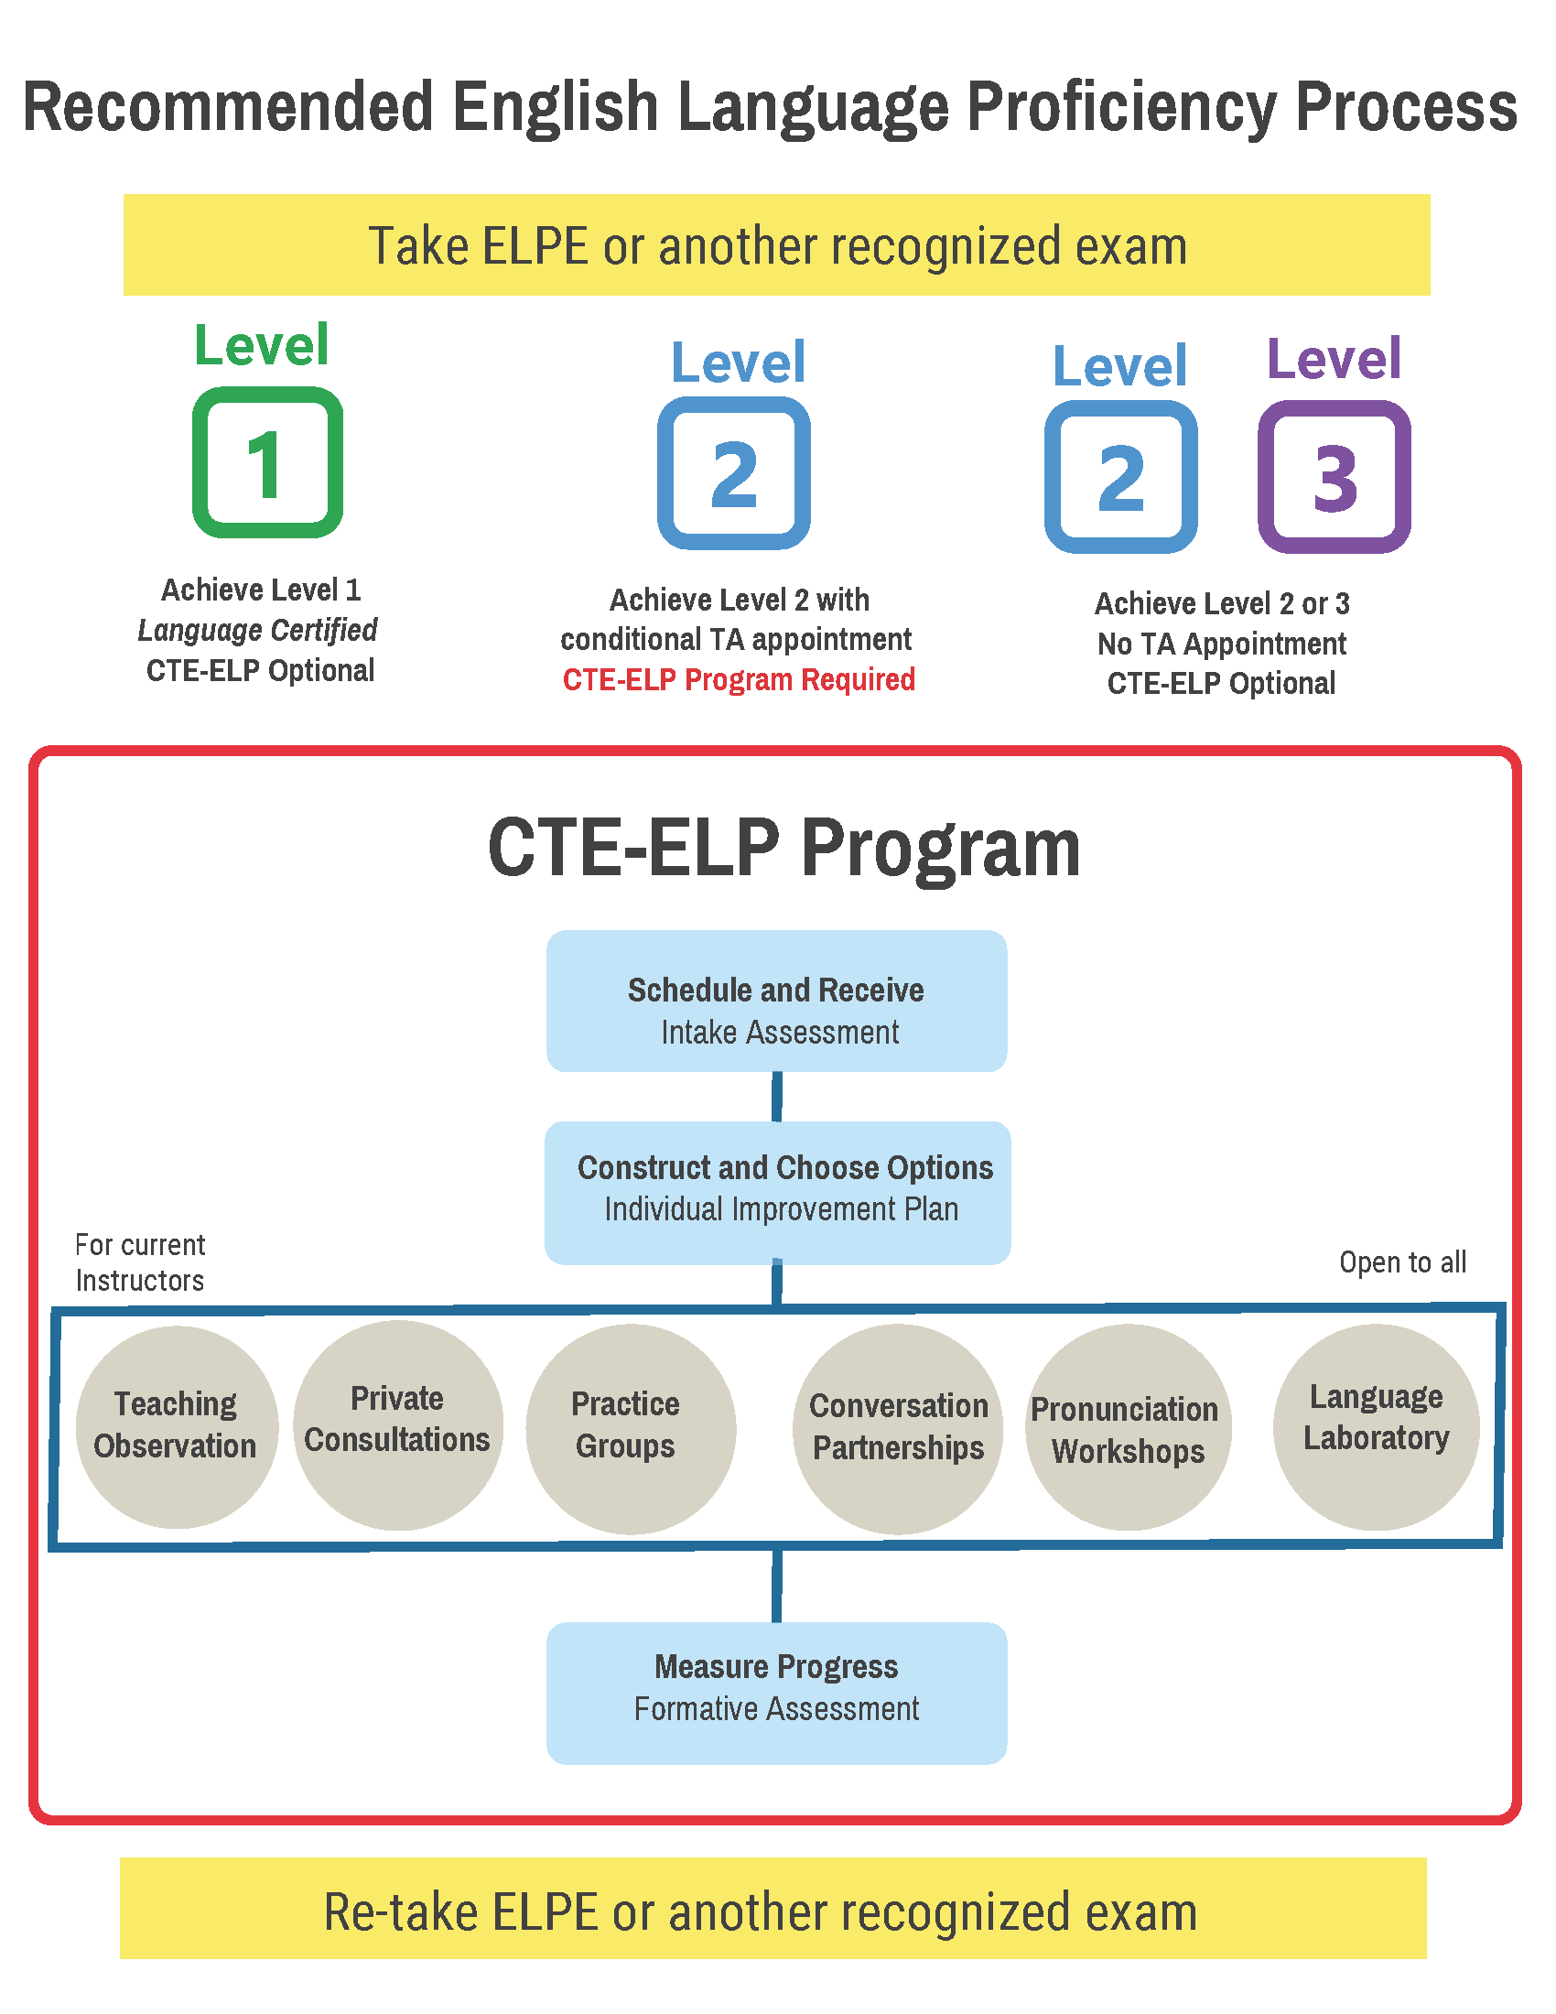

CTE-ELP Progress Assessment and ELPE Re-Testing for ELP Certification
Conditionally-appointed TAs receive regular formative assessment from English Language Proficiency Consultants during their time working with the CTE-ELP program. At midterm, they receive a report documenting their participation and progress, which they can share with their advisers. Once students become eligible to do so, they can retake the ELPE and certify their proficiency.

Students are eligible to retake the ELPE once every three months per Graduate and Professional School policy. Conditionally-appointed TAs only may request to retake the ELPE before three months have elapsed, but must do so through the CTE-ELP program. Early ELPE retest requests are granted only if students are following their Individual Improvement Plan and have made demonstrable progress in oral proficiency. The CTE-ELP program transmits early retest waivers directly to Testing Services.

Once a conditionally-appointed TA earns a Level 1 certifying score (such as 80 on the ELPE), that student is no longer obligated to participate in the CTE-ELP or adhere to the Individual Improvement Plan. This can happen at any time during the semester, but a Level 1 certifying score must be achieved before the next semester’s hire date or the student is ineligible to be a TA (i.e., a GAT, GAL, GAI, or GTF) again.

TA Training Requirements

Purpose of TATEP
The Teaching Assistant Training and Evaluation Program (TATEP) is intended to improve undergraduate teaching, enhance the classroom experiences of Graduate Teaching Assistants (TA), and respond to the need for more systematic preparation and evaluation of Teaching Assistants. For international Teaching Assistants, it will supplement programs already in place to evaluate and promote English language competency. Components of TATEP include the University-Level TA Training and the Discipline-Specific TA Training described below.
Components of TATEP:
University-Level TA Training
New TAs’ attendance at the Center for Teaching Excellence (CTE) Teaching Assistant Institute (TAI) is mandatory. TAs whose first teaching assignment is for the new academic year and TAs who have not previously completed TA training are required to attend the TA Institute on the date assigned to their college by the Graduate and Professional School. The TA Institute is offered twice a year, once each fall and spring semester. By the twelfth class day in the fall and spring semesters, departments will enter all TAs employed by their department in the TATEP Compliance System. Records will be compared with the list of students who attended the TA Institute. Departments will be notified by the Graduate and Professional School of students who are out of compliance.
1. The online FERPA Course #11012 via TrainTraq.
2. Attend the one-day face-to-face training held prior to the fall and spring semesters (registration required at https://ers.tamu.edu/). For details on these requirements of TAI, including instructions for accessing the online course and dates and locations of training, visit the CTE: https://cte.tamu.edu/Graduate-Student-Support/Teaching-Assistant-Institute.
TAs must also complete discipline-specific training offered by each academic unit.
Departments who wish to offer training equivalent to and in lieu of TAI, along with their discipline-specific training, may apply for a “Request for Teaching Assistant Institute Waiver.” Approval for waivers is granted by the CTE for a three-year period. Departments must reapply for a waiver every three (3) years. Departments are required to submit a syllabus outlining the departmental training program for new TAs, as well as copies of training materials for new TAs. For more information on the training of TAs, including training dates and requirements, please contact grad-tatep@tamu.edu.
Discipline-Specific TA Training
Discipline-specific training for new TAs will be provided at the college/department level. The nature of this training, while varying widely across different disciplines, will complement university-level training and will address the unique and specific needs of graduate students serving as TAs within their disciplines. Discipline-specific training will expose new TAs to the specific patterns of behavior, systematic methods, classroom management, and/or instructional practices associated with successful teaching within their disciplines.
Reporting TA Training Compliance
Departments or programs will provide a yearly report to their Graduate Operations Council (GOC) Dean stating evidence of their compliance with the University-Level TA Training and Discipline-Specific TA Training tenets for new TAs. These reports will be uploaded to the TATEP Compliance System using the departmental report template. Users may be added or deleted from the system by their GOC dean or by contacting grad-tatep@tamu.edu.

Using the information in the departments/programs reports, the GOC Deans will upload a college-level report of compliance to the TATEP Compliance System using the college report template.
CTE Best Practices Resources
The CTE periodically will publish a list of best practices for preparing graduate students for their assignments as new TAs for distribution to or access by each of the departments or programs. In addition, CTE will maintain a list of resources available for college/departmental TA training to encourage excellence in the TA training programs. The Best Practice Resources also include ideal practices gleaned from the annual college-level reports submitted to the Graduate and Professional School.

TA Evaluation
Each academic department employing graduate teaching assistants shall develop an appropriate set of procedures and evaluation instruments to employ in monitoring the performance of teaching assistants each semester. These procedures will be outlined in the departmental reports submitted each year and clearly communicated to students in the departments.

Graduate Classifications
Classification Definition
Each student has a classification which indicates the type of degree program in which the student is enrolled and reflects the student’s progress within that program at the professional level. The classifications follow:

G6 Postbaccalaureate Non-degree
Postbaccalaureate non-degree classification is intended for a student with a baccalaureate degree from an institution of higher education. If at a later date, a postbaccalaureate non-degree student decides to pursue a graduate degree, the student must understand that limitations may be placed on coursework taken while in G6 status. Specifically, the student must understand that a college or a department may decide whether or not to accept any G6 work toward the student’s graduate degree. However, with the approval of the student’s graduate advisory committee, the department head or chair of the Interdisciplinary Program, and the Graduate and Professional School, a maximum of 12 credit hours taken in postbaccalaureate non-degree status may be used on a student’s degree plan. Admission to postbaccalaureate non-degree status does not establish eligibility for admission to degree-seeking status. A postbaccalaureate non-degree student is not eligible to register for 691 Research hours.
An application for a postbaccalaureate non-degree classification is handled on a first come, first served basis. An application submitted within one month of registration may not be processed in time to begin that semester or term.
Enrollment of a G6 student in courses may be limited by college and departmental policies. Postbaccalaureate non-degree students must be reviewed by their department of affiliation for continuation at the end of each semester.
A postbaccalaureate non-degree student must maintain at least a 3.000 GPA on all coursework attempted to remain eligible to register. University departments and colleges may have additional and higher requirements.
For the scholastically deficient postbaccalaureate non-degree student (G6 classification), the student’s home department shall determine eligibility. It is the department’s responsibility to place a registration block on these students. Postbaccalaureate non-degree status normally is not available to an international student.

G7 Graduate, Master’s
G7 classification denotes admission to a master’s level program of study or admission to a doctoral program of a student who has not yet completed a master’s degree or 30 hours of eligible coursework taken at Texas A&M.

G8
G8 classification denotes admission to a doctoral level program of study.

G9 Graduate, Master’s/Doctoral Admitted
G9 classification denotes admission to graduate study but signifies documents must be completed before a student is allowed to file a degree plan. When the required documents have been received, the student’s classification will be changed. Approval of the Associate Provost and Dean of the Graduate and Professional School is required to change a student from G9 classification to the appropriate classification (i.e., G7 or G8).

Degree Level Change Information

Domestic Students
Degree level changes must be made no later than the 12th class day in the fall/spring and the 4th class day in the summer.

International Students
Degree level changes must be made no later than the 12th class day in the fall/spring and 4th class day in the summer. International students must have all immigration documents corrected with the International Student and Scholar Services (ISSS) no later than the 15th class day. After an approved level change is made by the Graduate and Professional School, a letter is sent to the student informing them to contact ISSS immediately.
Note: The ‘class days’ are the deadlines documents must be approved by the Graduate and Professional School. Remember that the Graduate and Professional School requires 10 working days to evaluate a document. There is no guarantee that documents submitted less than 10 working days prior to the semester will be approved for that semester.

Changing from G7 PhD to G8 PhD
These changes follow the same deadlines indicated above for domestic and international students. Classification changes may be made in two ways: (1) the Office of Admissions receives official transcripts for the master’s degree, or (2) upon completion of 30 doctoral hours at TAMU. Hours for courses with ‘incomplete’ grades are not counted. If you think that a student is incorrectly classified, please notify the Graduate and Professional School when you notice that a student may be eligible to be changed.
Additionally, a report is run once per semester to update all students who are eligible to be changed to a G8 classification according to completion of 30 hours at TAMU or official receipt of Master’s transcripts. Classifications may also be changed upon notification from a department of eligible students.

Semester Change for Late Classification Changes
A level change request received after the last day to make a level change for that semester will be made for the following semester. International students must be changed for their next semester of registration or they will fall out of status. If an international student changes degree levels after the 12th class day for spring, their level change should be made effective for the summer (if registering) or fall (if not registering for summer). It is important on the ‘Petition for Change of Major, Degree, or Department’ to identify the effective semester of the change according to an international student’s registration or the student will be out of status.

Subvention Funding
In Texas, public colleges and universities receive funding (subvention funding) from the State according to the number of students enrolled in a program. There is a meaningful difference between the subvention funding received for a G7 PhD and a G8 PhD. It is important that students are properly classified so that the University is able to receive subvention at the correct rate for our students.

99-Hour Doctoral Cap
Doctoral students have 7 years (21 semesters) to complete their doctoral degree without being penalized. During the 7 years, students who are otherwise eligible for in-state tuition will be charged as such, even if they accumulate more than 99 doctoral hours. After 7 years (21 semesters), any student accumulating more than 99 doctoral hours will be charged tuition at a rate equivalent to out-of-state tuition regardless of funding. Students who have been granted individual exemptions for the doctoral hour cap limit by the Texas Higher Education Coordinating Board and those students in programs which have received programmatic exemptions have 130 doctoral hours and 21 semesters before they are penalized with a higher tuition rate.
Please note that not all graduate courses are coded as doctoral courses. At the time a course is approved, the level of the course is determined by the highest level of degree in that major. In addition, the count of doctoral hours towards the 99-hour cap does not begin until a doctoral student is classified as a G8 student. Students may view their hour count through the Howdy Portal. Advisors may view the hour count in Compass at SZASSTD on the Supplemental Data tab, and the semester count can be seen by clicking on the User Defined Fields tab.
The following majors are exempt from the 99-Hour Cap on Doctoral Degrees:
- Biomedical Sciences
- Biochemistry and Molecular Biophysics
- Clinical Psychology
- Counseling Psychology
- Genetics and Genomics
- Health Services Research
- Medical Sciences
- Microbiology
- Nursing Practice
- Nutrition
- Oral and Craniofacial Biomedical Sciences
- Pharmaceutical Sciences
- Public Health Sciences
- School Psychology
- Toxicology

Separation of a Graduate Student for Scholastic Deficiency
Separation, Dismissal or Termination from the University
A department/program or graduate advisory committee may RECOMMEND separation (suspension, dismissal, or termination) from the university of a graduate student for scholastic deficiency by submitting a request in writing through the Dean of the School/College to the Associate Provost and Dean of the Graduate and Professional School. If the recommendation is made by the advisory committee, it must be signed by all members of the committee and the department head. The separation action could entail suspension (separation from the university for a definite period of time), dismissal (separation from the university for an indefinite period of time), or termination (permanent separation from the university).
The letter should include proper justification and supporting documentation of previous communications with the student discussing his/her scholastic deficiency. This could include items such as a probationary memo and/or emails. The letter needs to clearly specify the reason(s) for separation and the recommended separation action (suspension, dismissal, or termination).
Upon approval by the Graduate and Professional School, a letter will be sent to the student via certified mail and email and department via email, and the student will be blocked from registration for the approved period/condition of separation by the Graduate and Professional School. If the student is registered for classes in a future term, the department should un-enroll the student for the future term.
Separation, Dismissal or Termination from the Department
If a department/program or advisory committee wishes to recommend separation from the department/program only and allow the student the opportunity to find another department/program that is willing to admit them, this action is considered a dismissal – separation from the university for an indefinite period of time (until and if the student finds another academic home).
The letter from the department/program or advisory committee should provide the student with the same information as stated above for separation from the university. The Graduate and Professional School should be copied on this letter and sent a copy for the student’s permanent record. The department will place a block from registration on the student’s account. The registration block will be removed by the department ONLY if the student is accepted by another department/program. If the student is registered for classes in a future term, the department should un-enroll the student for the future term.
Scholastic Warnings and Probation actions are facilitated within the department/program. Please see Rule 12 for further details at http://student-rules.tamu.edu/rule12.

Registration

Full-Time Status
Nine (9) hours fall/spring terms and six (6) hours summer term in any combination for full summer benefits or three (3) hours in any combination for an individual summer session benefit, is required to be considered full-time for assistantship, scholarship, and fellowship purposes.

Half-Time Status
In order for domestic graduate students to be eligible for financial aid, they must be registered at least half-time. Half-time registration means:
Fall/Spring – 5 hours
10 Week Summer – 3 hours
5 Week Summer – 2 hours

Continuous Enrollment
Students in graduate degree programs requiring a thesis, dissertation, internship, or record of study, and who have completed all graded coursework on the degree plan, are required to be in continuous registration for Fall and Spring semesters until all requirements for the degree have been completed. Non-thesis students must maintain continuous enrollment until all degree plan courses are completed, but they are not held to the continuous registration requirement after that unless the department or college has a requirement to do so. The minimal requirement to maintain continuous enrollment can be satisfied by registering for 1 credit hour. Unless a student plans to take examinations or use University resources, including any interaction with their graduate committee, registration during the summer will not be required to fulfill the continuous registration requirement. However, colleges, departments, or intercollegiate faculty may have additional or higher requirements. International students should check with ISSS for the minimum hours they must be enrolled in for visa purposes. Students on assistantships and many fellowships must maintain full-time enrollment.

Excess Hours
Students are allowed to enroll in a maximum of 15 hours during the fall/spring semesters, 6 hours for each summer session, and 10 hours during the 10-week summer session. The Dean of the college can approve (and register) students for 18 hours (fall/spring), 9 hours (5-week summer sessions), and 15 hours (10-week session). Registration in addition to the 18, 9, and 15 hours, respectively, will require the Graduate and Professional School approval by submitting a Long Form Petition for Waivers or Exceptions that includes the number of hours, and the semester.

Examinations
Doctoral students must be registered during the semester they take any part of the preliminary examination and the final examination. Master’s thesis option students must be registered during the semester they take the final examination. Master’s non-thesis students are not required by the Graduate and Professional School to be registered during the semester of their final examination if all course work on the degree plan has been completed. Students who are attempting to hold an exam between semesters must be registered in the semester immediately preceding the exam in order to be eligible to take the exam. A department and/or college may have requirements in addition to those of the University.

Not Registering for Courses in Graduating Semester
If a master’s thesis option or doctoral student has completed ALL degree requirements, including being CLEARED by Thesis and Dissertation Services, by the last day to add courses for a semester, the student is not required to register for courses but must apply for graduation and pay the diploma fee. This rule does not apply to students on assistantships, scholarships, and fellowships. A department and/or college may have requirements in addition to those of the University.

Certification of Full-Time Enrollment
Graduate students may be certified as full-time with registration of less than the number of hours required for full-time enrollment for two reasons:
- Students participating in student teaching, internships, and cooperative education programs who are enrolled in less than nine (9) semester hours during a fall or spring semester or six (6) hours during a summer semester may be eligible to be certified as a full-time student with the approval of the Dean of the College or their designee.
- During their last semester prior to graduation, if a graduate student is enrolled at Texas A&M in all remaining hours needed to complete their degree, has applied for graduation, and does not hold a graduate assistantship, they may be certified as a full-time student for that final semester even though they may be enrolled in less than nine (9) semester hours during a fall or spring semester, or six (6) hours in a summer semester.
Please note the following restrictions to Certification of Full-Time Enrollment:
- A Q grade or W grade does not count toward the certification of enrollment status.
- International students must acquire approval from the International Student and Scholar Services (ISSS).
- These certifications listed above based on exceptions might not be used to qualify for Federal Financial Aid as federal regulations determine financial aid eligibility.

Residence Requirement
The residence requirement is the number of hours required to be taken in residence on the approved TAMU campus site for the student’s respective degree for a particular graduate degree and differs among degrees. In some degrees, the requirement is full-time enrollment of 9 hours during one or more semesters. For other degrees, it is a total of 12 hours during the degree. The residence requirement for each degree can be found in the self-service degree evaluation available online. Students who are also working full-time while completing their degree may request an exemption from this requirement with submission of a Long Form Petition for Waivers or Exceptions and a letter from their employer indicating that they are a ‘full-time’ employee with their dates of hire.

Undergraduates Registering for Graduate Courses
Undergraduate students may register for graduate courses and apply them to their degree in two different ways:
- A senior undergraduate student with a grade point average of at least 3.000 is eligible to enroll in a graduate course and reserve it for graduate credit by filing a petition obtained from the student’s undergraduate college and approved by the course instructor, the student’s major department head, the dean of the college offering the course, and the dean of the student’s undergraduate college.
- An academically superior undergraduate student with a grade point average of at least 3.250 is eligible to enroll in a graduate course and apply those graduate credit hours toward their undergraduate degree programs by filing a petition obtained from the student’s undergraduate college and approved by the course instructor, the student’s major department head, the dean of the college offering the course, and the dean of the student’s undergraduate college.

Leave of Absence
Under unusual circumstances, a student may petition for a leave of absence. The entire advisory committee, if formed, and head of the department or chair of the Intercollegiate Program, if appropriate, must approve the petition and send it to the Graduate and Professional School. If the Associate Provost and Dean of the Graduate and Professional School approves the petition, the registration requirement will be set aside during the period of leave. Leaves will be granted only under conditions that require the suspension of all activities associated with pursuing the degree. For certain types of approved leave, such as medical, the time period of the completion of the degree will stop with the leave and begin when the student returns to the program. Other types of leave may not stop the time limit for the degree. A student should refer to the Graduate and Professional Catalog section on Time Limits for their respective Master’s or Doctoral program. A leave of absence is granted for one (1) year. In case of extenuating circumstances, the leave of absence can be extended by the student’s committee and the Associate Provost and Dean for the Graduate and Professional School. A student who returns to the University after an approved leave of absence will not be required to submit an application for readmission to the Office of Admissions. An international student should visit with an International Student and Scholar Services advisor regarding how a leave of absence may impact his/her stay in or his/her re-entry into the U.S.
There are several different types of leave of absence. All requests must be submitted on the Petition for Waivers or Exceptions explaining the need for leave along with the appropriate approvals.
- Medical leave may be approved up to one (1) year and will ‘stop the clock’ on the 7- and 10-year time limit (this includes leave following childbirth or adoption of a child).
- Deployment leave may be approved up to one (1) year and will ‘stop the clock’ on the 7- and 10-year time limit.
- Personal leave may be approved with the proper request and justification. If approved, the 7- and 10-year time limit count will NOT stop.

Grade Point Average (GPA) Requirements
All graduate students have two GPAs, and both must be at least 3.0 to be in good standing, to conduct any type of exam, and to graduate. Course levels included in the GPAs are 300, 400, 600, 700, and 900. Courses NOT included in the GPAs are transfer courses and 100-200 level courses. See Student Rule 10.4.3.
- Degree Plan GPA – includes only courses listed on the degree plan except transfer course work.
- Cumulative GPA (Program GPA) – includes all graduate level course work completed at TAMU

Scholastic Requirements
Unless otherwise stated, students in graduate degree programs and post-baccalaureate non-degree students (G6 classification) must maintain a 3.00 cumulative GPA (computed as specified in Student Rule 10.4.3). Degree-seeking students also must maintain a GPA of at least 3.00 on all courses listed on the degree plan. Departments and colleges may establish higher GPA requirements for their students in graduate degree programs and for post-baccalaureate non-degree students (G6 classification).
A graduate student will not receive graduate degree credit for undergraduate courses taken on a satisfactory / unsatisfactory (S/U) basis. A graduate student may not receive grades other than satisfactory (S) or unsatisfactory (U) in graduate courses bearing the numbers 681, 684, 690, 691, 692, 693, 695, 697 and 791 (except for ALEC 695, BUAD 693, AGEC 695, GEOG 695, and IBUS 692). These officially designated S/U courses may be listed on the degree plan, along with other courses approved and noted as S/U in the graduate catalog. Graduate courses not on the degree plan may be taken on an S/U basis.
Only grades of A, B, C, and S are acceptable for graduate credit. Grades of D, F, or Unsatisfactory (U) for courses on the degree plan must be absolved by repeating the courses and achieving grades of C or above or Satisfactory (S). If a course has been taken more than once and a grade of D or F was earned and then repeated for a grade of C or higher, the original grades of D or F will be excluded from the GPA calculation for the degree plan (if applicable) and cumulative GPA, but remain on the student’s permanent record. A course in which the final grade is C may be repeated for a higher grade. If the second grade is higher, the original grade will be excluded from the GPA calculation for the degree plan (if applicable) and cumulative GPA but remain on the student’s permanent record.
Repeat grades and cumulative GPA for financial aid programs may differ based on the type of aid. Rules related to F* grades and repeat courses may be found in Student Rule 20 under Sanctions.
Rules related to F* grades and repeat courses may be found in Student Rule 20 under Sanctions. If the minimum GPA is not attained in a reasonable length of time, the student may be dismissed from graduate studies. A degree-seeking graduate student may also be considered scholastically deficient if they fail to show acceptable proficiency in such other requisites for their degree as may be assigned by the graduate committee, department or the Graduate and Professional School (e.g., qualifying and preliminary examinations, research, writing or a thesis or dissertation).
Grades for repeated courses are not automatically replaced; the change must be entered and recomputed manually by the Graduate and Professional School. Whenever a student has repeated a course and qualifies for the original grade to be replaced, please contact the Graduate and Professional School.
A student repeating a course in which a grade of B or better was originally earned will not receive grade points for the repeated course, unless the catalog states the course may be repeated for credit.
The cumulative GPA for a graduate student is computed by using all graded graduate (600- and 700-level) and advanced undergraduate (300- and 400-level) coursework completed at Texas A&M University and eligible to be applied toward a graduate degree. Those involving grades of W-drop (W), Satisfactory (S), Unsatisfactory (U), and Q-drop (Q) shall be excluded.
If either of a student’s cumulative GPA or the GPA for courses listed on the degree plan falls below the minimum of 3.000, the student will be considered to be scholastically deficient. If the minimum GPA is not attained in a reasonable length of time, the student may be dropped from graduate studies. The procedures for dismissal are explained in the Texas A&M University Student rules (refer to the website http://student-rules.tamu.edu/academicrules).
For a scholastically deficient post-baccalaureate non-degree student (G6 classification), the student’s home department shall determine eligibility, and the department is responsible for notifying the Graduate and Professional School if a registration block is to be placed on the student.
Departments or colleges may adopt specific guidelines pertaining to scholastic deficiency or dismissal in addition to these University policies.
Any eligible coursework not applied towards a prior graduate degree, and not exceeding time limits, will be included in the student’s GPA for the subsequent degree program.

GPA on the Degree Evaluation
When running a degree evaluation through the Howdy portal, there are several GPAs listed. The first, the Program GPA (also known as the Cumulative GPA), includes all courses taken at the Graduate Level (GR) that are eligible to be used on the degree plan. The secondentry is the Overall GPA which includes all courses taken at Texas A&M University. Finally, the Degree Plan GPA appears in the section entitled “Courses for Degree Plan” and includes only those courses on the degree plan.

Calculating GPAs
To calculate the GPA for a student, multiply the number of course hours by the grade points to get the quality points. Add all of the quality points and then divide by the total number of hours to get the GPA. Courses completed as S/U are not used in calculating the GPAs. Grade Points: A=4; B = 3; C=2; D=1; F=0.

Checking GPA without a Degree Plan on File
When a student does not have an approved degree plan, the cumulative GPA is calculated by generating a degree evaluation on the student’s current program. The cumulative GPA displays under the credits used column on the ‘Program GPA’ line. Courses which are eligible to apply toward the graduate degree will display in the ‘Courses for Degree Plan GPA’ area with a note indicating there is not an approved degree plan on file.

Degree Plan Information and Filing Degree Plans and Petitions
Degree plan forms can be submitted through the online Document Processing Submission System (DPSS), found at http://ogsdpss.tamu.edu. Degree plans must be approved by the student’s committee and the department head or the interdisciplinary faculty chair. Once these approvals are obtained, the degree plan must be approved and entered into Compass/Howdy by the Graduate and Professional School. It is highly recommended that programs have a pre-committee staff approver of degree plans built into their degree plan workflow to check degree plans for departmental requirements. Contact the Graduate and Professional School for more information on adding a pre-committee staff approver.

Online Document Processing Submission System (DPSS)
All graduate degree plans and petitions process through the online DPSS platform only. This is a web-based system that allows a graduate student to create, audit, and submit a degree plan or make changes by way of petitions. When a student submits a degree plan, it follows a predefined series of steps for approval. A degree plan is first routed to a Pre-Committee Staff Approver (a staff member or graduate advisor). Next, the degree plan must be approved by the advisory committee chair and then the other committee members. The degree plan then enters the workflow defined by the department. At least one faculty member with signing authority for Graduate and Professional School documents must be included. Everyone in the workflow must approve the student’s degree plan before it will forward to the Graduate and Professional School for review. Contact the Graduate and Professional School to change the defined workflow through an Authorized Signers Form.
Contact: Graduate Committee Faculty Administrative Coordinator – gradcom@tamu.edu or 979-845-3631
Graduate Records Processing – gradprocessing@tamu.edu or 979-845-3631

Staff/Committee/Departmental Approvers
Below are basic guidelines for the review and approval process for staff, committee, and departments.
- Go to https://ogsdpss.tamu.edu and select “Faculty & Staff”.
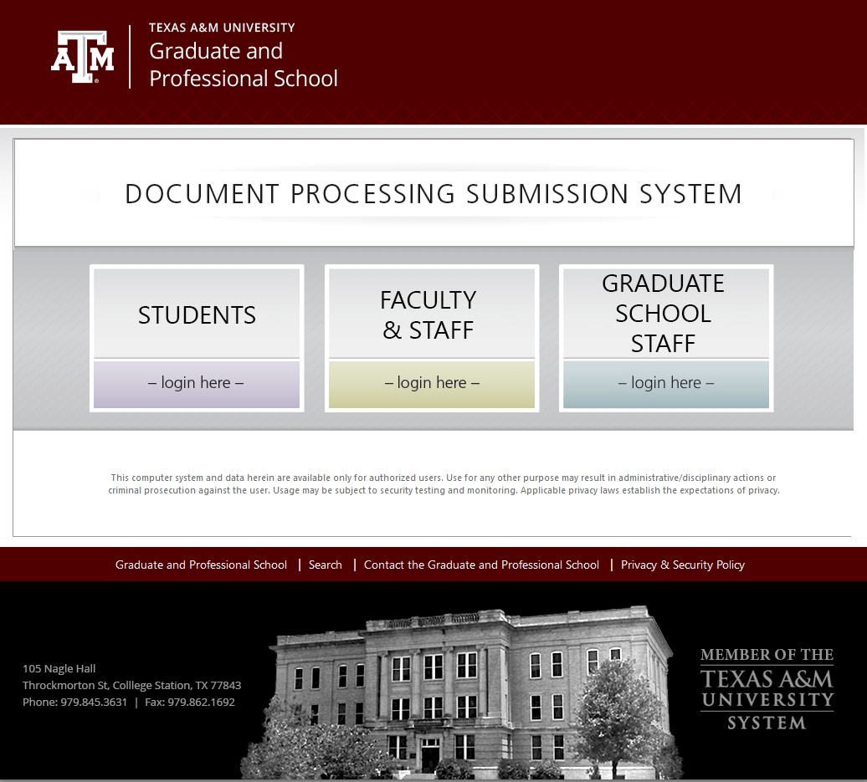
- Login using your NetID. (If you do not have a NetID, select “Activate your NetID” or if you do not remember your NetID, contact the CIS Help Desk at (979) 845-8300.)
- All degree plans requiring your approval will be listed under “Degree Plans for Review.” Select the link to the degree plan you wish to review.
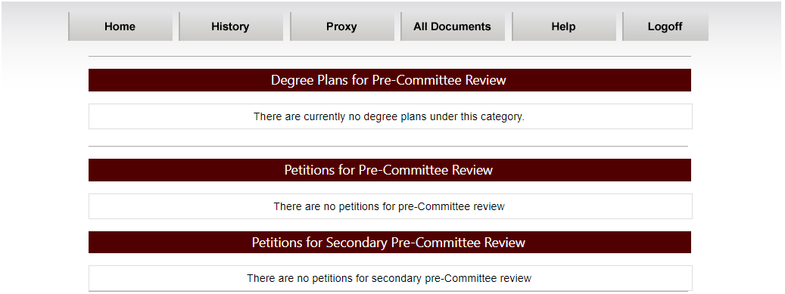
- After reviewing the degree plan, scroll to the bottom of the webpage and select “Approve” or “Disapprove”.
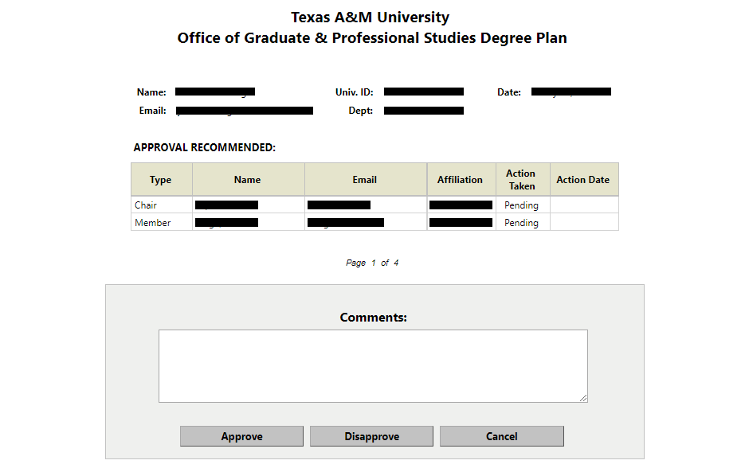
If the degree plan is disapproved, a reason must be provided for the student in the Comments box.
- Upon approval by the Department Head or Interdisciplinary Program Chair, the degree plan is routed to the Graduate and Professional School where it is entered in Compass. The student, advisory committee chair and members, and department will receive an email indicating final approval or disapproval of the degree plan.
Please note that it is the responsibility of the departmental approvers to verify that all official transcripts and standardized test scores have been received by Office of Admissions prior to the submission of a degree plan.

Proxy Approvers
Each Department should designate at least one member (recommend two) of the Graduate Faculty as a “Proxy Approver” for degree plans and other documents in DPSS. Proxy Approvers may log in and approve documents in the place of any faculty member in their department, including the designated Departmental Approver. Proxy Approvers will log in as usual but will click on “Proxy” at the top of the screen. The designated Departmental Approver is automatically considered a Proxy Approver, and has all the abilities therein.
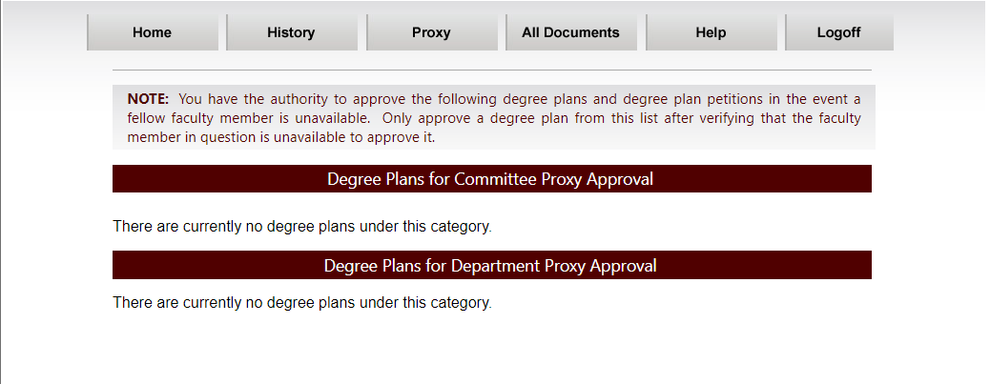
After choosing the degree plan or petiton from the appropriate section, the Proxy Approver will need to identify the person they are approving for in the “Proxy for” box.

Aquiring DPSS Accounts for New Faculty and Staff
All participants in DPSS processes must have an active UIN and NetID. Adjunct professors and visiting professors approved to hold membership in the graduate faculty, and serve on graduate advisory committees, may obtain an account and NetID. A departmental representative must complete the Texas A&M NetID Account Request Form at https://u.tamu.edu/Visiting-Scholars-Form. This form should be submitted directly to Identity Management (for more information on sponsored accounts, please see the Division of Information and Technology’s Identy and Access Management webpage at https://u.tamu.edu/Sponsored-Accounts. Once a UIN has been issued, the department can submit a Graduate Committee Faculty nomination. The faculty member must also visit th Aggie Account Gateway (http://gateway.tamu.edu) to claim a NetID. Members of the Graduate Committee Faculty must also publish an @tamu.edu email address to the TAMU Directory.
Contact: Identity and Access Management – identity@tamu.edu
Help Desk Central – helpdesk@tamu.edu or 979-845-8300

Special Appointments and Degree Plans
Nominations for Special Appointments to a student’s advisory committee process through https://gradcom.tamu.edu/ but do not require a sponsored NetID or UIN. They are not listed on a student’s degree plan and do not hold voting privileges but will be noted in a comment on a student’s record in Compass.
Contact: Identity and Access Management – identity@tamu.edu
Help Desk Central – helpdesk@tamu.edu or 979-845-8300

Miscellaneous DPSS Tips
- Select the “History” link to view all degree plans the user has approved.
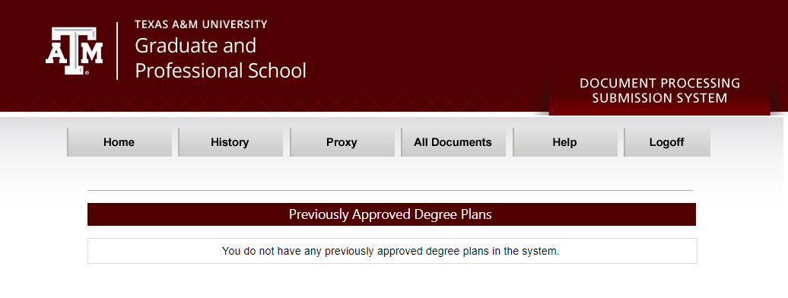
- Audit rules in DPSS are based only on University-wide rules. If a program has specific requirements, they must be monitored at the program level (by the pre-committee staff, advisory committee, and departmental approvers) before a degree plan is approved and submitted to the Graduate and Professional School.
- Faculty or staff who are part of a program workflow can select “All Documents” to view all degree plans and petitions created by students in their department since the user joined the program workflow.
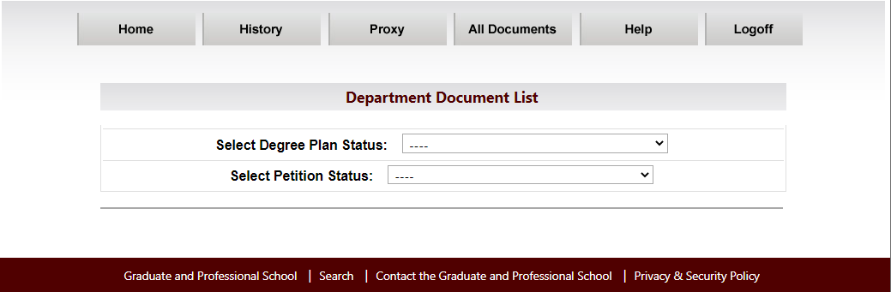

Transfer Course Work
- Course(s) must be completed at an accredited U.S. institution or approved international institution with a grade of A or B and must be graduate level or upper level undergraduate courses.
- The maximum number of credit hours which may be considered for master’s students to transfer is the greater 12 hours or one-third (1/3) of the total hours of the degree plan with the approval of their graduate committee, department, and the Graduate and Professional School. Students should refer to the Graduate and Professional Catalog for specific transfer limitations by degree (https://catalog.tamu.edu).
- A final official transcript (with grades) must be received by the Office of Admissions for all transfer work listed on the degree plan. A degree plan listing transfer work ‘to be taken’ may be approved pending receipt of the final official transcript listing such work. Once the transcript has been received, it will be used to verify that the courses in question meet all eligibility criteria.
- Master’s students who are scheduling their final exam and are currently registered for transfer work must have confirmation of registration in the course from the attending university on file with the Graduate and Professional School prior to approval of the final examination. Notification may be in the form of an unofficial transcript or a copy of the student’s registration. Doctoral students are not eligible to transfer in course work during their last semester or the semester of their final examination.

Verifying Outdated Standardized Test Scores as Official
Graduate students who have been admitted to TAMU with outdated standardized test scores may request verification from the Graduate and Professional School of official scores one of the following ways:
- The test scores are listed on an official transcript from a previously attended university.
- The previously attended university certifies, in writing, that they received official scores with the scores listed.
- The student may bring their copy of the score report from the testing center to the Graduate and Professional School for verification.

Petitions
Graduate students may use petitions to (a) request a change of major, degree, or department; (b) request changes to the coursework or committee membership as established by the degree plan; (c) request extension to time-limits; or (d) request exceptions to published rules. Each petition will be considered on its own merit by the Associate Provost and Dean of the Graduate and Professional School. The student should make such requests by submitting either a Major, Degree, or Department petition (MDD) or a Long Form petition through DPSS. The petition will be routed for the required approval by the members of the student’s advisory committee, if appointed, and the department head, or his or her designee (or chair of the intercollegiate faculty, if appropriate).

Degree Plan Blocking Criteria
Each School/College sets its own deadlines for filing a degree plan, with different criteria for Master’s and Doctoral students. If a student does not meet these deadlines, the Graduate and Professional School will enact a block on the student’s registration for the next academic term per the School/College-specific timelines listed below.
COLLEGE | MASTER'S | DOCTORAL
AGRICULTURE | During 2nd Regular Semester | During 4th Regular Semester
ARCHITECTURE | Block after 18 completed hours | Block after 30 completed hours
 | MLA Students Only: Block after 30 completed hours
ARTS AND SCIENCES | Before the start of the 3rd Regular Semester | Before the start of the 4th Regular Semester
 |  | ECON Students Only: Before the start of the 6th regular semester
BUSH SCHOOL | During 3rd Regular Semester | End of 5th Regular Semester

BUSINESS | All Master's (except for MBA and PPA) Block after 24 completed hours | MBA Block after 36 completed hours | Block after 48 completed hours
DENTISTRY | 3rd semester |  | 5th semester
EDUCATION | Block after 15 completed hours |  | Block after 36 completed hours
ENGINEERING | Block after 9 completed hours |  | Block after 36 completed hours
GALVESTON | Do Not Block. GV will manage Blocks |  | Do Not Block. GV will manage Blocks
LAW | MJ – block after 23 hours |  | N/A
 | LLM – block after 18 hours
MEDICINE | At the conclusion of the 5th semester (spring semester of their second year). |  | At the conclusion of the 5th semester (spring semester of their second year).
NURSING | During 2nd Regular Semester |  | During 2nd Regular Semester
PERFORMANCE, VISUALIZATION AND FINE ARTS | Block after 18 completed hours |  | N/A
PHARMACY | N/A |  | End of 5th Regular Semester
PUBLIC HEALTH | After completing (9) semester credit hours |  | After completing (30) semester credit hours.
VET. MEDICINE | No later than the end of the 2nd Regular Semester |  | No later than the end of the 4th Regular Semester

All eligible hours are used in the count:
  - 300/400, 600, 700, 900 level hours.
  - Up to 12 hours of non-degree course work.
  - Nothing older than 10 years for doctoral, nothing older than 7 years for master’s.

Viewing Degree Evaluations – Graduate Advisors
Graduate advisors should run degree evaluations on students in the department to monitor degree progress and prior to submitting the request for final exam to the Graduate and Professional School (in order to verify eligibility to take the exam). To run a degree evaluation, follow these steps:
- Log onto your Howdy account at howdy.tamu.edu.
- Click on the ”Howdy Dashboard” tab.
- Enter the student’s UIN and click Submit.
- Click the “Student Record” dropdown.
- Under the Degree Evaluation Section, select “Degree Evaluation”.
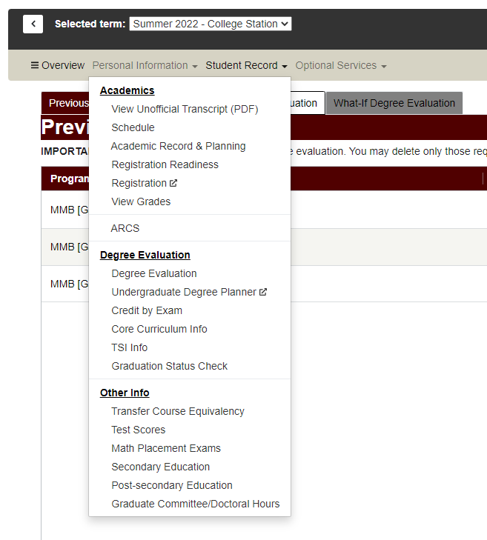
- Click “Generate New Degree Evaluation”.
- You will need to select the current term and select the appropriate curriculum option then click “generate request”.
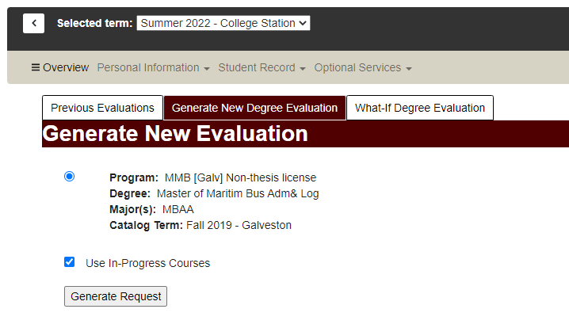

- On the evaluation, you can view the student’s required courses and GPA information. Note: This screen will display the courses listed on the student’s degree plan, completed courses not applied to the student’s current degree plan, the cumulative graduate GPA (listed as Program GPA), and the degree plan GPA (listed under “Overall GPA” under program requirements).
- You can also view the student’s examinations and non-course degree requirements. Note: This screen will display non-course requirements such as the graduate degree plan, preliminary exam, proposal, residency, admission to candidacy, final exam/defense, and thesis/dissertation/record of study, etc. Other information such as course and exam time extensions may also be displayed on this screen.
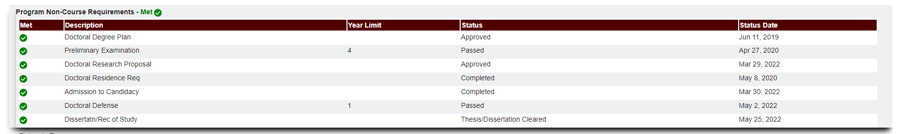

Viewing Degree Evaluations – Committee Chairs
Graduate committee chairs and co-chairs are encouraged to run regular degree evaluations on their student advisees in order to (1) verify student eligibility for funding (e.g., tuition waivers, assistantships, fellowships); (2) evaluate student progress to degree; (3) review the courses a student takes each semester and individual course grades; (4) verify completion of non-course degree requirements; and/or (4) determine degree plan and cumulative GPA.
In order to be able to generate a degree evaluation, the faculty must first be listed as the chair or co-chair on the student’s Graduate and Professional School approved degree plan, and second, they must complete a one-time FERPA training via TrainTraq (if not previously completed).
This tool cannot be used for students who have not yet filed a degree plan; however, advisors and students have similar degree evaluation tools available in Howdy that are available for students who have not filed a degree plan. Information for students without a degree plan would be limited to courses taken and cumulative GPA.
For questions regarding the Graduate Committee Degree Evaluation tool contact gradprocessing@tamu.edu. To run a degree evaluation, follow these steps:
- Log onto your Howdy account at http://howdy.tamu.edu.
- Click on the “Faculty/Teaching” tab.
- Under the Teaching Graduate Students section, select “Graduate Committee Degree Evaluation.”
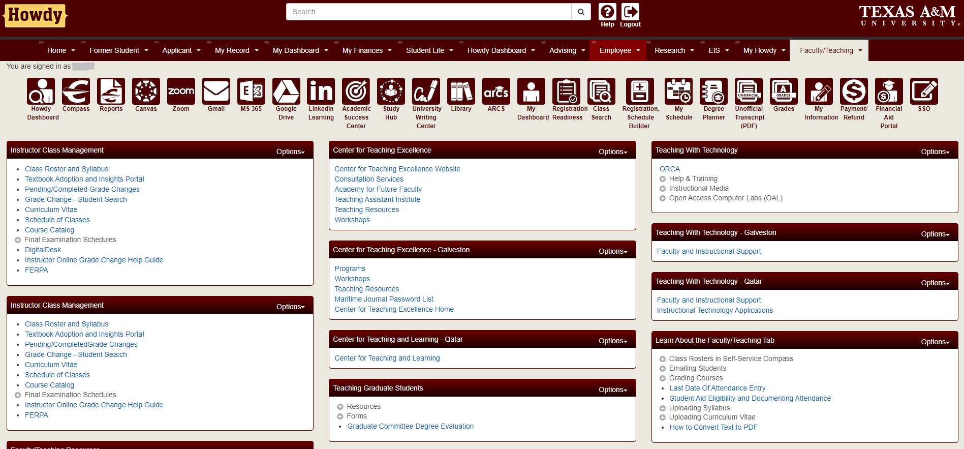
- You will need to select the current term and then hit the submit button. Note: If you are directed to a screen which indicated you need to complete FERPA training, please refer to the FERPA Training Steps (in a separate guide).
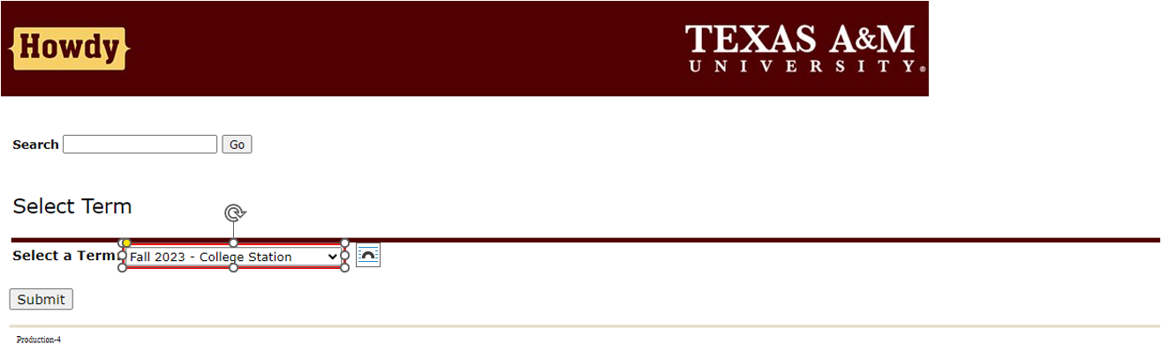
- Select a student from your list of active students/advisees. Note: Only students for whom the faculty member is a committee chair or co-chair (on a Graduate and Professional School approved degree plan) will be displayed.

- Click the button to go to the “Degree Evaluation for Selected Student”.
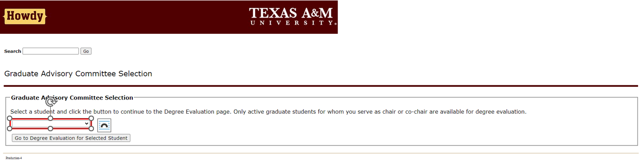
- The Degree Evaluation Record will appear, and you will need to select the “Generate New Evaluation” link at the bottom of the page.
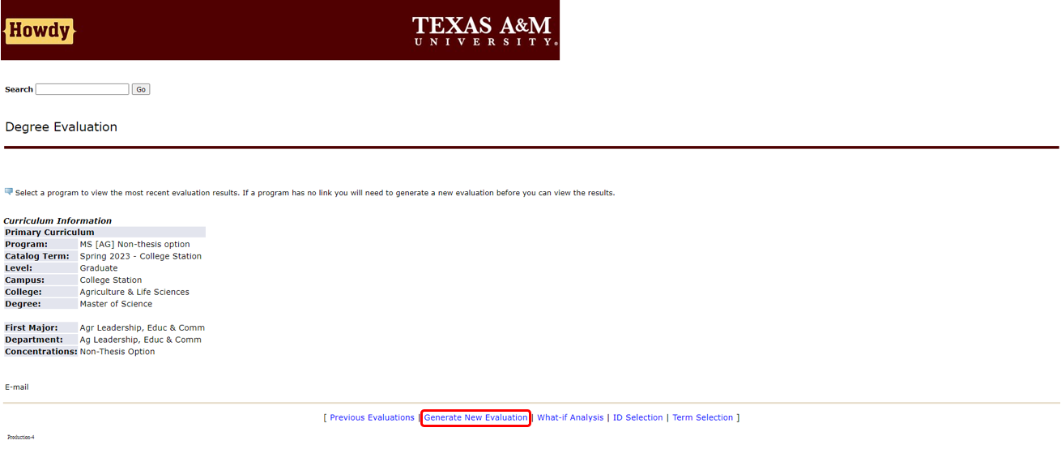

- The Generate New Evaluation section will appear, and you will need to select the student’s program. Make sure the correct term is selected and then select the generate request button. The evaluation may take a few seconds to generate.

- Once you generate the request, the three Degree Evaluation Options will appear: General Requirements, Detail Requirements, and Additional Information.
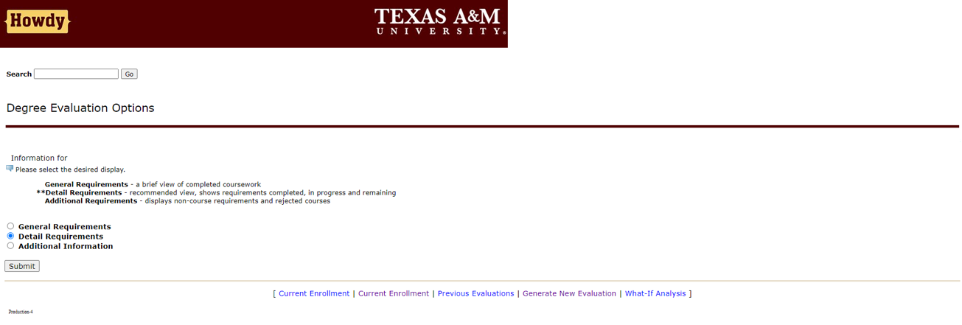
- Select “Detail Requirements” to view the student’s required courses and GPA information. Note: This screen will display the courses listed on the student’s degree plan, completed courses not applied to the student’s current degree plan, the cumulative graduate GPA (listed as Program GPA), and the degree plan GPA (listed under “Total Credits and GPA” in the “Courses for Degree Plan GPA” area). Both the cumulative and degree plan GPAs must be 3.0 or higher for a student to be in good academic standing.
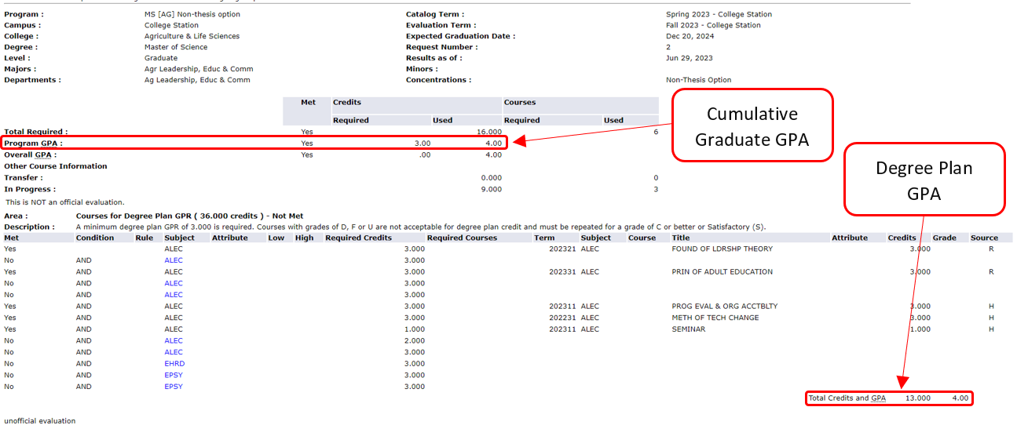

- To view the student’s examinations and non-course degree requirements, go back to the display options and select “Additional Information”. Note: This screen will display non-course requirements such as the graduate degree plan, preliminary exam, proposal, residency, admission to candidacy, final exam/defense, and thesis/dissertation/record of study. Other information, such as course and exam time extensions, may also be displayed on this screen.
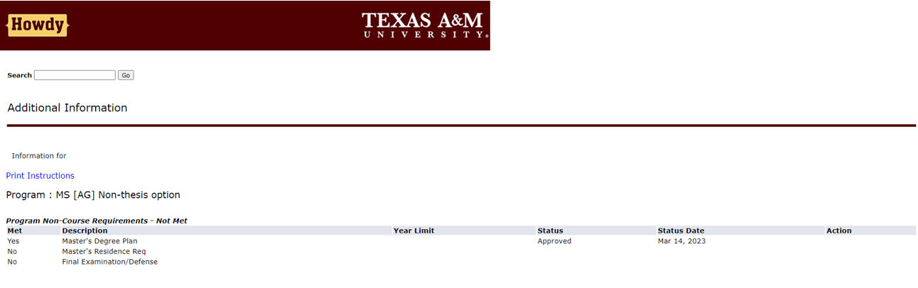

- If a degree evaluation needs to be generated for another student, select “Return to Graduate Committee Student Selection” in the top right-hand corner of the browser window, and repeat the previous steps.
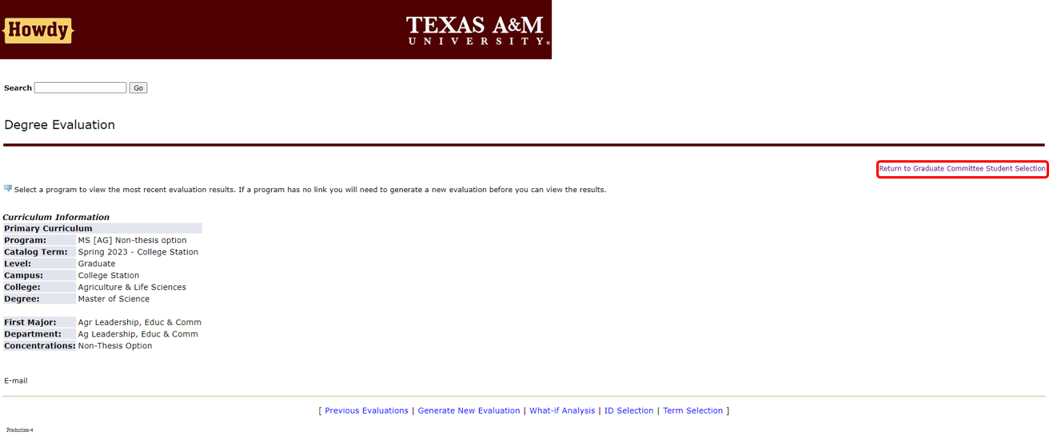

Research Proposal
The research proposal is a major milestones for Doctoral and Thesis-Option Master’s students. This Milestone is completed through the Academic Requirements Completion System (ARCS). Guides to using ARCS for this milestone can be found in section 10.2.
The formatting of the proposal is up to a student’s chair and advisory committee to decide.
Compliance requirements of research involving human subjects, animals, infectious biohazards, and recombinant DNA must be addressed prior to submission of the research proposal. It is the department’s responsibility to make sure this requirement has been met.
Advisors and students can check the approval status of a research proposal either through a degree evaluation in Howdy or ARCS.

Preliminary Examinations

Preliminary Examination for Doctoral Students
The student’s major department (or chair of the interdisciplinary degree program faculty, if applicable) and their advisory committee may require qualifying, cumulative, or other types of examinations at any time deemed desirable. These examinations are entirely at the discretion of the department and the student’s advisory committee.
The preliminary examination is required. The preliminary examination for a doctoral student shall be given no earlier than a date at which the student is within 6 credit hours of completion of the formal coursework on the degree plan (i.e., all coursework on the degree plan except 681, 684, 690, 691, 692, 693, 695, 697, 791, or other graduate courses specifically designated as S/U in the course catalog). The student should complete the Preliminary Examination no later than the end of the semester following the completion of the formal coursework on the degree plan.

Preliminary Examination Format
The objective of the preliminary examination is to evaluate whether the student has demonstrated the following qualifications:
- A mastery of the subject matter of all fields in the program,
- An adequate knowledge of the literature in these fields and an ability to carry out bibliographical research, and
- An understanding of the research problem and the appropriate methodological approaches.
The format of the preliminary examination shall be determined by the student’s department (or interdisciplinary degree program, if applicable) and advisory committee, and communicated to the student in advance of the examination. The exam may consist of a written component, an oral component, or a combination of written and oral components.
The preliminary exam may be administered by the advisory committee or a departmental committee; herein, referred to as the examination committee.
Regardless of exam format, a student will receive an overall preliminary exam result of pass or fail. The department (or interdisciplinary degree program, if applicable) will determine how the overall pass or fail result is determined based on the exam structure and internal department procedures. If the exam is administered by the advisory committee, each advisory committee member will provide a pass or fail evaluation decision.
Only one advisory committee substitution may provide an evaluation decision for a student’s preliminary exam, and it cannot be the committee chair. Substituting faculty members must meet the same graduate faculty eligibility requirements as the member they replace.
If a student is required to take, as a part of the preliminary examination, a written component administered by a department or interdisciplinary degree program, the department or interdisciplinary degree program faculty must:
  - Offer the examination at least once every six (6) months. The departmental or interdisciplinary degree program examination should be announced at least 30 days prior to the scheduled examination date.
  - Assume the responsibility for marking the examination satisfactory or unsatisfactory, or otherwise graded, and in the case of unsatisfactory, stating specifically the reasons for such a mark.
  - Forward the marked examination to the chair of the student’s advisory committee within one week after the examination.

Preliminary Examination Scheduling
Prior to commencing any component of the preliminary examination, a departmental representative or the advisory committee chair should review the eligibility criteria with the student to ensure the student is eligible for the preliminary examination. The following list of eligibility requirements applies:
- Student is registered at Texas A&M University for a minimum of one semester credit hour in the long semester or summer term during which any component of the preliminary examination is held. If the entire examination is held between semesters, then the student must be registered for the term immediately preceding the examination.
- An approved degree plan is on file with the Graduate and Professional School prior to commencing the first component of the examination.
- Student’s cumulative GPA is at least 3.000.
- Student’s degree plan GPA is at least 3.000.
- All English Language Proficiency requirements are satisfied.
- At the end of the semester in which at least the first component of the exam is given, there are no more than 6 hours of coursework remaining on the degree plan (except 681, 684, 690, 691, 692, 693, 695, 697, 791, or other graduate courses specifically designated as S/U in the course catalog). The head of the student’s department (or chair of the interdisciplinary degree program, if applicable) has the authority to approve a waiver of this criterion.

Grading of the Preliminary Exam
The committee and any approved substitute (if applicable) grades the Preliminary Examination through ARCS.
Credit for the preliminary examination is not transferable in cases where a student changes degree programs after passing a preliminary exam.
If a written component precedes an oral component of the preliminary exam, the chair of the student’s examination committee is responsible for making all written examinations available to all members of the committee. A positive evaluation of the preliminary exam by all members of a student’s examination committee with at most one dissension is required to pass a student on their preliminary exam.
The student’s department will promptly report the results of the Preliminary Examination to the Graduate and Professional School via ARCS. This should be submitted to the Graduate and Professional School within 10 working days of completion of the preliminary examination.
After passing the required preliminary examination for the doctoral degree, the student must complete the final examination for the degree within four (4) calendar years. Otherwise, the student will be required to repeat the preliminary examination.

Failure and Expiration of Preliminary Examination

First Failure
Upon approval of a student’s examination committee (with no more than one member dissenting), and approval of the Department and Graduate and Professional School, a student who has failed a preliminary examination may be given one re-examination. In accordance with Student Rule 12.5, the student’s department head or designee, intercollegiate faculty, or graduate advisory committee should make a recommendation to the student regarding their scholastic deficiency.
Second Failure
Upon failing the preliminary exam twice in a doctoral program, a student is no longer eligible to continue to pursue the PhD in that program/major. In accordance with Student Rule 12.5.3 and/or 12.5.4, the student will be notified of the action being taken by the department as a result of the second failure of the preliminary examination.

Retake of Failed Preliminary Examination
Adequate time must be given to permit a student to address inadequacies emerging from the first preliminary examination. The examination committee must agree upon and communicate to the student, in writing, an adequate time-frame from the first examination (normally six months) to retest, as well as a detailed explanation of the inadequacies emerging from the examination. The student and committee should jointly negotiate a mutually acceptable date for this retest. When providing feedback on inadequacies, the committee should clearly document expected improvements that the student must be able to exhibit in order to retake the exam. The examination committee will document and communicate the time-frame and feedback within 10 working days of the exam that was not passed.
Expiration of Preliminary Examination
After passing the required preliminary examination for the doctoral degree, the student must complete all remaining requirements within four (4) calendar years. The student may be required to repeat the preliminary examination or, with the approval of the advisory committee and department head or chair of the interdisciplinary program, the student may request an extension of the four (4) year time limit with the submission of a Petition for Extension of Time Limits to the Graduate and Professional School.
Please refer to the Graduate and Professional Catalog (http://catalog.tamu.edu) for additional information.

Final Examination/Final Defense

Final Examination for Doctoral Students
The candidate for the doctoral degree must pass a final examination by deadline dates announced in the “Graduate and Professional School Calendar” each semester. The doctoral student is allowed only one opportunity to take the final examination.
Grades of D, F, or U for any course cannot be listed on the degree plan. The student must be registered for any remaining hours of 681, 684, 690, 691, 692, 791 or other graduate courses specifically designated as S/U in the course catalog during the semester of the final exam. No student may be given a final examination until they have been admitted to candidacy and their current official cumulative and degree plan GPAs are 3.00 or better.
To be admitted to candidacy for a doctoral degree, a student must have:
- Completed all formal coursework on the degree plan with the exception of any remaining 681, 684, 690 and 691, 692 (Professional Study), or 791 hours,
- A 3.0 Graduate GPA and a Degree Plan GPA of at least 3.0 with no grade lower than C in any course on the degree plan,
- Passed the preliminary examination,
- Submitted an approved dissertation proposal, and
- Met the residence requirements.
The request to hold and announce the final examination must be submitted to the Graduate and Professional School a minimum of 10 working days in advance of the scheduled date. Any changes to the degree plan must be approved by the Graduate and Professional School prior to the submission of the request for final examination.
The student’s advisory committee will conduct this examination. The final examination is not to be administered until the dissertation or record of study is available in substantially final form to the student’s advisory committee, and all concerned have had adequate time to review the document. Whereas the final examination may cover the broad field of the candidate’s training, it is presumed that the major portion of the time will be devoted to the dissertation and closely allied topics. Persons other than members of the graduate faculty may, with mutual consent of the candidate and the chair of the advisory committee, be invited to attend a final examination for an advanced degree. A positive vote by all members of the graduate committee with at most one (1) dissension is required to pass a student on their exam. A department can have a stricter requirement, provided there is consistency within all degree programs within a department. Upon completion of the questioning of the candidate, all visitors must excuse themselves from the proceedings.
Final Examination for Master’s Students
A positive evaluation by all members of the graduate committee with at most one (1) dissension is required to pass a student on their exam. Persons other than members of the graduate faculty may, with mutual consent of the candidate and the chair of the advisory committee, be invited to attend a final examination for an advanced degree. Upon completion of the questioning of the candidate, all visitors must excuse themselves from the proceedings.
A student shall be given only one (1) opportunity to repeat the final examination for the master’s degree and that must be within a time period that does not extend beyond the end of the next regular semester (summer terms are excluded). A department can have a stricter requirement provided there is consistency among all degree programs within a department.
All committee members must grade the final exam in the Academic Requirements Completion System (ARCS).
Thesis Option
For thesis option students, the final examination may cover the thesis and all work taken on the degree plan. At the option of the committee, it may be written, oral, or both. The final examination may not be administered before the thesis is available to all members of the student’s advisory committee in substantially final form and all members have had adequate time to review the document. The examination is conducted by the student’s advisory committee. A thesis option student must be registered at the university in the semester or summer term in which the final examination is taken.
Thesis option candidates may request to be exempt from their final examination provided their degree plan GPA is 3.500 or greater and they have approval of the advisory committee, the head of the student’s department, and the Graduate and Professional School. It is recommended that the request for exemption be submitted the same semester the student intends to submit the thesis. The Request for Exemption of the Final Examination is submitted through ARCS.
Non-Thesis Option
​For non-thesis option students, a final comprehensive examination may be required. The final exam cannot be held prior to the mid-point of the semester if questions on the exam are based on courses in which the student is currently enrolled. If a student has completed all required degree plan coursework, the student is not required to be registered for classes in the semester the final examination is administered (unless they hold an assistantship). For specific final examination requirements, students should check the program requirements for the degree they are pursuing.

Grading of Final Exam
The student’s department/committee will promptly report the results of the Final Examination to the Graduate and Professional School through ARCS. If an already-approved exam gets cancelled, the Graduate and Professional School must be notified in writing before the day of the cancelled exam.
A positive evaluation of the final exam by all members of a student’s advisory committee with at most one (1) dissension is required to pass a student on his or her final exam. While grading, the advisory committee chair may elect to change all Incomplete (I) grades on 691 or 692 courses to Satisfactory (S); if they do so, ARCS will automatically make that change.
Thesis-option and doctoral students have one (1) year from successfully completing the final examination to clear Thesis and Dissertation Services and graduate. Otherwise, the student will be required to repeat the final examination. With the approval of the advisory committee and department head or chair of the interdisciplinary program, the student may request an extension of the one-year time limit with the submission of a Petition for Extension of Time Limits to the Graduate and Professional School.

Theses, Dissertations, and Records of Study
Texas A&M University requires a dissertation or record of study from all doctoral candidates and a thesis from all thesis option master’s candidates. The dissertation, record of study, or thesis should be presented in a scholarly, well-integrated, and properly documented manner that reflects the student’s original work done under the advisory committee’s supervision.
Thesis and Dissertation Services provides a number of resources to assist with manuscript preparation, including Thesis and Dissertation Guidelines, manuscript templates (Microsoft Word and LaTeX), pre-submittal conferences, information seminars, and workshops. Resources can be found online at http://thesis.tamu.edu. Students are encouraged to participate in a pre-submittal conference or watch the online version prior to their final exam (defense).
Prior to submitting the thesis, dissertation, or record of study, the student must successfully pass the final exam (defense) or be approved for a waiver of the final exam. The student must also complete any corrections requested by the committee and ensure the document is in final format and prepared according to Thesis and Dissertation Services Guidelines.
To maintain eligibility to graduate in a given semester, students must meet the scheduled deadline for submittal of (1) the signed, Written Thesis/Dissertation Approval Form and (2) the thesis, dissertation, or record of study in final form as a PDF file. The final document is submitted by the student at http://etd.tamu.edu. This date, along with other dates of interest, is posted with the Graduate and Professional School dates and deadlines. Students should only submit their PDF document in the semester they intend to graduate. The thesis/dissertation submittal site is shut down for over one month following the submittal deadline. Students wanting to submit a thesis/dissertation for the next semester may consult the Graduate and Professional School dates and deadlines calendar for information about the next semester’s first day for submission.
Thesis and Dissertation Services will contact the student via email after the manuscript’s first review is completed. The student will carefully make all requested corrections in the original Word (or other) file, convert the revised document to a new PDF file, and upload the new PDF to the ETD Submittal System, Vireo.
Students may make only those corrections required by Thesis and Dissertation Services after the manuscript is submitted. Additional content changes requested by the student will not be accepted.
All corrections must be made promptly and thoroughly. Students may require several rounds of review in order to meet Texas A&M University formatting standards. It is important that students provide a high quality manuscript adhering to Thesis and Dissertation Services Guidelines upon initial submission.
Manuscripts are reviewed in the order received. No exceptions.
In addition to making corrections, students must fulfill other requirements for Thesis and Dissertation Services graduation clearance, including:
- Registering for the semester.
- Applying for graduation in the semester graduating through the Howdy portal.
- Submiting the Copyright and Availability Form: complete and have form signed by student and committee chair/co-chair.
- Submiting the Survey of Earned Doctorates and AAUDE Survey completion certificate via email (Doctoral students).
Students cannot receive a Letter of Completion or the diploma until all requirements have been met. Graduation will be postponed if all requirements are not met by the dates outlined in the Graduate and Professional School dates and deadlines calendar.

Financial Processing

Fellowship Payments

Fellowship Payment
Students must be registered fulltime (9 hours each fall and spring, any combination totaling 6 hours for summer) to receive their stipends. Stipend and tuition and fee payments are posted to the student’s account via Compass. Financial Aid provides the deadlines for posting fall and spring funds. The amounts are based on the payment options (9- or 12-month disbursement) departments select on their financial commitment forms.
Departments approved to give a scholarship (instead of an assistantship) to Dr. Dionel Avilés ’53 and Dr. James Johnson ’67 Fellowship students are responsible for providing a payment for health insurance from the graduate student health plan each year for the duration of the fellowship.

NSF GRFP Fellowship and Other National Fellowship Payments
Stipend and scholarship payments are posted to the student’s account via Compass. Tuition payments are posted to the TWAPMTS report in Compass. The Compass system will adjust payments if students add classes.
- Upon tenure notice from NSF, the Graduate and Professional School posts $15,416.65 for fall and $12,333.32 for spring and $9,249.99 for summer. This will post as a fellowship so that the students will receive a stipend of approximately $3,083.33 at the end of each month for the following month.

Payment of Tuition and University Required Fees for Graduate Assistants
Resident Tuition and Required Fee Payment Guidelines:
Effective FY21 (fall 2020), resident tuition and required fees will be paid for PhD students in Graduate Assistant Teaching (GAT), Graduate Assistant Lecturer (GAL), and Graduate Assistant Research (GAR) titles. This mandate applies for all Texas A&M University and Texas A&M University at Galveston PhD students employed in these positions sourced from any account or award of Texas A&M University or Texas A&M agency.

- Resident tuition and required university and college fees will be paid at least through the 5th year of study for PhD students admitted without a master’s degree and initial PhD enrollment in fall 2016 forward.
- Resident tuition and required university and college fees will be paid at least through the 4th year of study for PhD students admitted with a master’s degree and initial PhD enrollment in fall 2017 forward.
- Payment of resident tuition and required fees for PhD graduate assistants employed in different positions than those listed above will be determined on a student by student basis by the employer. This includes PhD Graduate Assistant Non-Teaching (GANT) positions.

Payment of resident tuition and/or required fees for master’s students employed as a graduate assistant will be at the discretion of the employing department or faculty member.
The tuition and fee payment guidelines do not change any processes related to or eligibility for non-resident tuition waivers on the basis of receiving a competitive scholarship of $1,000 or more, or employment as a graduate assistant in an eligible title code.

Students receiving fellowships (from either the University or outside sources) should check with the fellowship program or the Graduate and Professional School to determine if they are eligible for the tuition and fee payment program.

More information, including the mandate, is available on the Graduate and Professional School Tuition and Fee Mandate webpage.

Standard Operating Procedure (SOP) for Assistantship Non-Resident Tuition Waivers for Graduate Students
Graduate assistants qualify for an Assistantship Non-Resident Tuition Waiver that allows payment of tuition at the in-state rate. The purpose of the following Standard Operating Procedure (SOP) for Assistantship Non-Resident Tuition Waivers is to establish consistent policies and procedures across Texas A&M University for the awarding and processing of Assistantship Non-Resident Tuition Waivers.
Texas A&M University Established 99-Hour Cap on Doctoral Degrees
In Texas, public colleges and universities are funded by the state according to the number of students enrolled. In accordance with legislation passed by the Texas Legislature, the number of hours for which state universities may receive subvention funding at the doctoral rate for any individual is limited to 99 hours. Texas A&M University and other universities will not receive subvention for hours in excess of the limit.
Institutions of higher education may charge the equivalent of nonresident tuition to a resident doctoral student who has enrolled in 100 or more semester credit hours of doctoral coursework.
Doctoral students at Texas A&M have seven (7) years to complete his/her degree before being charged out-of-state tuition. A doctoral student who, after seven years of study, has accumulated 100 or more doctoral hours will be charged tuition at a rate equivalent to out-of-state tuition. Please note that the tuition increases will apply to Texas residents as well as students from other states and countries who currently are charged tuition at the resident rate. This includes those doctoral students who hold GAT, GANT, GAL, and GAR appointments of 20 or more hours and recipients of competitive fellowships who receive more than $1,000 per year. Doctoral students who have not accumulated 100 hours after seven years of study are eligible to pay in-state tuition if otherwise eligible.
For count purposes, a year is counted as three (3) semesters - normally fall, spring and summer. Using this system, a student is allowed 21 semesters as a G8 student to complete the doctoral degree before being penalized with the higher tuition rate. Any semester in which a G8 student is enrolled for a doctoral level course is counted.
Doctoral students who exceed the credit limit will receive notification from the Graduate and Professional School during the semester in which they are enrolled and exceeding the limit in their current degree program. The notification will explain that the State of Texas does not provide funding for any additional hours in which a student is enrolled in excess of 99 hours. Texas A&M University will recover the lost funds by requiring students in excess of 99 hours to pay tuition at the non-funded, non-resident rate. This non-funded, non-resident tuition rate status will be updated for the following semester and in all subsequent semesters until receipt of a doctoral degree. Please see the Tuition Calculator at the non-resident rate for an example of potential charges.
The following majors are exempt from the 99-hour Cap on Doctoral Degrees and have a limit of 130 doctoral hours:
- Biochemistry
- Biomedical Sciences
- Clinical Psychology
- Counseling Psychology
- Epidemiology and Environmental Health
- Genetics and Genomics
- Health Services Research
- Medical Sciences
- Microbiology
- Neurosciences (College of Medicine)
- Nutrition
- Oral and Craniofacial Biomedical Sciences
- Pharmaceutical Sciences
- Public Health Sciences
- School Psychology
- Toxicology

Procedure
- Academic Departments
All Assistantship Non-Resident Tuition Waivers for eligible graduate students employed in academic units should be approved and entered into TWAPMTS by the employing academic unit before the 12th class day in the regular fall/spring semester and the 4th class day of the summer semester. For waivers that need to be entered after the 12th class day in the regular fall/spring semester and the 4th class day of the summer semester please refer to the subsection below on “Late Assistantship Non-Resident Tuition Waivers”. Assistantship Non-Resident Tuition Waivers should not be entered into TWAPMTS by an academic department if the student is not employed by that department.
- Non-Academic Departments
All Assistantship Non-Resident Tuition Waivers for eligible graduate students employed in non-academic units will be approved and entered into TWAPMTS by the Graduate and Professional School. Tuition waiver request forms must be submitted to the Graduate and Professional School before the 12th class day of the regular fall/spring semester and the 4th class day of the summer semester.
- Health Science Center Units
All Assistantship Non-Resident Tuition Waivers for eligible graduate students employed in Health Science Center units but enrolled in College Station or Galveston courses must be sent to the Graduate and Professional School for approval and will be entered into TWAPMTS by Student Business Services. Tuition waiver request forms must be submitted to the Graduate and Professional School before the 12th class day of the regular fall/spring semester and the 4th class day of the summer semester. For waivers that need to be entered after the 12th class day in the regular fall/spring semester and the 4th class day of the summer semester, please refer to the subsection below on “Late Assistantship Non-Resident Tuition Waivers”.
- Spouse and Dependents of Graduate Assistants
Spouses and dependents of eligible graduate assistants also qualify for resident tuition. Assistantship Non-Resident Tuition Waivers for spouses and dependents of eligible graduate students employed by academic units will be approved and entered into TWAPMTS by the academic units. Assistantship Non-Resident Tuition Waivers for spouses and dependents of eligible graduate students employed by non-academic units will be approved and entered into TWAPMTS by the Graduate and Professional School. The Spouse Waiver form along with legal proof of marriage/dependency must be submitted to the Graduate and Professional School before the 12th class day of the regular fall/spring semester and the 4th class day of the summer semester. Assistantship Non-Resident Tuition Waivers for spouses and dependents for eligible graduate students employed at other institution should be submitted to Student Business Services directly.
- Late Assistantship Non-Resident Tuition Waivers
All Assistantship Non-Resident Tuition Waivers requested after TWAPMTS closes must be submitted to the Graduate and Professional School for approval. Late waivers require additional documentation. This documentation includes the Non-Resident Tuition Waiver request form, a screenshot of the Workday Job Details screen, and a memo from the employing department stating the reason the waiver is being submitted late. The memo must also include an outline of the department/unit procedures to prevent late waivers in the future. Late waivers approved by the Graduate and Professional School will be entered into TWAPMTS by Student Business Services.
Academic Eligibility
- Full-time registration. Must be enrolled in 9* credit hours in the fall and spring semester.
- See Chart 1 in section 5.3.2 for summer semester hour requirements.
- Student must meet residency status requirements as a non-resident or international student who is not being charged for excess credit hours.
- Student must be making satisfactory academic progress as per the policies outlined by Scholarships and Financial Aid.
*Students employed in the GAL title only need to register for 1 credit hour and be employed at 50% effort in any semester to be eligible for the non-resident tuition waiver. Students in the Advanced Dental Education programs may be considered full-time with fewer hours per Student Rule 1.8.1.
Employment Eligibility
- Texas Education Code 54.212
Sec. 54.212. TEACHING OR RESEARCH ASSISTANT
A teaching assistant or research assistant of any institution of higher education and the spouse and children of such a teaching assistant or research assistant are entitled to register in a state institution of higher education by paying the tuition fees and other fees or charges required for Texas residents under Section 54.051 of this code, without regard to the length of time the assistant has resided in Texas, if the assistant is employed at least one-half time in a teaching or research assistant position which relates to the assistant’s degree program under rules and regulations established by the employer institution.
- Graduate Assistants Employed in Non-Academic Departments and graduate assistants employed in Health Science Center units but enrolled in College Station or Galveston courses:
  - The Non-Resident Tuition Waiver request form can be accessed on the Graduate and Professional School NRTW webpage.
- Spouse/Dependents of Graduate Assistant:
  - The Non-Resident Tuition Spouse or Dependent request form can be accessed on the Graduate and Professional School NRTW webpage.
  - Legal proof of marriage/dependency is required to be attached.
- Late Waiver Request for Graduate Assistants Employed in Academic Departments, Graduate Assistants Employed in Non-Academic Departments, and Graduate Assistants employed in Health Science Center units but enrolled in College Station or Galveston courses:
  - The Non-Resident Tuition Waiver request forms can be accessed on the Graduate and Professional School NRTW webpage.
  - A screenshot of the Workday Job Details screen is required.
  - A memo from the employing department stating the reason the waiver is being submitted late and an outline of the department/unit procedures to prevent late waivers in the future is also required to be attached.
Required Documentation
See below to access the list of required documents published by the Graduate and Professional School.
- Graduate Assistants Employed in Non-Academic Departments or employed in Health Science Center units but enrolled in College Station or Galveston must submit the NRTW Request form.
- Spouse/Dependents of Graduate Assistant must submit the NRTW Spouse or Dependent form
- Late Waiver Request for Graduate Assistants Employed in Academic Departments, Graduate Assistants Employed in Non-Academic Departments, and Graduate Assistants employed in Health Science Center units but enrolled in College Station or Galveston courses must submit the following:
  - NRTW or NRTW Spouse or Dependent form
  - Copy of the job details screen in Workday verifying employment title code and start date
  - Memo from the employing department stating the reason the waiver is being submitted late
Student Business Services Auditing
- After the official census date for the semester, Student Business Services will audit the Assistantship Non-Resident Tuition Waivers using enrollment data and payroll data to verify eligibility.
- Student Business Services will work with departments to obtain documentation of eligibility if data in the student system and the payroll system does not show that all requirements have been met.
- Student Business Services will remove Assistantship Non-Resident Tuition Waivers for students who have not met all eligibility requirements.
- Additional information for the Assistantship Non-Resident Tuition Waiver audit process can be found on the Student Business Services webpage.

Enrollment Issues
- A full course waiver does not qualify a student for a tuition waiver – there could also be ISS (International Student Services) issues
- Check Compass reports SZAREGS or SGASTDN for residency for tuition – sometimes TX residents turn in waiver in error.

Registration Requirements Graduate Assistantships
Graduate Students employed in a Graduate Assistant Teaching, Graduate Assistant Research or Graduate Assistant Non-Teaching title must be registered full-time which is equivalent to a minimum of 9 semester credit hours in fall and 9 semester credit hours in spring terms. Graduate Students employed in a Graduate Assistant Lecturer title must be registered a minimum of 1 semester credit hour in fall and 1 semester credit hour in spring terms.
Summer registration fulfillment may be achieved in any of the sessions as noted below.

Registration Fulfillment Options
Summer Session I
Summer Session II
10-Week Only
Summer Session I and II
10-Week, Summer Session I, and Summer Session II
Summer Session I and 10-Week
Summer Session II and 10-Week

The table below defines the minimum number of registered hours required, as determined by the summer enrollment session and the associated GA position title.

Graduate Assistant Title | Summer Employment Session | Minimum  Registered  Hours Required
Graduate Assistant Lecturer [GAL] | Employed ANY portion of the summer semester | 1
Graduate Assistant Teaching [GAT] | Employed ONLY Summer Session I or II | 3
Graduate Assistant Teaching [GAT] | Employed (Summer I AND II) or (10-week session) | 6
Graduate Assistant Research [GAR] | Employed ANY portion of the summer semester | 6
Graduate Assistant Non-Teaching [GANT] | Employed ANY portion of the summer semester | 6

Maximum Allowed Graduate Assistant Work Hours Per Term
- Students that hold positions of Graduate Assistant Teaching (GAT), Graduate Assistant Non-Teaching (GANT), Graduate Assistant Research (GAR), and Graduate Assistant Lecturer (GAL) are normally required to work 20 hours per week (50% FTE). * The information in items 2, 3, and 4 outlines allowed work hours per term. Visit the graduate assistant registration requirements page for additional requirements regarding minimum enrolled semester credit hours.
- Maximum Additional Hours During Fall and Spring when Classes are in Session: Students employed in GAT, GANT, GAR, and GAL positions are not allowed to work beyond 20 hours (50% FTE) without the approval of the Graduate and Professional School. This also applies to processing one-time payments for graduate assistants.
- Domestic: Domestic students may request approval to work up to 29 hours per week (72.5% FTE) in all combined jobs.
  - If in a graduate assistant position and working more than 20 hours a week, an Academic Department Request of Graduate Assistant >50% Effort form must be submitted and approved before starting the additional work. See section #5 below.
- International: International students may not exceed 20 hours per week (50% FTE) in Fall or Spring in all combined jobs and in accordance with the Department of Homeland Security Regulation 8 C.F.R. §214, paragraph (f)(9)(i).
- Maximum Additional Hours During Summer Session:
- Domestic: Domestic students may request approval to work up to 40 hours (100% FTE) in all combined jobs.
  - If in a graduate assistant position and working more than 20 hours a week, an Academic Department Request of Graduate Assistant >50% Effort form must be submitted and approved before starting the additional work. See section #5 below.
- International: International students may request approval to work up to 40 hours (100% FTE) in all combined jobs
  - If in a graduate assistant position and working more than 20 hours a week, an Academic Department Request of Graduate Assistant >50% Effort form must be submitted and approved before starting the additional work. See section #5 below.

- Maximum Additional Hours During Break Periods and When Classes are Not in Session (Thanksgiving, Winter Break, Spring Break, Intercession periods between fall and spring, spring and summer, and summer and fall):

- Domestic: Domestic students may request approval to work up to 40 hours (100% FTE) in all combined jobs.
  - If in a graduate assistant position and working more than 20 hours a week, an Academic Department Request of Graduate Assistant >50% Effort form must be submitted and approved before starting the additional work. See section #5 below.
- International: International students may request approval to work up to 40 hours (100% FTE) in all combined jobs
  - If in a graduate assistant position and working more than 20 hours a week, an Academic Department Request of Graduate Assistant >50% Effort form must be submitted and approved before starting the additional work. See section #5 below.
- Submitting a Request to Work Additional Hours: Additional jobs can only be submitted for the current semester for registration verification purposes.
- A completed Academic Department Request of Graduate Assistant >50% Effort form must be attached to the Workday payroll action requesting an increase in % effort or “Start Additional Job” function for graduate assistant.
- One-time Payments: One-time payments are considered additional work. A one-time payment for extra work outside of the scope of an employee’s primary graduate assistant duties (not recurring) is processed in Workday using the Request One-Time Payment business process. Employers are encouraged to check with their HR office before processing to confirm a one-time payment is appropriate. If approved, the employer will submit an Academic Department Request of Graduate Assistant > 50% Effort form for approval stamp and attach it to the Workday process.
Graduate Employment Resources
- 33.99.08.M0.01 Student Employment
- 31.01.99.M0.02 Supplemental Compensation and Dual Employment
- Graduate and Professional School Graduate Student Employee Webpage
- Graduate Assistant Employment Comparison Table
- HROE Graduate Student Employers Webpage
- Texas A&M Engineering Experiment Station Graduate Assistant Toolkit
- College of Agriculture & Life Sciences Graduate Assistantships
International Students
- 33.99.09.M0.01 Employment of Foreign Nationals
- ​F-1 On and Off Campus Employment
- J-1 On and Off-Campus Employment

Graduate Student Health Insurance

Student Insurance
Students who are not on assistantships are responsible for finding a health plan that is suitable for them.
All students who are on assistantships (at least 50% FTE) are entitled to benefits as a graduate student employee. Texas A&M Human Resources and Organizational Effectiveness (HROE) benefits office can assist the student employee with enrollment in a graduate student employee health plan through the university. Beginning in fall 2020, all Texas A&M University (TAMU-02, HSC-23) new hires may choose one of the following options:
  - Immediately enroll in a Texas A&M University System sponsored insurance plan on their date; or
  - Defer enrollment until the first of the month following their hire date; or
  - Defer enrollment until the first of the month following a 60-day waiting period
Employees must send an email to benefits@tamu.edu (or for relevant A&M health departments) within 5 days of their hire date to request on of the first two enrollment date options. Until the first day of the month following 60 days of employment, employees will have the full cost of premiums deducted from their paycheck on a pre-tax basis.

Avilés ’53 and Dr. James Johnson ’67 Fellowship Students
Students on Avilés-Johnson fellowships who are not eligible for TAMU insurance because of an assistantship appointment of less than 50% effort are eligible to participate in a Texas A&M University System (TAMUS) insurance program as a graduate student fellow. Effective fall 2021, the Graduate and Professional School will reimburse fellows participating in a TAMUS insurance program for medical insurance at an amount equivalent to the cost of the employer contribution for grad students employed at 50% FTE for the same plan type on the A&M Grad Plan. Students must submit receipts and their plan coverage showing payments and expenses to the Graduate and Professional School.
Departments approved to award scholarships (instead of assistantships) to Avilés-Johnson fellows must also provide payment for the student health insurance plan each year.

Dissertation Fellowship Students
Students on Dissertation fellowships are eligible to participate in a TAMUS insurance program as a graduate student fellow. Effective fall 2021, the Graduate and Professional School will reimburse fellows participating in a TAMUS insurance program for medical insurance at an amount equivalent to the cost of the employer contribution for grad students employed at 50% FTE for the same premium category on the A&M Grad Plan. Students must submit receipts and their plan coverage showing payments and expenses to the Graduate and Professional School.

National Science Foundation – Graduate Research Fellowship Program Students
Students on NSF-GRFP fellowships are eligible to participate in a TAMUS insurance program as a graduate student fellow. Effective fall 2021, the Graduate and Professional School will reimburse fellows participating in a TAMUS insurance program for medical insurance at an amount equivalent to the cost of the employer contribution for grad students employed at 50% FTE for the same premium category on the A&M Grad Plan. Students must submit receipts and their plan coverage showing payments expenses to the Graduate and Professional School.

Graduate Assistantship Titles and Checklist
There are four types of graduate assistantships (GA) available through the academic departments, colleges, Texas A&M University System (TAMUS) agencies and administrative offices:
- Teaching (GAT)
- Research (GAR)
- Lecturer (GAL)
- Non-teaching activities (GANT)
Most of these positions require employment of 20 hours per week. Although individual colleges may have higher requirements, graduate students holding assistantships must meet the GA registration requirements by the census date (see Section 5.3.2). The university does not mandate assistantships be terminated upon failure to maintain enrollment requirements after the census date. However, assistantships may be terminated by the employer upon failure to maintain the minimum enrollment requirement. Students serving in the four aforementioned GA titles are eligible for insurance benefits. Non-resident students may also qualify to pay tuition and fees at the in-state rate. More information can be viewed in the Assistantship Non-Resident Tuition Waivers section 5.3.
Graduate assistant checklist and position requirements can be found on the Graduate and Professional School Graduate Assistant Employment Comparison webpage. *NOTE: International Students employed at ANY percentage of graduate student title code GAT or GAL requires English Language Proficiency Certification.

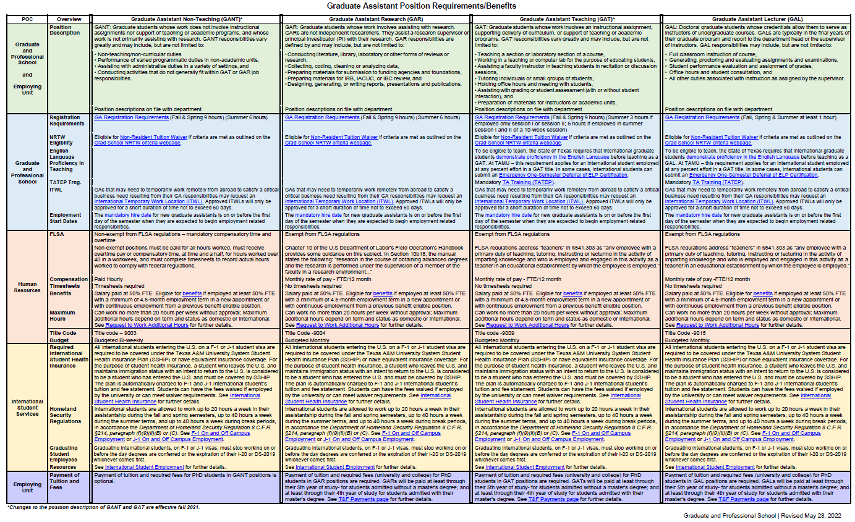
This Graduate Assistant Position Requirements/Benefits table can be found at http://grad.tamu.edu.

Graduate Admissions Processing

Directory
Mailing Addresses
Office of Graduate Admissions
Texas A&M University
P.O. Box 40001
College Station, TX 77842-4001
Physical Address for Express Mail
Office of Admissions – Texas A&M University
General Services Complex
750 Agronomy Road, Suite 1601
0200 TAMU
College Station, TX 77843-0200
Physical Location
The General Services Complex is on the corner of Agronomy Rd and F & B, just down from the Physical Plant.
General Phone
(979) 845-1060 (Aggie One Stop)
Graduate program staff are strongly encouraged to contact their Admissions liaison for more efficient assistance.
General Website
URL: http://admissions.tamu.edu

Items Required by Admissions Office
Application form – Centralized Application Services:
Texas A&M University GraduateCAS (UniCAS) | NursingCAS
EngineeringCAS | TMDSAS
BusinessCAS | AMCAS
SOPHAS/SOPHAS Express | LSAC
HAMPCAS | LLM CAS
PharmCAS

Applicants may apply to one program per college per entry term.
Application fee – Academic programs: $90 for international students and $65 for U.S. citizens, permanent residents and applicants who qualify for Texas residency under Senate Bill 1528 plus applicable CAS processing fees. Application fees for professional programs vary.
Official transcripts – from every senior level college/university attended (not required from community colleges unless requested by the specific program). Transcripts issued in a language other than English must be accompanied by an official English translation. Academic credentials from China must be verified by the Center for Student Services and Development (CSSD).
Official test scores – GRE, GMAT, TOEFL, IELTS must be reported directly to TAMU by the testing agency.
TAMU’s ETS code for GRE is 6003 for the TAMU GradCAS and 4119 for EngineeringCAS.
TAMU’s ETS code for TOEFL is 6003 for the TAMU GradCAS, B887 for EngineeringCAS and B888 for BusinessCAS.
IELTS scores must be sent to “Texas A&M University (College Station and Galveston).”

Applicants Who Are Citizens of the Following Countries Do Not Need to Submit Proof of English Proficiency:

American Samoa
Anguilla
Antigua and Barbuda
Australia
Bahamas
Barbados
Belize
British Virgin Islands
Canada (except Quebec)
Cayman Islands
Dominica
Federated States of Micronesia
Gambia
Ghana
Gibraltar
Grenada
Guyana
Ireland
Jamaica
Liberia
New Zealand
Nigeria
Saint Kitts and Nevis
Saint Lucia
Trinidad/Tobago
Turks and Caicos Islands
United Kingdom

Graduate Confirmation Process
Graduate applicants to academic programs (excluding Law, Nursing, and Public Health) must accept an offer of admission in Howdy to enable registration. Admission decisions provided in WebAdMIT will display in the Manage Applications channel on the Applicant tab in Howdy. Admitted applicants must accept an offer of admission to receive a letter of admission and populate a SGASTDN record for registration. Offers of admission that are not accepted by the start of the admission term will be cancelled. Professional program applicants do not need to accept an offer through the Office of Admissions.
College/Dept | Analyst Contact | Secondary Contact | Tertiary Contact
Perf, Viz, & Fine Arts  Engineering  AERO ECEN OCEN  CHEN ISEN PETE  CSCE MEEN  CVEN MSEN | Alice Brown  mary-a-brown@tamu.edu  458-5136 | Linda Klimple  lindaklimple@tamu.edu  458-5160 | Crystal Little  crystal-little@tamu.edu  458-5128
Architecture | Linda Klimple  lindaklimple@tamu.edu  458-5160 | Alice Brown  mary-a-brown@tamu.edu  458-5136 | Crystal Little  crystal-little@tamu.edu  458-5128
Agriculture  Arts & Science  Engineering  BAEN  BMEN ETID  MTDE NUEN | Jennifer Cox  jennifercox@tamu.edu  458-5137 | Crystal Little  crystal-little@tamu.edu  458-5128 | Howard Nelson  Howard.h.nelson@tamu.edu  458-5125
Bush School  GV Assist | Verna Davis  Davj_1@tamu.edu  458-5122 | Gwen Phillips  gphillips@tamu.edu  458-5132 | Crystal Little  crystal-little@tamu.edu  458-5128
Vet Med  Education  TAMU Health | Gwen Phillips  gphillips@tamu.edu  458-5132 | Verna Davis  Davj_1@tamu.edu  458-5122 | Crystal Little  crystal-little@tamu.edu  458-5128
Qatar  SSP  Business  GV, DVM, Law | Crystal Little  crystal-little@tamu.edu  458-5128 | Howard Nelson  Howard.h.nelson@tamu.edu  458-5125 | Catherine Roueche-Herdman  catherinerh@tamu.edu  458-5124

Evaluation and Admission Tools

WebAdMIT
WebAdMIT is the application review portal provided within the respective CAS and includes functions such as customizable review assignments, scoring models, and email templates. Admission decisions are provided in WebAdMIT and downloaded to Compass by EAS. WebAdMIT is integrated with the Texas A&M’s Central Authentication Service, and users may access production (current) WebAdMIT via the Employee tab in Howdy using their NetID. Access to prelaunch WebAdMIT requires a separate log in and password. Email your Graduate Admissions Liaison to gain access to WebAdMIT.

Current WebAdMIT: https://current.webadmit.org
Prelaunch WebAdMIT: https://prelaunch.webadmit.org

Admissions hosts a monthly meeting forCAS Department Admins on the first Thursday of the month. Minutes from prior meetings and recordings of previous WebAdMIT trainings can be found in the TAMU Google Shared Drive. Email your Graduate Admissions Liaison for Google drive access.

Graduate Tracking Report and Decision Codes
The Graduate Tracking Report is a useful tool for your admission process. This report will provide a comprehensive list by program of all applicants who have received an admission decision within WebAdMIT. Please refer to these decision codes to learn which applicants have accepted the offer of admission:
- RF = applicant has not accepted the offer OR Admissions has not yet processed the acceptance (CONF)
- AF = offer has been accepted and applicant is admitted
- CF = offer/admission is cancelled
- DG = applicant was denied admission
- SD = applicant should contact the Office of Admissions to resolve an issue preventing admission
An updated report is available in both PDF and CSV format every day through Compass Reports on the Employee Tab of the Howdy Portal. This report will display the admission decision, test scores, and international and/or sponsored status. Please contact your liaison in the Admissions Office if you have any questions about this report or do not see it in Compass Reports.

TAMUDocs (http://tamudocs.tamu.edu)
TAMUDocs is the admission document database. Application documents (excluding letters of recommendation) for admitted students will be imported to TAMUDocs from WebAdMIT.
To request access to TAMUDocs, send an email to tamudocs-admissions@tamu.edu with the following information:
- Last Name:
- First Name:
- College:
- Department(s):
- Title:
- Email address:
- Phone number:
- NetID:
- UIN:

Uploaded Transcripts
Graduate applicants may upload transcripts in the CAS they are utilizing for admission, or via the Applicant Information System (AIS) after an admission decision has been provided. Admitted applicants must submit official transcripts to replace uploaded transcripts prior to initial registration.

Applicant Information System (AIS)
The Applicant Information System (https://applicant.tamu.edu) is the primary method of communication between the Office of Admissions and applicants. After an admission decision has been provided within WebAdMIT, EAS will load the application data to Compass. This is when the UIN is assigned, and the applicant record populates in AIS after an overnight data feed. Early the next morning, AIS generates the Application Acknowledgment letter with UIN and instructions on creating a NetID to access Howdy and view the admission decisions. AIS will send the App Ack letter (by email) every three days for two weeks if the applicant does not log in to AIS. After two weeks, emails will cease and a paper version is mailed.

Special Circumstances

TAMU Undergraduates Admitted to Graduate and Professional School
TAMU undergraduates who have been admitted to graduate study will be dropped from their graduate courses the week prior to the start of the term of admission if they have not graduated with their undergraduate degree.

Admission without Final Transcript or Diploma
Applicants admitted with a final transcript or diploma (degree statement) pending will be required to submit the missing credential during their first semester of enrollment. Failure to submit the required credential to the Admissions Office during the first semester of enrollment will result in a registration hold for subsequent semesters. However, registration holds for initial registration will not be removed until official transcripts (not uploaded) are provided to the Admissions Office. These do not need to be final transcripts but should replace the uploaded transcripts used to review for admission.

Readmission to Graduate and Professional School
(Students who have previously enrolled in graduate and professional studies at Texas A&M University)
Returning graduate students (G6, G7, G8) who have attended Texas A&M University within the past 12 months will not have to apply for readmission.
Applications from returning graduate students (G6, G7, G8) who have not attended Texas A&M University for a period of one year or more will be sent to the department for approval before the students are readmitted.

Admission Deferrals
The process to defer admission from one term to another is labor-intensive. In addition to building a completely new application on SAAADMS and adjusting the checklist, the Admissions Office must also make corrections to SGASTDN and/or SZAREGS and SZASSTD. The Admissions Office asks that you please confirm the appropriate deferral term before requesting a change of term through the Admissions Office. Deferral requests must be made before the beginning of the term of original application.

Graduate Admissions Compass Forms Guide
This guide will provide basic information about the admission-related forms and offer some hints and tips about navigating in Compass.

SPAIDEN- General Person Identification
- Contains Compass ID, Alternate Identification, Address, Telephone, Biographical, Email, Emergency Contact.
- Alternate ID Tab includes the CAS ID as last name so that it is a searchable field.
- SP denotes the permanent address. SM denotes local/current mailing address.
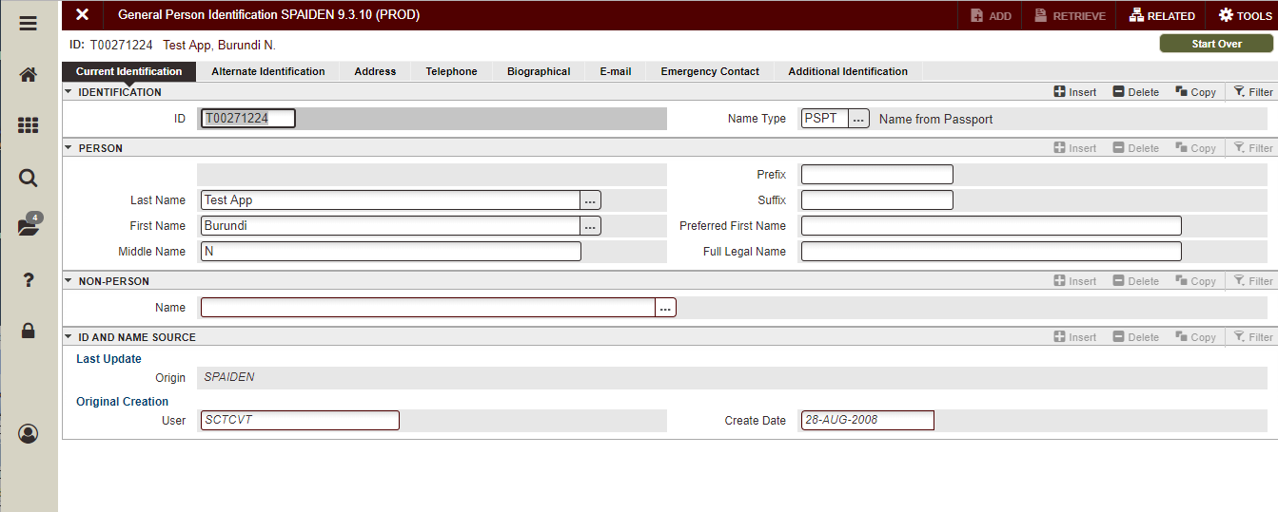
- Several email address types may be present. The Texas A&M University email address will be marked as priority.

SOAIDEN – Name search form
Click the three dots between the ID and the + on SPAIDEN:
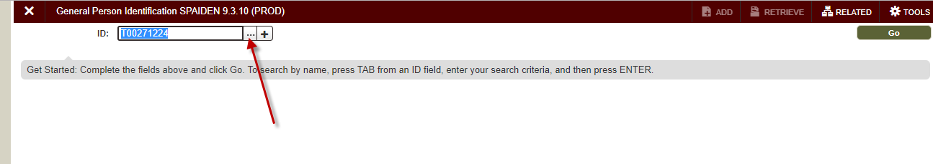
This opens a dialog box. Click Person Search.
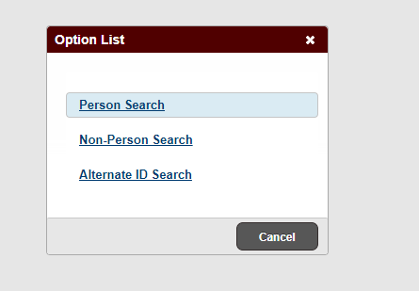
This opens SOAIDEN:
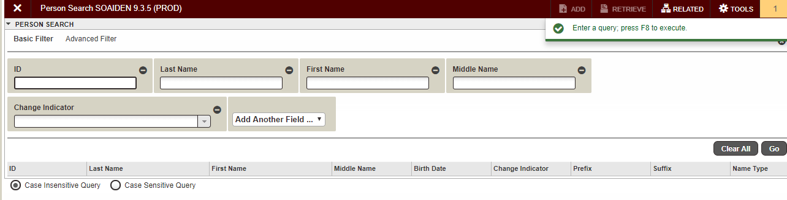
Enter the applicant’s last name and first name. Hit F8 to execute the search. You may also search by CAS ID (followed by %) in the Last Name field. Example: 123456789% for the Last Name, then search.

SAASUMI – Admissions Application Summary
- Shows summary of all applications, application number, Admission Type, Student Type, Residence Type, Status, Status Date, Decision, Decision Date, Curricula.
- Leave elements in Key block to view all applications submitted in Summary block.
- Enter term and/or Program code to filter to only see apps of a particular type.
- Information in Curricula Summary and Field of Study is related to the application highlighted in the Summary block.

SAAACKL - Admission Application/Checklist Summary
- Items marked as Mandatory are required for completion prior to a decision.
- Other items may be required later, sometimes requiring a hold to be placed on the applicant.
- Use of term in Key block will filter to only show applications for that term. Leave blank to view all terms.
- Use scroll bar in Application Summary block to select a specific term. Information in the checklist will reflect requirements for the selected term.
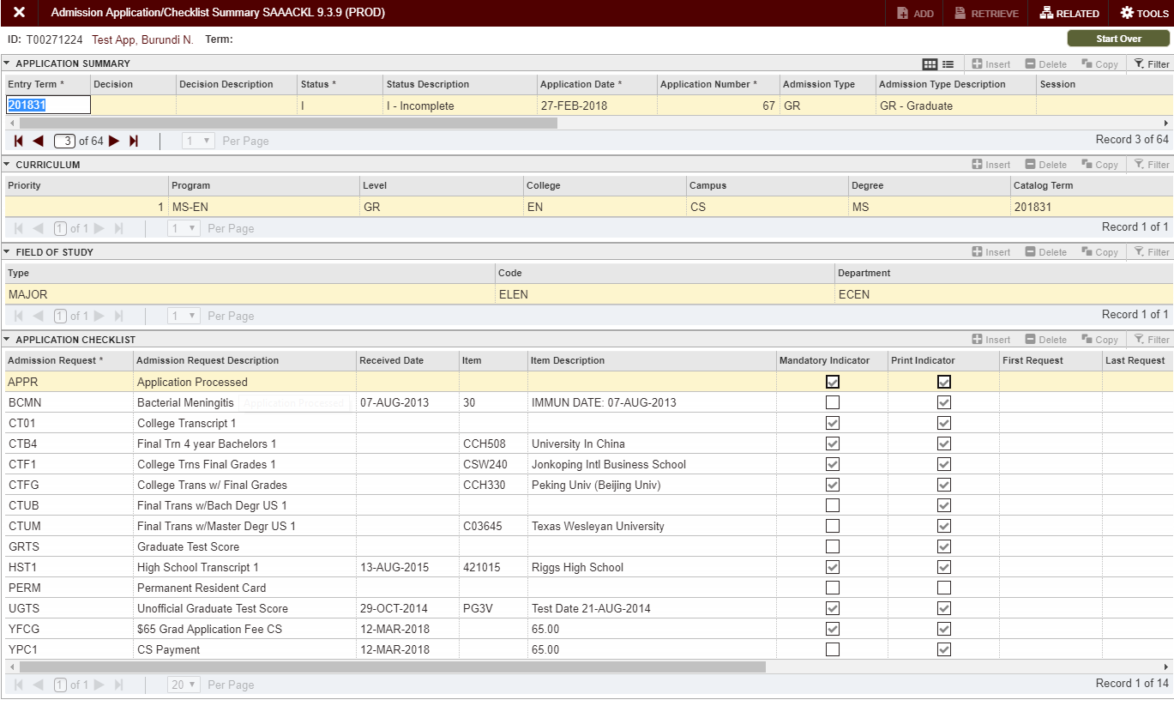

SOAPCOQ- Prior College and Degree
- Prior college, Transcript Received Date, Degree, Attendance Dates, Prior College Address.
- Degree date is entered when proof of award of degree is received.
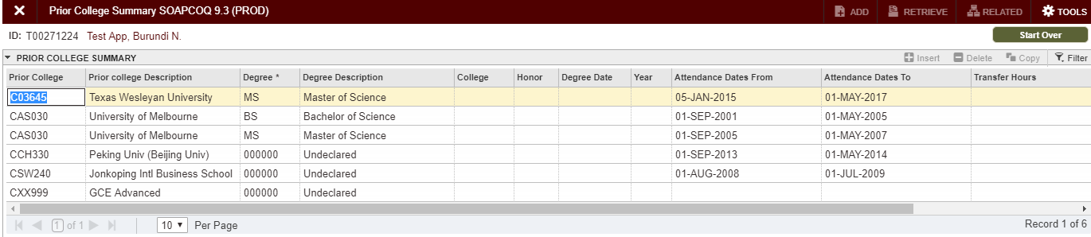

SOATEST- Test Score Information
- Test Code, Test Score, Test Date, Admissions Request, and Source.
- Test Codes that begin with a “P” are student-reported and not official.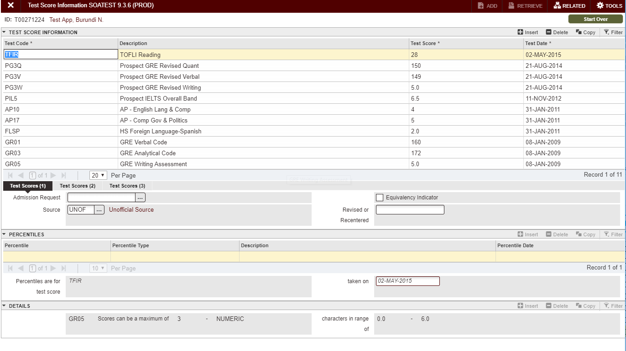

SOAHOLD/WOAHOLD- Hold Information
- Staff who place holds will need access defined by Hold Type and Originator code. Contact your Compass PAA for access.
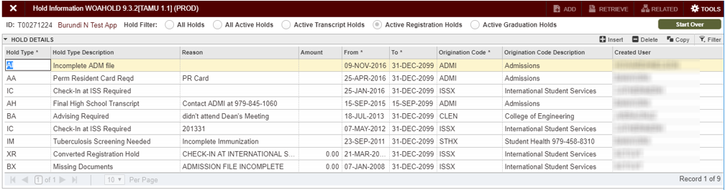

SPACMNT- Person Comment
- Comments related to student.
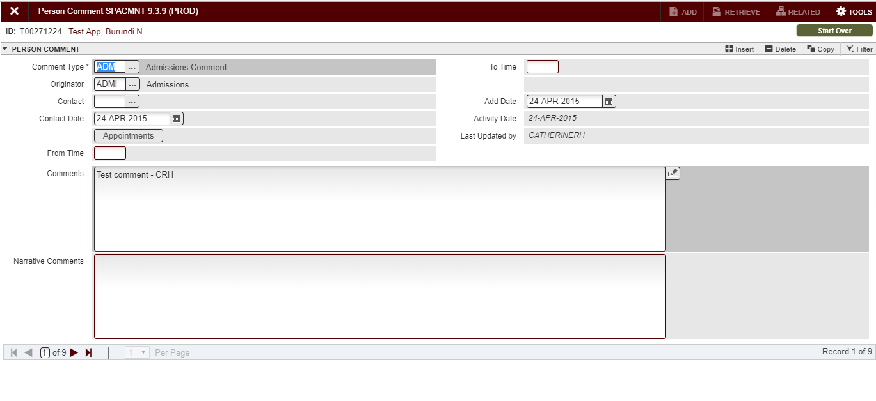

SOASUPL- Application Supplemental Information
- Information used for Texas Higher Education Coordinating Board reports.
- User defined flags and fields.
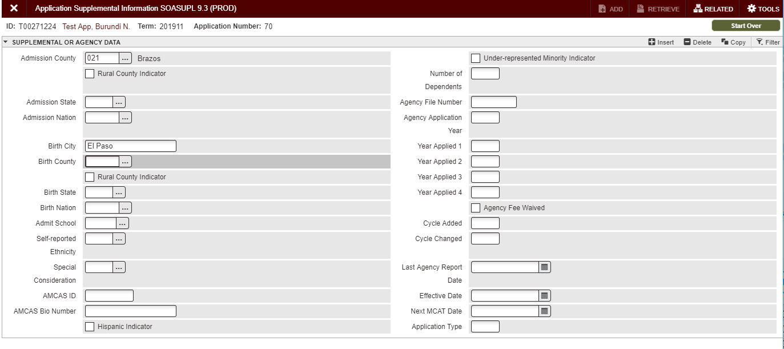

SUAMAIL- Student Mail
- Where Admissions letters are tracked.
- Click “Clear All” to remove the search filters.
- Use the F8 key to query the form for any entries.
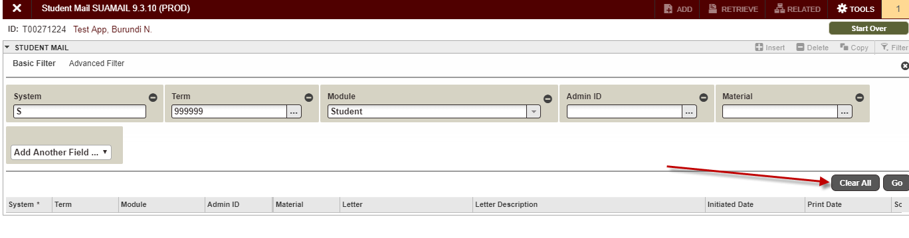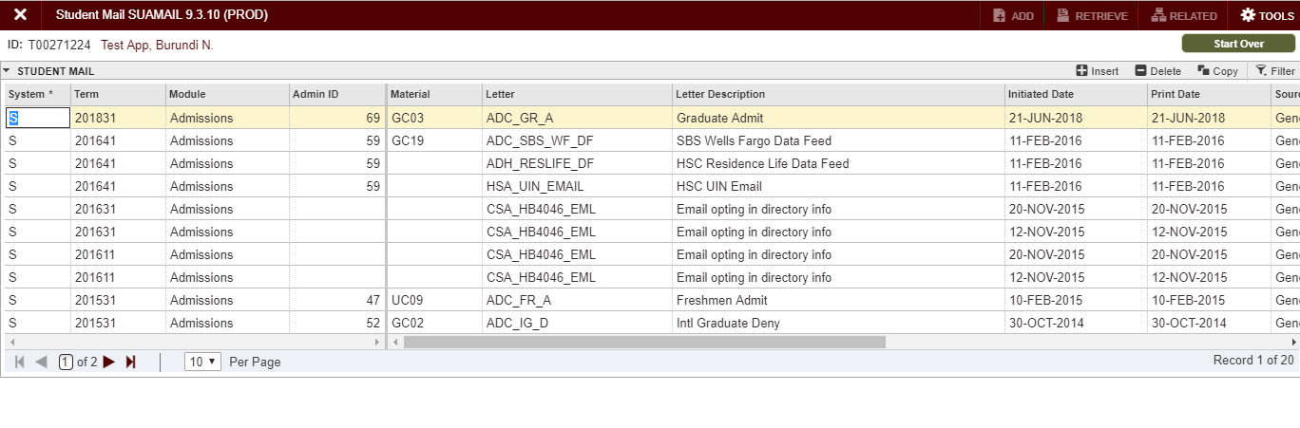

GOAINTL- International Information
- Visa Information-Admissions will enter Permanent Resident (PR-Visa Type) info.
- Document Information.
- Passport Information.
- Certificate of Eligibility.
- Nationality-Admissions will enter nation of birth, nation of citizenship.
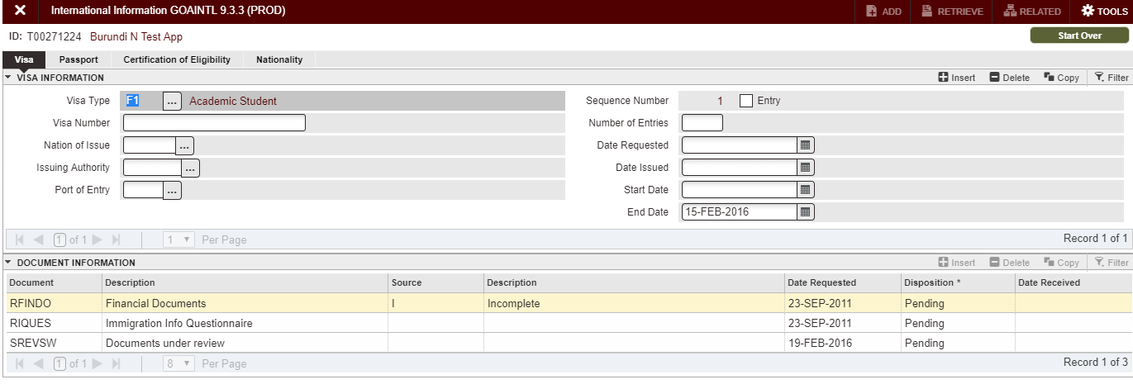

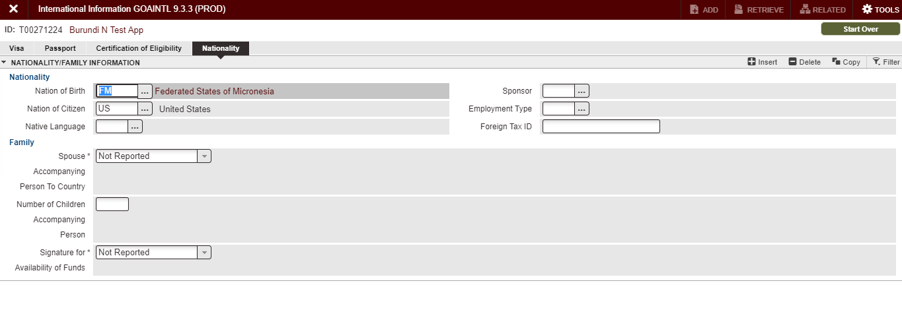

International Student and Scholar Services

Directory
International Student and Scholar Services
(979) 845-1824
Pavilion Room 110
1226 TAMU, College Station, TX 77843-1226
https://global.tamu.edu/isss

Overview of International Student and Scholar Services
International Student and Scholar Services (ISSS) supports international students, scholars and their families as they navigate the U.S. immigration system and life in the U.S. ISSS educates on policies and regulations and provides programs to enhance the Texas A&M international community experience. ISSS assists students and scholars in complying with the Department of State and Department of Homeland Security regulations and updates the Student Exchange Visitor Information System (SEVIS). Annually, ISSS supports approximately 6,000 currently enrolled international students from over 130 countries, 2,000 incoming students who need documentation from ISSS prior to enrolling, and 2,000 former students who are still in the U.S. with work authorization through an immigration status that is monitored by ISSS. ISSS supports international students at the College Station campus, Galveston campus, Health Science Center locations, McAllen Higher Education Center, Bush School D.C. Teaching Site, Houston City Centre, and the School of Law. ISSS provides resources to students on adjusting to life in the United States and the local community, coordinates and presents workshops on various subjects such as work authorization and taxes, and manages compliance with the Texas A&M System mandatory health insurance requirement for F-1 and J-1 students.

Texas A&M University defines an international student as any individual who is not a U.S. Citizen or U.S. Lawful Permanent Resident. While most international students have F-1 or J-1 immigration status, there are international students enrolled at Texas A&M in many other immigration statuses as well. All international students, regardless of immigration status, are required to complete an online check-in with ISSS prior to their first academic term of enrollment at Texas A&M. Additional information about the ISSS check-in requirement can be found at https://global.tamu.edu/isss/students All international students are strongly encouraged to review the ISS online New International Student Orientation at https://iss.tamu.edu/Events-and-Programs/NISO to learn about the various Texas A&M campuses, F-1 and J-1 immigration status requirements and benefits, health and safety tips, numerous campus and community resources, and even the Aggie Network.

Information about F-1 and J-1 status
Steps after Admission to the University
After international students are admitted to the University and have accepted their offer of admission, they will need to follow the instructions on the ISSS website at https://global.tamu.edu/isss/students. At minimum, all international students must complete a mandatory online check-in.
If the student will need a U.S. F-1 or J-1 visa to enter the United States, the student will then apply for a Form I-20 (F-1 status) or a Form DS-2019 (J-1 status). After obtaining the I-20 or DS-2019, the student can then schedule an appointment with a U.S. embassy or consulate to apply for the visa. New incoming students may enter the United States no earlier than 30 days prior to the program start date on the I-20 or DS-2019, which should correspond with the first day of classes. After arriving in the U.S., the student must complete the mandatory online check-in with ISSS.
If the student is already in the U.S. in F-1 or J-1 status and wants to maintain that status at Texas A&M, they will first need to transfer their SEVIS record from their current U.S. school to Texas A&M University and then apply for a Form I-20 or DS-2019 from ISSS. After receiving the Form I-20 or DS-2019 from ISSS, then the student must complete the mandatory online check-in.
Maintaining F-1 or J-1 Status
It is important for F-1 and J-1 students to maintain their immigration status while pursuing their academic program. Here are the main ways an F-1 or J-1 student can maintain status:
- Keep their documents up-to-date.
  - I-20/DS-2019: Students should not let their I-20 or DS-2019 expire prior to graduation.
  - Passport: Students should never let their passport expire.
  - Visa: It is okay if the F-1 or J-1 visa stamp in the student’s passport expires while they are in the U.S. F-1 and J-1 students can continue to maintain status and remain eligible for all benefits of their F-1/J-1 status even if the visa stamp in the passport has expired. If the student travels internationally, they will likely have to renew the visa in order to return to the U.S.
- Maintain full-time enrollment.
  - Fall and Spring: Graduate F-1 and J-1 international students are required to enroll in a minimum of 9 credit hours during fall and spring terms.
  - Summer: If summer is a student’s first or last term of enrollment in a new academic program or with a new F-1 or J-1 status, the graduate student must enroll in a minimum of 6 credit hours .
  - Reduced Course Load (RCL): If an F-1 or J-1 international student needs to drop below full-time enrollment, then they must first receive an approved Reduced Course Load (RCL) from ISSS. If a student drops below full-time enrollment without ISSS permission, then the student may lose legal status.
  - Distance Learning: Only 3 hours of distance learning courses may count toward the full-time enrollment immigration requirement for F-1 students. One distance learning course may count towards the full-time enrollment immigration requirement for J-1 students.
- Obtain work authorization.
  - On-Campus Work: F-1 students are automatically eligible to work on campus while they are in legal status. J-1 students need to apply for ISSS authorization prior to working on campus and must receive annual renewal of the work authorization.
  - Off-Campus Work: Both F-1 and J-1 students need ISSS authorization and possibly also federal government authorization to work off-campus. It can take months for the student to receive the appropriate work authorization.
  - Working without authorization is considered a serious violation of status and will result in significant financial and other costs to the student. If you believe a student has worked without authorization, advise the student to consult with ISSS right away.
Mandatory Health Insurance
Texas A&M University System rules require students with F-1 or J-1 status to be automatically enrolled in and billed for the System Student Health Insurance Plan. The Department of State also requires all exchange visitors in J-1 status as well as their dependents in J-2 status to always maintain acceptable health insurance coverage. Visit the ISSS Health Insurance webpage for more information: https://global.tamu.edu/isss/health-and-safety/health-insurance.
Travelling Inside and Outside the United States
Texas A&M University System rules require students with F-1 or J-1 status to be automatically enrolled in and billed for the System Student Health Insurance Plan. The Department of State also requires all exchange visitors in J-1 status as well as their dependents in J-2 status to always maintain acceptable health insurance coverage. Visit the ISSS Health Insurance webpage for more information: https://global.tamu.edu/isss/health-and-safety/health-insurance.

Academic Departments and ISSS
Each academic term, ISSS must report to the U.S. government that F-1 students are continuing to make progress toward completing their academic program and that they are maintaining F-1 status. Many of the ISSS processes for international students involve the academic departments. Academic departments provide ISSS with valuable information regarding the students’ academic status and progress. More resources can be found at https://global.tamu.edu/isss/departments-and-partners/international-students-101.
Common ISSS Processes that involve Academic Departments
- Reduced Course Loads – permission to drop below full-time enrollment
- Extensions – permission to extend the I-20 or DS-2019 expiration date for academic purposes
- Curricular Practical Training (CPT) – U.S. work authorization for F-1 students to participate in an internship that is a required part of the academic program
- Optional Practical Training (OPT) – U.S. work authorization for F-1 students to apply the skills learned in their academic program through U.S. employment typically after completion of the program
- Academic Training – U.S. work authorization for J-1 students to participate in either an internship during an academic program or employment after completion of an academic program
- On Campus Employment for J-1 students – U.S. work authorization for J-1 students to engage in on-campus employment while completing their academic program
International Student On-Campus Employment
Students on F-1 or J-1 status are limited to 20 hours per week of on-campus employment during the fall and spring semesters. Students may work more than 20 hours per week in the summer, winter, or spring break periods. Eligibility for on-campus employment automatically ends if a student graduates, if their I-20/DS-2019 expires, or if they violate their status. If a student exceeds 20 hours per week of on-campus employment during a fall or spring semester, or if a student continues to work on-campus after their eligibility to do so expires, they may lose legal status.
Texas A&M University Funding Offer Letters
F-1 and J-1 students must submit evidence of financial resources to ISSS in order to receive an I-20 or DS-2019. If the student is offered a Texas A&M assistantship, fellowship, scholarship, or grant, they are strongly encouraged to use that funding offer for the purpose of I-20 or DS-2019 issuance. This will significantly reduce (or fully eliminate) their requirement to show personal or third-party funding and University funding is viewed more favorably by the U.S. government for the purpose of showing reliable financial resources. The following information about the content of award letters is important, not only when the letters are prepared for newly admitted students, but also whenever federal regulations require currently enrolled international students to obtain letters proving financial support.
The financial offer letter must be printed on department letterhead and must include the following:
- The student’s name.
- The contact information for the employing/awarding department or office.
- The applicable date(s) or academic term(s) of the offer. ISSS cannot accept financial documentation for past terms as evidence of financial support for current or future terms. To calculate the financial benefit, the funding offer must apply to current or future dates/terms.
- The specific dollar amount(s) being awarded, including any applicable salary or pay rate.
- The frequency by which the financial support will be distributed (e.g., once, each semester, monthly, bi-weekly).
- The benefits (i.e., insurance), if any, that accompany the financial offer. If the letter does not specify insurance or any other benefit, ISSS cannot assume they are included.
- Any waivers or contributions toward the cost of the student’s tuition and/or fees. It is best to be very specific with wording in the letter. Some examples include:
  - The student is receiving a waiver of the out-of-state tuition only and they can pay tuition at the in-state rate.
  - The student’s tuition is being paid but they are still responsible for fees.
  - All the student’s tuition and fees will be paid.
- Students who receive funding assistance from Texas A&M University are urged to work with their departments to better understand their aid package. In some cases, University funding does not fully cover the ISSS estimated cost of attendance for at least 1 year. If that is the case, the student will be required to show additional financial resources to make up the difference. This could include personal funding, third-party funding, or sponsored student funding. For additional information about ISSS estimated cost of attendance and the financial documentation that can be accepted, visit https://global.tamu.edu/isss/resources/costs-and-financial-documents.

Financially Sponsored Students
Some international students are financially sponsored by government agencies, major corporations, or other sponsoring organizations. ISSS refers to these students as sponsored students. ISSS serves as a liaison among the Office of Admissions, academic departments, financial sponsors, and students regarding matters related to their immigration status and sponsorship. If the sponsor is paying the University directly, then Student Business Services (SBS) processes the third-party billing. All invoices are issued by SBS.

Identifying a Sponsored International Student
A Texas A&M sponsored student is a student who, in pursuing his or her educational objective in the United States, seeks admission to TAMU under any of the following conditions:
- The student’s educational program is the result of a written agreement between the United States government and a foreign government or a written agreement between an American and foreign educational institution, or
- The student receives primary financial support from a source other than personal or family funds or a Texas A&M academic department, or
- The student’s educational objective has been agreed to by both prospective student and sponsor and may not be changed without the written approval of the sponsor.
Financial support for a sponsored student may be provided by the United States government, the government of the prospective student’s home country, an international organization, or other private or public entities. Most sponsored students are selected to study in the U.S. under programs designed to enhance the development of their country and are required to return to their home country following the completion of the academic objective. As a result, their educational objectives are clearly delineated in agreements (contracts) the students sign prior to receiving funds for academic study. Each sponsor and/or agency representing sponsors who fund students to pursue academic degrees will have a unique set of requirements.

Restrictions
In addition to federal regulations governing all international students, sponsors may impose their own, such as:
- Course Selection and Full Course of Study
Whereas sponsored students must enroll in required University classes as stipulated by Texas A&M regulations and departmental requirements, students who drop courses or elect to enroll in courses not considered required or related to their sponsor’s academic objectives must obtain their sponsor’s permission.

- Employment/Payment of Tuition
Advisors should inquire whether a sponsored student is permitted by their sponsor to seek or accept employment in the U.S. In some cases, sponsors permit employment without a penalty; in other cases, sponsors may authorize employment but reduce their financial contribution to the student. All questions on such matters should be directed to the student. Furthermore, all sponsored students must comply with federal employment regulations. Departments offering assistantships should bear in mind that many sponsored students receive stipends for living expenses that may be tax free.
Sponsored students whose sponsors pay tuition and fees may not be eligible for departmental/grant Graduate and Professional School payment of tuition unless there are special circumstances involved. The student should check with their sponsor should there be questions regarding sponsorship conditions related to payment of tuition and fees.
- Additional Degrees and/or Practical/Academic Training
Advisors should not assume a student may remain in the U.S. and/or is authorized to pursue degrees and/or training beyond that which was funded by a sponsor. Permission from the sponsoring agency should be secured prior to offering assistance to a sponsored student for pursuing an additional degree and/or encouraging a sponsored student to obtain practical training authorization.

Sponsor Visits
Sponsors or their representatives may schedule visits to Texas A&M. These visits are coordinated through ISSS.

Resources And Services For A&M Students Going Abroad

Directory
Education Abroad
(979) 845-0544, abroad@tamu.edu
112 Pavilion -3262 TAMU, College Station, TX 77843-3262
https://global.tamu.edu/ea/
Pascale Parker – Director
Education Abroad is committed to meeting the goals of all Texas A&M University graduate students through various transformational, international opportunities including research, internship, academic and volunteer programs abroad. Specific services available to graduate students include identifying programs, applying for or renewing your passport, obtaining international health insurance, information about available scholarships, 24/7 emergency support as needed when you are abroad, and help locating courses or appropriate programs that will enrich your graduate degree. Please visit https://global.tamu.edu/ea/ for additional international opportunities, policies, insurance, health and safety, and education abroad fees.
Graduate students planning to travel abroad to study, intern, research, and attend conferences will need to register their travel through the Education Abroad portal before departure. This also applies to independent travelers and students who will receive no credit or will travel internationally as TAMU employees. Also note that countries and regions listed on the TAMU-System International Travel Advisory List may require pre-approval from the university president or delegate. This process is facilicated through Education Abroad and should be started as early as possible.

Passport Services
Education Abroad is also a Passport Acceptance Facility. This provides students, faculty, and staff with a convenient location for all their passport needs, including photo services for U.S. Passports, international passports, and visa applications. The office is open to the public and parking is available nearby. For information on passport processing fees please visit the U.S. State Department website at travel.state.gov. For information on facility hours and fees please visit the Education Abroad website at Global Engagement - Passports (tamu.edu).

International Medical Insurance
Graduate students studying, interning, volunteering, conducting research, or presenting at a conference overseas can purchase a comprehensive, and very affordable, health insurance plan through Cultural Insurance Services International (CISI). Since 1992, CISI has insured over 1 million students worldwide. The plan available to Texas A&M graduate students includes a comprehensive medical plan with no deductible, 24-hour emergency support, medical evacuation, repatriation, and affordable premiums. For more information, contact Education Abroad at https://global.tamu.edu/ea/ or (979) 845-0544.

Texas A&M Education Abroad Programs

Texas A&M Faculty-Led Programs
Every year Texas A&M faculty teach courses abroad during the fall, spring, and summer sessions. A number of Texas A&M University faculty-led programs provide stacked graduate – undergraduate coursework. Some courses are designed specifically for graduate students only and combine both research and classroom experiences. Graduate students can work with their advisors to develop an opportunity that incorporates one or both of these elements.
It is also possible for graduate students to accompany an undergraduate or graduate program abroad as an assistant to a faculty leader; just as they would assist with an on-campus course. In such cases, graduate students can be added to a program either in a dual role (50% student and 50% employee) or in a full work role (100% employee). Graduate students interested in these opportunities should contact their graduate advisor or faculty leader.

Exchange Programs
Exchange Programs are student exchanges authorized by the Texas legislature and governed by special regulations. Exchanges provide students the opportunity to study and live at an international university for either a semester or an academic year. Exchange programs are established through a Memoranda of Agreement between Education Abroad or an academic department at Texas A&M and an international institution. Parity for such exchanges must take place over a five-year period. Participating students pay Texas A&M tuition and fees while enrolled at the foreign institution, typically for one semester.

Non-Degree Programs
Many foreign universities will accept non-degree-seeking students to take courses at their institution or to pursue research for academic credit. Graduate students who wish to spend some time at a foreign university should write directly to the school or schools of choice, requesting admission as a non-degree student. To receive credit for this coursework, graduate students will have to work with their department, advisory committee and Education Abroad to facilitate the credit transfer.

Independent Research Abroad
Conducting thesis or dissertation research outside of the United States requires registration with Education Abroad as an Independent Traveler. This provides students access to resources including health and safety information, international insurance, and Education Abroad’s 24/7 emergency support. Arrangements for research hours should be made directly between the student and his/her department. For more information, call (979) 845-0544 or visit https://global.tamu.edu/ea/.

Internships
Graduate students who would like to complete an international internship may find opportunities through Education Abroad, Career Center Work Abroad Programs, or the Graduate Student Career Services. For more information, contact Education Abroad or the Texas A&M University Career Center at careercenter.tamu.edu, or (979) 845-5139. The Career Center is located in Koldus 209.

Scholarships Available for Students
Graduate students engaged in education abroad programs are eligible for special scholarships. More details about these and other funding opportunities for international education are available on the Education Abroad website at abroad.tamu.edu.

Junior Fulbright
The Fulbright is a prestigious national competition. If awarded, students live in a selected country and conduct research, teach, or attend school and are funded by both the U.S. and the host country. The opportunities available depend upon the particular country. The likelihood of receiving a Junior Fulbright increases if the graduate student applies for a country that is identified by the Fulbright committee as highly desirable. Information about applying for the Junior Fulbright is available on the L.A.U.N.C.H. office website at launch.tamu.edu. You can also visit the Fulbright site at www.cies.org.

British Marshall
This program is for a master’s degree at a British institution. Recipients may be married but must be under the age of 26 by October 1 of the year of the award. The student must also have a Bachelor’s degree with an overall GPA of 3.7 by the date of the receipt of the award. For more information, go to launch.tamu.edu.

Rhodes
This award is available to graduate students and graduating seniors for two (2) years of study at Oxford University. An applicant must be a U.S. citizen between the age of 18 and 24 and have at least a 3.75 GPA. For more information, go to launch.tamu.edu.

Rotary Foundation Ambassadorial Scholarship
This scholarship provides graduate, undergraduate, vocational students, teachers of the handicapped, and journalists, with funds to conduct studies and research abroad. Students must be proficient in the language of the host country. The applicant must be a citizen of a county in which there is a Rotary Club. For further information, contact the Bryan/College Station Rotary Club at https://portal.clubrunner.ca/3795.

National Security Education Program (NSEP) – Boren Fellowship
This program awards fellowships to American graduate students to study in foreign countries and world regions critical to U.S. national security. NSEP awards are available for a maximum of $8,000 per semester or $16,000 per academic year. The competition is merit-based. Students may apply for study in summer, fall, and spring. The application deadline is February. For more information, visit http://www.borenawards.org.

Study Abroad Fellowship
This is a need-based scholarship, furnishing up to $2,000 to full time undergraduate and graduate Texas A&M University students for participating in Texas A&M Education Abroad programs. At the time of scholarship application, graduate students must be enrolled for at least 9 hours with a cumulative GPA of 3.0. Applications are available on the university Scholarships and Financial Aid website at uwide.tamu.edu.

International Education Fee Scholarship – Graduate and Professional
This is a merit- and need-based scholarship program. At the time of the scholarship application, graduate students must be enrolled for at least 9 hours with a cumulative GPA of 3.0 and all students must be enrolled in a credit-bearing education abroad experience (i.e., study abroad program, co-op, internship or international practicum). International students studying in the United States are eligible to apply. Applications are available online at uwide.tamu.edu. All students who paid the international education fee are eligible to apply based on financial need, academic qualifications, and international activities.

International Education Fee Study Grant – Graduate and Professional
All students who paid the international education fee are eligible to apply for up to $500. The award may be used towards the expenses in presenting a paper at or attending a recognized conference. For more information, visit the International Student Services website at: iss.tamu.edu

Patti and Weldon Kruger ’53 scholarship
This scholarship supports up to a semester long academic experience in international locations. The scholarship supports travel for graduate students to participate in academic programs, research, attendance at international conferences, seminars, or short courses in international locations. There is a strong preference for students who have not previously traveled outside of the United States. The Application is available on the university Scholarships and Financial Aid website at scholarships.tamu.edu.

Office Of The Registrar - Records Administration & Archives

Directory
For the most up-to-date staff directory:
- Administrative Services Leadership Directory
- Office of the Registrar Directory (all staff)
Office of the Registrar Listserv
Contents of this section are subject to change as we continue to evaluate processes. New or improved initiatives may be implemented after this publication. It is strongly encouraged to subscribe to the Office of the Registrar listserv in order to receive general information, updates, and reminders from our office. See Office of the Registrar Listserv (http://registrar.tamu.edu/About-Us/Office-of-the-Registrar-Listserv) for more information about how to join.

Registration Information
The following registration information should assist you with determining what forms, if any, are required to make registration requests during various stages of the registration process.
Registration Access
Students & many advisors have registration access to drop and/or add courses to their schedule through the end of the Add/Drop registration period as published in the Academic Calendar. Effective with the first day of the term, students wanting to drop all classes are considered to be withdrawing and cannot drop all classes via Add/Drop. Students are to be advised to submit their withdrawal request in Howdy. After the Add/Drop registration period, only the dean (or dean designees) have registration access to drop and/or add courses through the official census date for the term. It is encouraged that all registration schedule adjustments be made prior to the official census date to avoid any unintended implications that may arise due to changes made after this time (i.e., state and federal enrollment reporting issues, financial aid adjustments, international student status changes, student-athlete eligibility, etc.).
If registration changes are needed after the official census date for the term, these must be requested using the online Add/Drop request in the Howdy Dashboard. If a student is registering for the first time after the census date, the department will need to submit the paper Request for Registration After Census form.
Please reference Student Rules 1.18 to 1.20 for more information about Registration and Change in Schedule (http://student-rules.tamu.edu/rule01).
Registration-Related Forms
Request/Form | Circumstances for When to Use or Submit: | Time Frame When to Submit
Add/Drop Requests online | Student already has enrollment and needing to make changes to existing enrollment. NOTE: Adding classes to an existing schedule after census resulting in a net increase in hours will result in a $50 late add fee.  Do NOT use this form to drop all classes (i.e. withdraw) unless dropping all as a no record. (with appropriate documentation). For withdrawals, students initiate online in Howdy.  An online processing guide is available to view to assist with using the online request system as follows:  Employee tab > Compass User Training > Records, Registration, and Advising > Registration > Online Course Change Submission | The online Add/Drop request system is to submit requests after a term’s census date.  It is not intended to be used to submit current term requests made prior to the current term census date as Deans and Dean’s designees are given registration access to manage add/drop requests before census.
Request for Registration After Census Form  Use to add classes after the official census date.  Form is on the Registrar’s website under News and Resources > Forms and Resources > Records Administration & Archives. | The student is not enrolled in any courses as of the official census date. This form must be used to add courses to a student’s schedule who was not enrolled in any classes as of census.  NOTE: Adding courses any day after census for the term, if not enrolled in courses as of census, will result in a $200 late registration fee. | Submit these forms to the Office of the Registrar.  Forms can be submitted to the Office of the Registrar via:  - Fax: 979-845-1086  - In Person: GSC Bldg, Suite 1501  - Via Filex to recordsadmin@tamu.edu

Late Registration/Add Penalties (Student Business Services – sbs.tamu.edu)
Students who add classes after the Census Date (12th class day for fall and spring term and 4th class day for summer sessions) that result in a net increase in hours enrolled are assessed a $50 registration after census fee.
Students who were not enrolled as of 1st class day, and who register on or after the first day of classes, but before the thirteenth day of classes (before the 5th class day for summer sessions) are assessed a $100 late registration fee. Students who were not enrolled as of the 12th class day, and who register on or after the twelfth class day are assessed a $200 registration after census fee (4th class day for summer sessions).
Note: The University reserves the right to cancel registrations not paid by their due date, or by the official census date for semester or summer term, to comply with state laws requiring payment of tuition and fees. The late registration fee and late add fee will be applied to student accounts that are required to reenroll because their registrations were cancelled for non-payment. Registrations are subject to cancellation and/or financial penalties if sufficient payment is not received before 5:00 p.m. on the last business day before classes begin and on the Census Date (12th class day for fall and spring term and 4th class day for summer sessions), to free the classroom spaces for other students, and to ensure the most efficient use of University resources.
Add/Drop Request:
  - Always include a reason for the request being made as a comment or upload a document (i.e. memo). This is important backup documentation if there is ever a question about why a schedule change was made.
  - The Academic Dean’s approval is the only approval required by the Office of the Registrar. Some academic deans may require an advisor to vet the request and submit documentation to them before they will review and/or approve the request.
- Drops- When dropping a course, keep in mind that students dropping individual courses while remaining enrolled in other courses, may have their courses dropped and not kept on their record dropped during the first twelve (12) class days of a fall/spring term, or first five (5) class days of summer. Drops during this time result in the course not appearing on the student’s transcript, do not reflect a grade, and does not have charges* associated with these drops.
*This only applies if the student is still enrolled in other courses and dropping during the first twelve (12) class days of a fall/spring term, or first five (5) class days of summer.
  - NR Drop Type (No Record) – No record drops prior to census are expected as a means to correct student registration so records are accurately maintained on the student’s record and can be reported accurately according to state and federal rules and regulations. No record drops are NOT intended to be used after the official census date except in extenuating circumstances where an administrative error has been detected and is necessary to correct the student’s enrollment record(s). NR drop type removes a course from the student’s permanent record as if they were never in the course and results in no charges associated with the course. No Record drop requests made after census must be accompanied by a memo from the academic dean providing further explanation of the extenuating circumstances for why the no record is being requested and further support why it was not able to be addressed in a timely manner on or before census. In general, courses in which a student has attended/participated, would not be eligible for a no record request. No record requests must be approved by the Office of the Registrar.
  - “W” Drop Type - generally used to drop a course with a “W” grade for extenuating, non-academic reasons, anytime during the term. Requires a dean’s approval. W-drops will be retained on the student’s record with a “W” grade and do not generate any refund. Deadline for a W drop is on or before the last day of class for the term as indicated on the Academic Calendar. Drops for prior terms, in general, will not be considered. See NG drop type, for situations where extenuating circumstances exists and considering a course drop from a prior term.
  - NG (No Grade) requests- See Grade Changes Section for more information.
- Changing number of Credit Hours – These should be made on or before census. To change the number of hours of a variable credit course in which a student is enrolled, click on the section you want to update in the online Add/Drop on the Howdy Dashboard and select the link for the hours to change.Generally, when the number of hours is lowered, tuition and fees are adjusted and may result in a refund; when the number of hours is increased, tuition and fees are adjusted and may result in additional charges. There may also be additional late fees and/or non-fund as well as a late add fee of $50 on hours added after the census date. A change of this nature could also have financial aid implications which may also impact the overall financial costs associated with the changes made.
- Changing a grade mode BEFORE grades are posted (whether S/U to letter grade or letter grade to S/U) – To change the grade mode of an eligible course in which a student is enrolled, click on the section you want to update in the online Add/Drop on the Howdy Dashboard and select the link for the Grade Mode to change for that specific section.
  - Once final grades have been posted, a grade of X will be entered for the course if the grade mode is changed and the instructor will have to submit a grade change online in Howdy that routes to the department head for approval.
Withdrawals (drop all classes)
- Beginning with the 1st day of classes each term, a student wishing to drop all courses is to be considered withdrawing from the term.
- Beginning with the first day of classes, students wishing to withdraw must initiate their request online in the Howdy portal.
- If a student is withdrawing during the first twelve (12) class days of a fall/spring term, or first four (4) class days of summer, the student’s courses will not appear on the student’s transcript and do not reflect a grade.
  - Students who withdraw during this time period will have some financial obligation in accordance with the State’s withdrawal refund calendar published on the Student Business Services website.
  - Withdrawals made after census will result in the courses and grades of “W” appearing on the student’s official transcript.
Request Registration after Census Form
- This form is to be used only AFTER census date for students with no course enrollment. Do not use this to add hours to an existing schedule.
  - $200 late registration penalty will be assessed.
- The form must be filled out completely, including UIN or T-number, name, major, classification, term, year, and all parts of the course information. Please include a “Reason for Request.”
- Must be signed by BOTH the student’s major Department Head & the student’s Dean (or their designees) on file with the Office of the Registrar.
- Completed forms must be submitted to the Office of the Registrar for processing.

Grade Changes
Online Grade Change System (Howdy)
The process will allow primary instructors to access and initiate a grade change request electronically from their Class Roster in Howdy (for courses with grades already posted), as well as allowing department heads and deans (if needed) to review and submit required approvals electronically. The final approval submission will result in the student’s new grade being reflected within minutes!
Grade change approval authority is based on departmental and dean signature cards on file within the Office of the Registrar.
*Please note grade changes in Howdy are initiated byprimary instructors of record, then routes to department and dean’s designees authorized as grade change approvers on signature cards AND who already have Compass Access.
Grade Change Report form (paper form)
Paper Grade Change Report forms will only be accepted if one or more of the following applies:
- Grade change request is for a grade earned prior to Fall 2009.
- If dean’s signature and memo justification is required due to absence of the primary Instructor of Record being able to submit the grade change request.
  - Only the primary instructor of record is eligible to sign a grade change form for their course. Additional graders for courses are NOT able to submit grade change requests, nor sign grade change report forms.
- No Grade (NG) is requested. These can only be submitted on paper grade change report forms and only requires the signature of the student’s Dean.
If submitting a paper form, be sure the information entered on the Grade Change Report form by the instructor (i.e., the complete UIN or T-number, the course/section numbers or CRN, and the “assigned grade” you are requesting to be changed) agrees with what is currently reported in Compass. The academic department is responsible for checking for completeness and accuracy before the form is submitted to the Records Administration & Archives Team in the Office of the Registrar for processing. Incomplete and/or inaccurate forms will be returned to the department. When a correction is made to the form, the individual making the change must initial and date each correction.
Instructor of Record not available for signature: If the individual initiating the grade change is not the instructor of record, the dean of the college, in addition to the department head in which the course is taught, must sign the Grade Change Report form. The form will also need to have an accompanying dean’s memo explaining why the instructor of record did not sign the form. In the case of a Grade Change Report form not signed by the instructor of record for a Military Science, Naval Science, or Aerospace Studies course, the Commandant must sign the form and submit the memo to the Registrar.
No-Grade (NG) Requests: The Grade Change Report is used to change a previously graded course grade to No-Grade (NG). No-Grade (NG) is generally used to change a grade from a course for extenuating, non-academic reasons, in a previously graded term. A NG requires extensive documentation of the extraordinary circumstances justifying the No Grade and must be approved by the dean of the student's academic college at the time the student was enrolled in the course being NG. The student’s grade will reflect a “NG” grade on their official record and does not generate any refund. This could be an appropriate consideration for a prior term course that was not dropped on or before the drop deadline for the prior term, due to extenuating circumstances.
Submit Paper Grade Change Report forms to the Office of the Registrar as follows:
- Fax: 979-845-1086 (is routed directly into registrar staff workflows and routed to student’s record).
- In Person*: GSC Bldg, Suite 1501.
- Via Filex to recordsadmin@tamu.edu
- Forms should NOT be emailed directly to anyone.
*If submitting in person or via campus mail, the Grade Change Report forms MUST be submitted to the Office of the Registrar in a SEALED departmental envelope. Grade Change Report forms not delivered (by hand or campus mail) in a sealed departmental envelope will be returned to the appropriate office for resubmission.
Students Handling Grade Change Forms: Under no circumstances should students handle Grade Change Report forms once they are initiated. This includes forms being routed for signatures and completed forms being delivered for processing.
Obtaining Blank Grade Change Forms: If a paper grade change form is needed, please email recordsadmin@tamu.edu for assistance in obtaining a blank form.
Additional Grade Change Guidelines
Signature Authority: Make certain the individuals signing the form (i.e. department head and, if required, the dean) have signature authority to sign for grade changes. Signature(s) must agree with the signature cards on file in the Office of the Registrar or the form will be returned to the department.
Grades more than one year old and lowering grades: Grade changes for grades more than one year old and those lowering the student's grade must have the approval and signature of the dean of the student's academic major at the time the student was enrolled in the course in addition to the signatures of the instructor and department head.
Missed Grading Deadline: Grades cannot be submitted online in Howdy after the grading deadline. Grades not entered by the deadline will have temporary grades of “X” populated and will require the instructor to submit a grade change for each student registered in the section. The online grade change system can be utilized once the ‘X’ grades have been posted.

Full-Time Classification for Internships/Co-Op Experience
- The internship/co-op experience must satisfy degree requirements and represent the equivalent of a full-time load.
- A process runs after the add/drop period for the term to mark any student in a Co-Op course or internship as full-time.
- Only full-time classification for co-op experience can be used to qualify for Federal Financial Aid. Full-time classification for internships is not used to qualify for Federal Financial Aid.
- Minimum and maximum hours required for the student to be enrolled will be set to the number of hours the student is enrolled in along with the internship course. This will prevent the student from being able to make schedule changes (i.e. adding or dropping) the required course without permission and appropriate documentation.

Graduate Certificates (Degree Audit)
- Certificate programs will appear on each student’s record as a separate curriculum record.
- There are three types of certificates:
Major Dependent | A student is admitted to the program through the offering department. Admission to the program requires the student to be pursuing a specific degree/major at Texas A&M University. This type of certificate program typically serves as a track within a degree program. The certificate and degree are awarded simultaneously.
Degree Dependent | A student is admitted to the program through the offering department. Admission to the program requires the student to be pursuing a degree at Texas A&M University. The certificate is awarded upon completion of the requirements independent of a degree.
Stand-Alone | A student is admitted to the program through the Office of Admissions. The student may pursue the certificate without being enrolled in a degree program. The certificate may be awarded upon completion of requirements.
- A list of approved certificate programs can be found here.
- If a student is admitted to a Major or Degree Dependent certificate, the new curriculum record is added through the University Adjustment System (UAS) using an Additional Curriculum Request.
  - Students can also be admitted into Stand-Alone certificates through the UAS if they are currently pursuing a degree, degree-dependent certificate, or another stand-alone certificate at Texas A&M
    - If the student is not pursuing one of these programs, they would have to be admitted to the stand-alone program through the Office of Admissions
  - Requests can be initiated by the student’s primary advisor, or the advisor over the certificate program (secondary advisor).
  - The UAS will route each request through an approval workflow and after all necessary approvals are granted, Degree Audit will add the certificate program as a new curriculum record for the student.
  - After the curriculum record is added, a degree evaluation is available for the certificate program to allow the student and advisor(s) to track the student’s progress towards certificate completion.
- Other UAS Requests related to Graduate Certificates
  - Other than an Additional Curriculum Request to add a certificate, all remaining UAS requests type related to a specific certificate program can only be initiated by the certificate advisor.
Request: | Purpose:
Adjustment | Substitute a course for a specific certificate requirement.
Graduate Exception | Mark the completion of a non-course requirement; update the catalog term for the certificate program; change the certificate program option (distance vs. non-distance).
Additional Curriculum Request - Remove | Used to remove a certificate from the student’s record if they no longer wish to pursue the program.

- Other Certificate Information
  - It’s best to have a certificate added as soon as the student expresses interest in the program.
    - The program can always be removed later if the student does not plan to complete it.
    - Doing this early gives the student and advisor access to the certificate degree evaluation which allows them and their certificate advisor to track their completion progress.
    - The student will not be able to apply for graduation for the certificate program until it is added through the UAS. Adding this early allows for a seamless transition when it comes time to apply to graduation for the certificate program.
  - Distance vs. Non-Distance
    - If a certificate has been approved as a distance program, the program code will end in -XDE.
    - In Non-Distance Certificates (program code does not contain XDE) no more than 50% of the courses required for the degree plan can be taken as Distance Education courses.
      - Example: in a 12-hour certificate program only 6 of those hours can be distance courses.
  - Certificate Clearance Reports
    - Each semester a nightly report runs for students that have submitted a certificate graduation application. This report will provide a snapshot of the student’s certificate progress/completion to assist advisors in clearing unmet requirements.
    - Report Name: SRC_CS_DC_CLEAR_CT_XX_CSV.
      - XX = your college code.
  - Certificate Awarding Schedule
    - Monthly Awarding: Degree Dependent and Stand-Alone certificates can be awarded at the end of each month if the student has applied to graduate with the certificate and is meeting all certificate requirements (all courses are graded and rolled to history).
    - All certificate types can also be added at the end of a semester along with degrees.
    - Awarding Schedule:
      - Fall Semester: September 30th, October 31st, November 30th, December conferral date.
      - Spring Semester: January 30th, February 28th/29th, March 31st, April 30th, May conferral date.
      - Summer Term: June 30th, July 31st, August conferral date.
  - Once a certificate is awarded, the student will be sent a physical certificate. These should only be issued by the Office of the Registrar.

Graduation Application (Degree Audit)
- Graduation applications for graduate degrees and certificates are submitted through Howdy.
  - Applications open the Monday after the prior terms graduation.
  - A single graduation application must be submitted for each credential the student will be awarded (one per degree and one per certificate).
- Deadlines and Submission Time Frame – Graduate Degrees
  - Student Rule 14.1
    - Fall/Spring Semester: graduation applications should be submitted no later than the Friday of the fifth week of the semester.
    - Summer Term: graduation applications should be submitted no later than Friday of the first week of the second summer term.
    - Applications are accepted after the initial deadlines, but a late fee ($50) would be charged.
    - The last day to submit a graduation application is the last day of classes for a semester/term.
  - Online Application Submission Window.
    - Graduation applications for degrees are available in Howdy the day the application opens.
    - It will be available in Howdy until 11:59 p.m. on the day before pre-registration for the next term(s) during fall or spring semesters, or the first Friday of the second summer term during the summer.Graduate degree applications submitted after this date (prior to the last class day) must be submitted through a paper graduation application.
- Certificate Graduation Applications
  - Unlike degrees, Certificate Graduation Applications will be available in Howdy from the time the application opens until the last class day of the semester/term.
  - If a graduation application is not submitted for a certificate program, the credential will not be awarded when the student completes all certificate requirements.

Graduate and Professional School - Student Milestones and Forms

Special Request Letter
Background: When a student requires more information than a transcript can provide for another institution, a special request letter can be generated. This letter can contain information about a student’s GPA, courses not applied to a TAMU degree, and various other requests.
- This form is completed through AdobeSign.
  - The link to the AdobeSign form can be found on the Special Request Letter page at https://grad.tamu.edu/knowledge-center/forms/special-request-letter.
- Student must provide a description of what they request the letter to state.
  - NOTE: The Graduate and Professional School can only issue Special Request Letters stating information that is factual.
- Student’s name should be listed exactly as it appears in Compass. Include the UIN, phone number, TAMU email address, and signature of the student.
- Check the appropriate boxes to indicate if letter is being picked up, emailed, or mailed to a physical address.
- If letter is being emailed, list the email address where the letter should be emailed.
- If letter is being mailed, list the address where the letter should be mailed.
Note: A Special Request Letter takes a MINIMUM of 5 workings days to be processed.

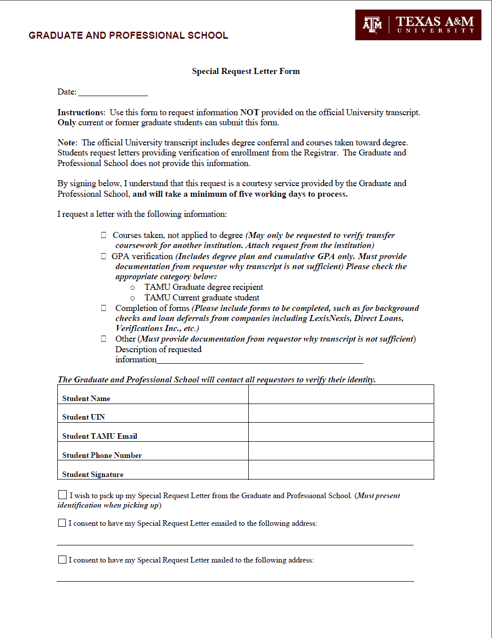

Research Proposal, Preliminary Examination, and Final Examination ARCS guides
These milestones are completed in the Academic Requirements Completion System.
The Student Guides can be found at https://staticfiles.as.tamu.edu/EIS/ARCS/ARCS_Student_Guide.pdf
The Grad Advisor (Precommittee) Guides can be found at https://staticfiles.as.tamu.edu/EIS/ARCS/ARCS_Grad_Advisor_Guide.pdf
The Department Guides can be found at https://staticfiles.as.tamu.edu/EIS/ARCS/ARCS_Department_Guide.pdf
The Committee Guides can be found at https://staticfiles.as.tamu.edu/EIS/ARCS/ARCS_Committee_Guide.pdf
The Chair of Committee Guides can be found at https://staticfiles.as.tamu.edu/EIS/ARCS/ARCS_Chair_of_Committee_Guide.pdf

Request for Exemption from the Final Examination
Background: Sometimes departments may allow for an Exemption of the Final Exam. Make sure the student is eligible for an exemption. MS-THO students must have a 3.5 overall GPA. Certain master’s NTO programs allow an exemption, but most do not.
This request is completed in the Academic Requirements Completion System. Guides for requesting an exemption can be found on our website at https://grad.tamu.edu/knowledge-center/forms/request-for-exemption-from-the-final-examination.
Master’s students must meet all requirements as noted in the ‘Requirements to be Met Prior to Approval of the Final Examination’ listed under ‘Final Examination Request.’

Request for Letter of Completion
Background: A letter of completion states that a student has completed all degree requirements, but the degree has not yet been conferred. This can be useful when another institution (such as a new place of employment or schooling) needs confirmatation that a student has completed all degree requirements before graduation. Students must have completed ALL requirements for the degree before a Letter of Completion can be approved by the Graduate and Professional School. This includes being CLEARED by Thesis and Dissertation Services for master’s thesis option and doctoral students, applying for graduation, and being cleared by the Office of Student Debt Management and not having any active holds that could withhold diploma. A Letter of Completion cannot be issued once the degree has been conferred.
- This form is currently completed through Adobe Sign but in the future will be submitted through the Academic Requirements Completion System.
  - Updated information can be found on the Letter of Completion page found at https://grad.tamu.edu/knowledge-center/forms/request-for-letter-of-completion
- Check the appropriate boxes to indicate if letter is being picked up, emailed, or mailed to a physical address.
- If letter is being emailed, list the email address where the letter should be emailed.
- If letter is being mailed, list the exact address where the letter should be mailed.
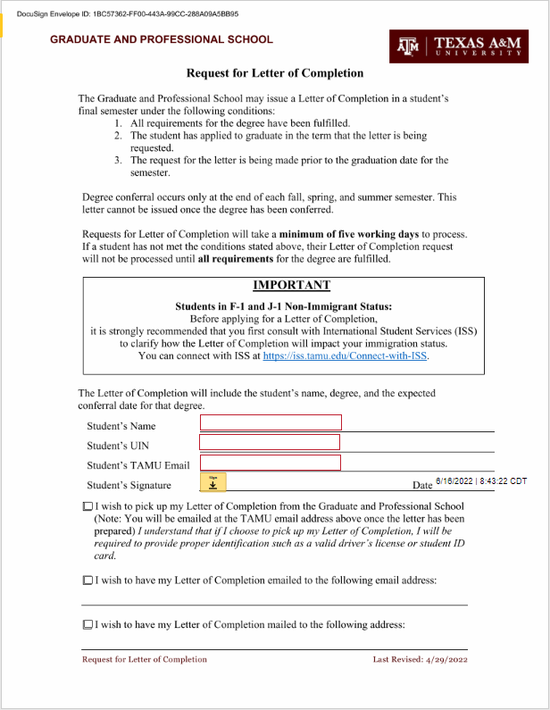

Letter of Intent
Background: A student completing a graduate degree who wants to continue for another graduate degree may request to do so by filing an letter of intent with the Graduate and Professional School. They may only do this if there is no break in enrollment, or if the break is less than one calendar year. A student who has an enrollment break of more than one calendar year or longer following graduation must re-apply through Graduate Admissions.
- This form is completed in AdobeSign.
  - The form can be found at the Letter of Intent page found at https://grad.tamu.edu/knowledge-center/forms/letter-of-intent
- This form must route to the Graduate Advisor and the Department Head.
- Enter the degree and semester of the completed degree, the proposed continuing degree, department, major and the semester to begin the proposed degree.
- The student’s signature is required along with their name, UIN, and mailing address.
- The department head, or the Chair of the Intercollegiate Faculty, must sign indicating their acceptance of the student and date. The signer checks if the student must begin in the term listed only, or if they receive the one-year time frame to register.
Upon approval of the Graduate and Professional School, a copy will be sent to the student, department, the Office of the Registrar, the Office of Admissions, and ISSS (if appropriate). The student will then be eligible to register for the new program during the normal registration period for continuing students.
This form may be signed and submitted to the Graduate and Professional School according to the timeframe considered appropriate for making departmental admissions decisions for the requested semester start date (a maximum of one year from the requested semester start date). In signing a Letter of Intent, the department is making an admission decision. Therefore, this process should be given the same level of scrutiny as an application for admission.
Students who are approved for a Letter of Intent that is semester specific, but do not begin study in the semester indicated, must file a new Letter of Intent with the new semester indicated (if within one year of graduation).
If the student does not successfully complete the current degree in the semester indicated, action will be taken by the Graduate and Professional School to place the student back in the original degree program. Unless the admission decision is valid for a future term, it will be removed from Compass.
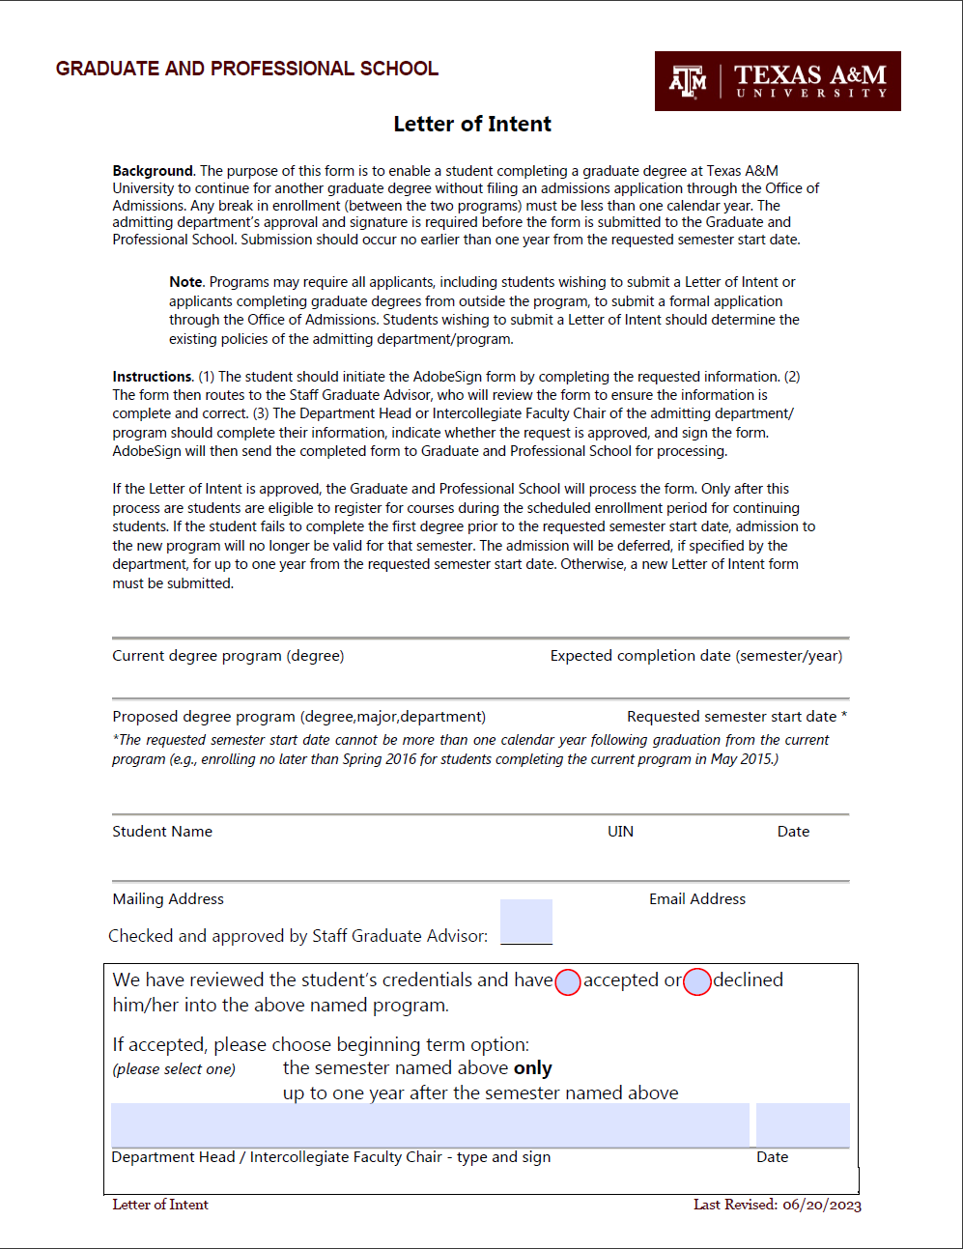

Graduate Student Graduation Cancellation Form
Background: A student may need to cancel their graduation if they no longer foresee that they will be able to complete their degree requirements. All graduation cancellation forms are subject to Graduate and Professional School approval. If a student has met all degree requirements, the cancellation will not be approved. Students who are canceled receive a confirmation email.
- This form is completed through AdobeSign.
  - This form can be found on the Graduation Cancellation Form page found at https://grad.tamu.edu/knowledge-center/forms/graduate-student-graduation-cancellation-form
- This form routes to the Committee Chair and the Department Head (If necessary)
- Students should list their name exactly as it appears in Compass, along with their UIN, Degree and Major.
- Student’s signature required.
- Committee Chair signature with date required.
- Any graduation cancellations submitted more than 30 working days prior to the graduation ceremony or after the Q-drop date must include the signature of the Department head or Chair of the Interdisciplinary Program.
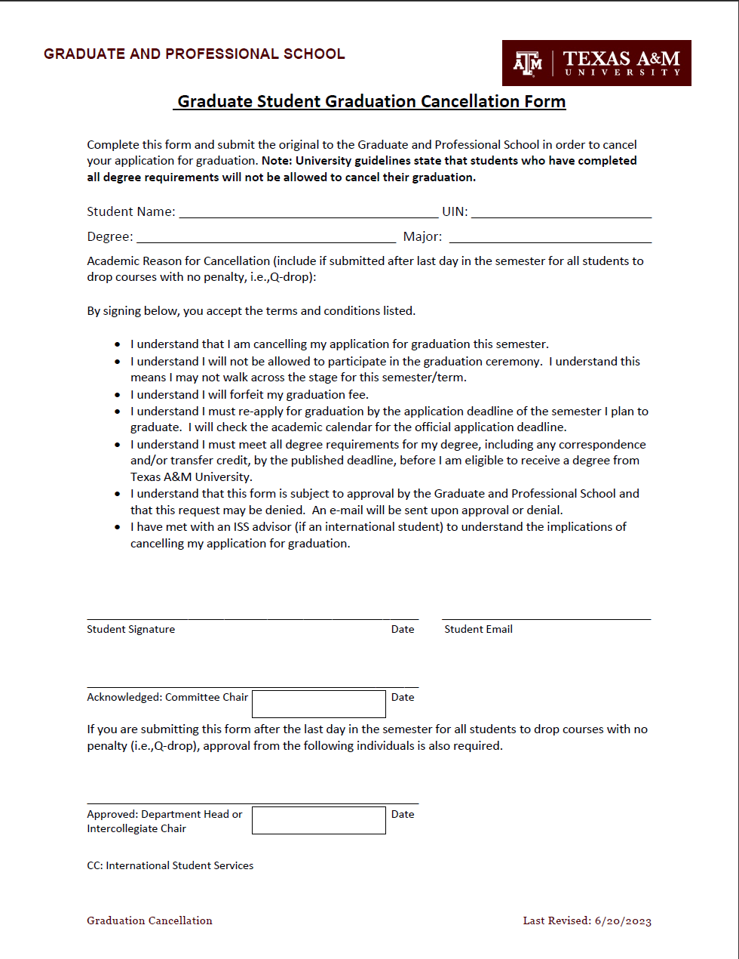
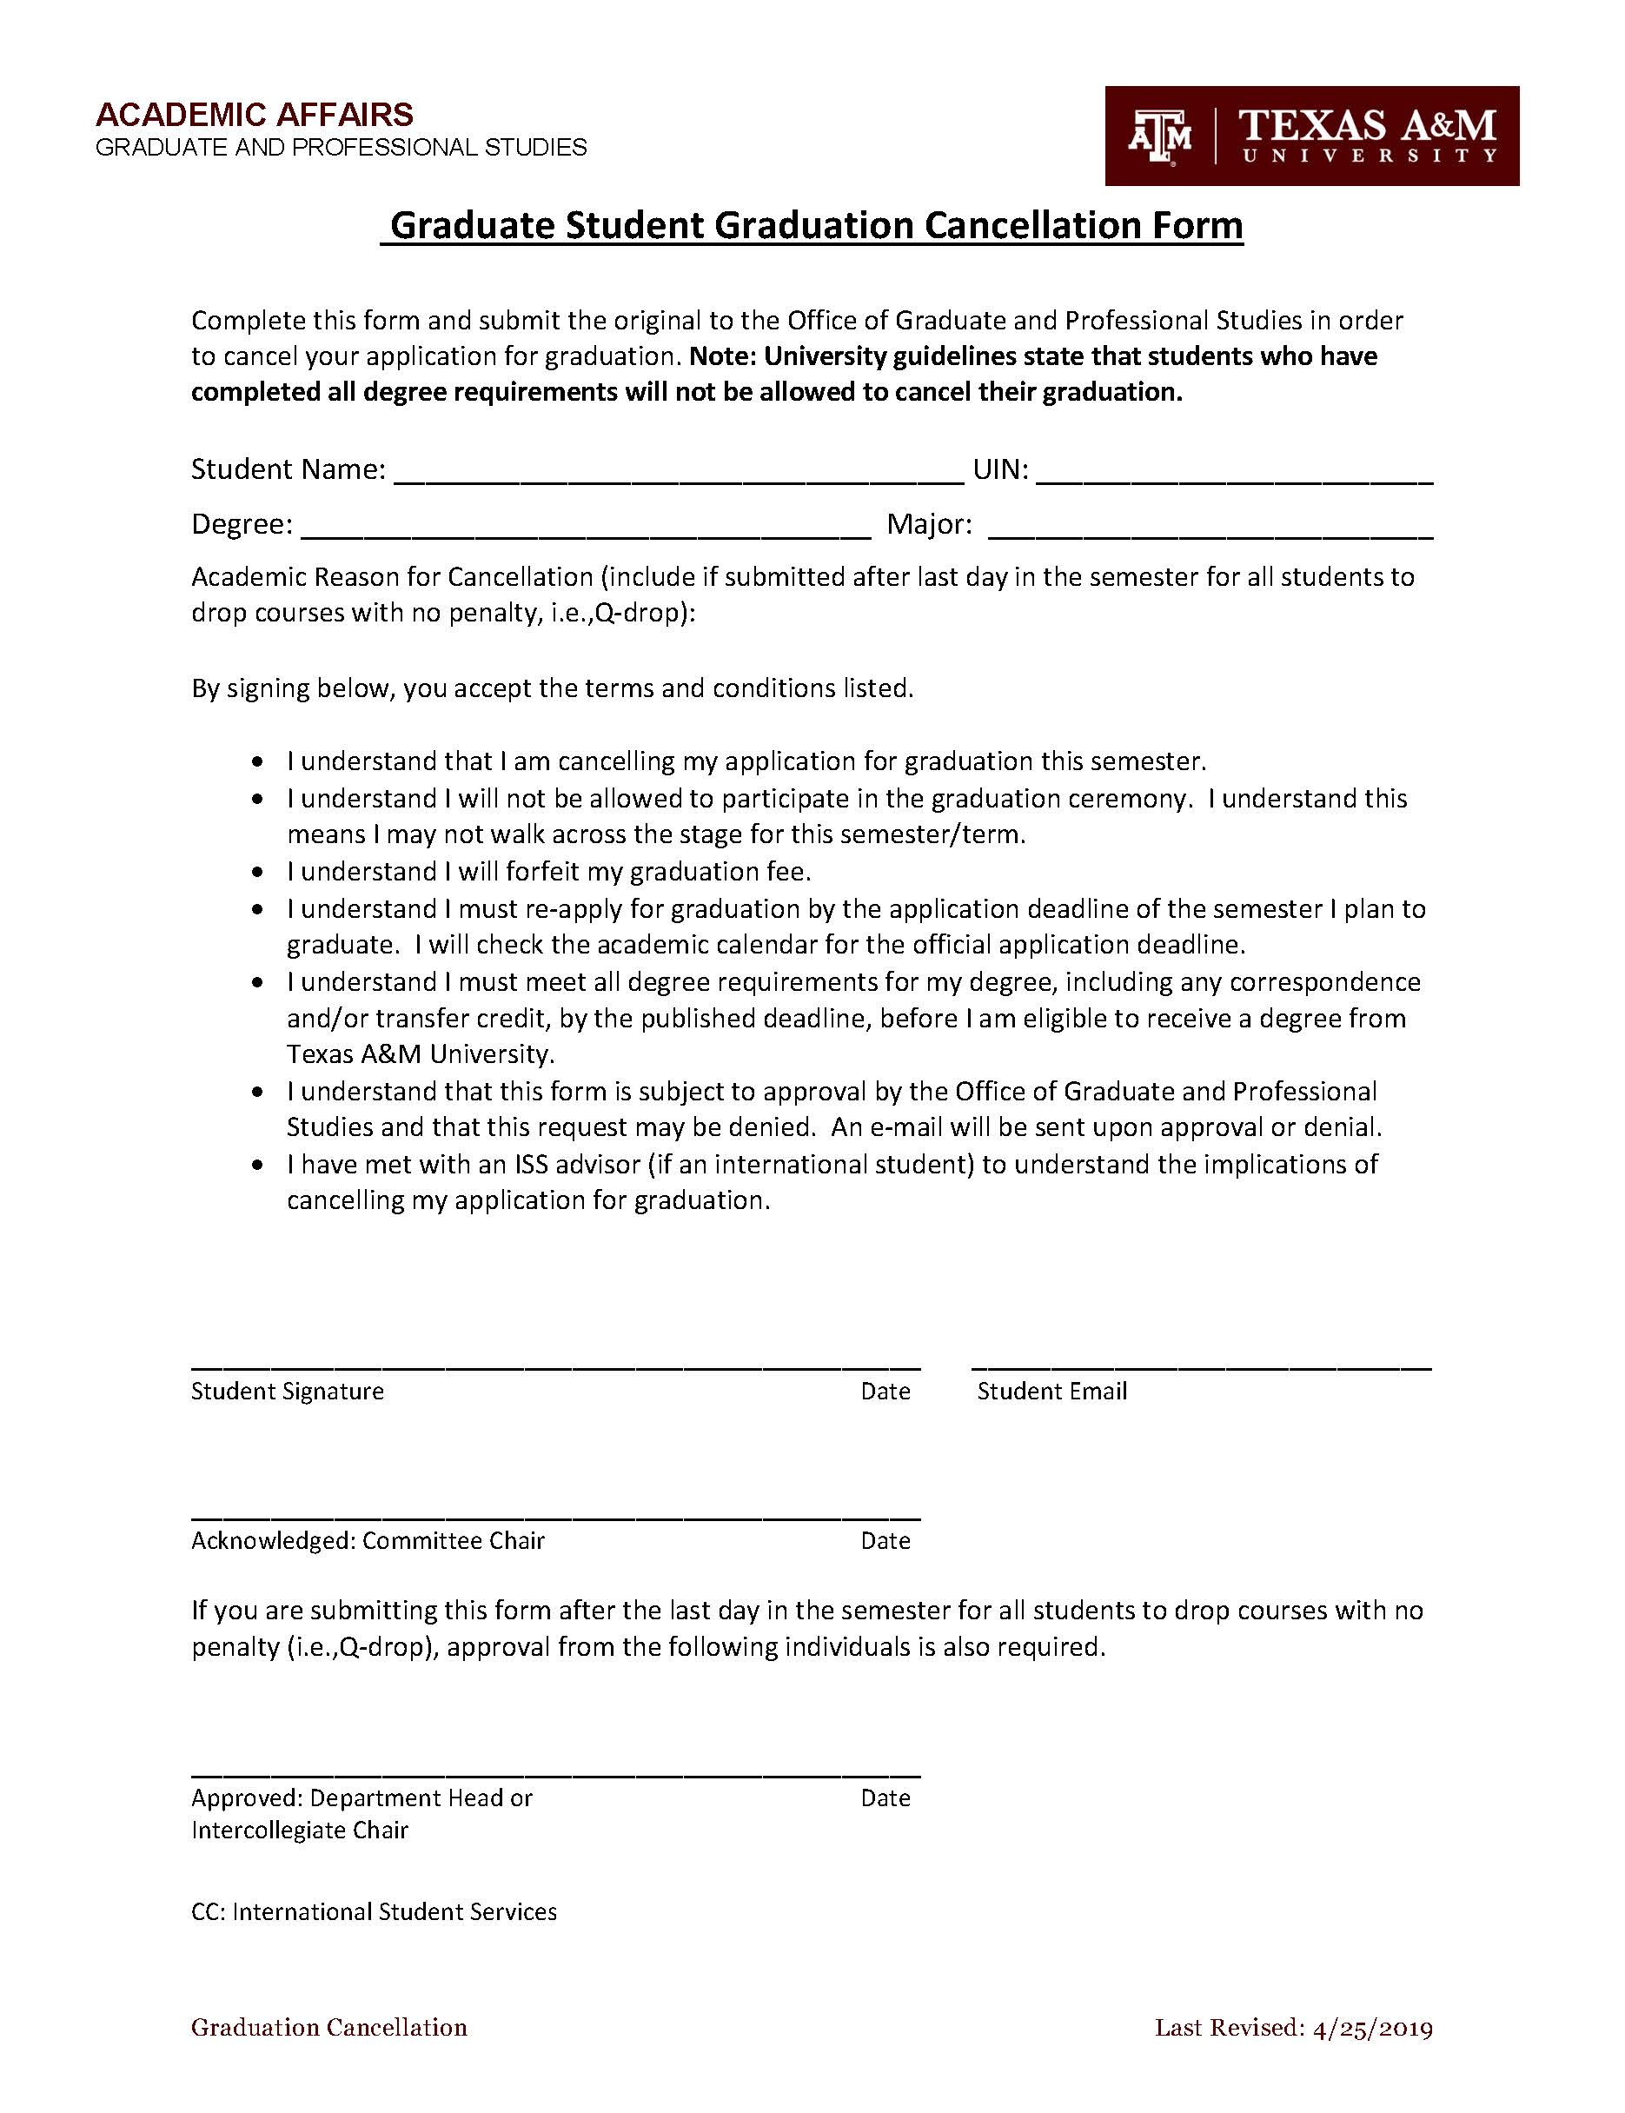

Non-Resident Tuition Waivers
- Student’s name should be listed exactly as it appears in Compass. Include the UIN of the student.
- List the number of hours for which the student is currently registered. Please note that Graduate Assistants must be enrolled full time to hold an assistantship. No waivers will be processed until a student is enrolled in the required number of hours.
- Indicate the semester for which the request is being made. Requests must be submitted every semester.
- The student should sign and date the form, provide a contact phone number, and provide their TAMU email address.
- Fill out the employing department name.
- Indicate the Graduate Assistant’s job title (Graduate Assistant Non-Teaching, Graduate Assistant Teaching, Graduate Assistant Research, etc.)
- Indicate the assistantship hire date (must be before the official census date of the semester for which the request is being submitted), the students FTE percentage, and the job title code.
- Indicate the anticipated assistantship termination date and a telephone number for the student’s supervisor.
- Summarize the student’s job duties and how the relate to the student’s academic program (may be attached on departmental letterhead.)
- An authorized signer from the employing department should sign section B verifying that the student is employed in an eligible position for the semester.
- Fill out the academic department name and four-letter department code.
- An authorized signer from the academic department should sign and date section C verifying that the student’s job duties support his or her degree program.
The Non-Resident Tuition Waiver for Graduate Assistants is submitted using DocuSign. The form can be accessed on the Graduate and Professional School NRTW webpage. An example of the required fields is available on the next page.

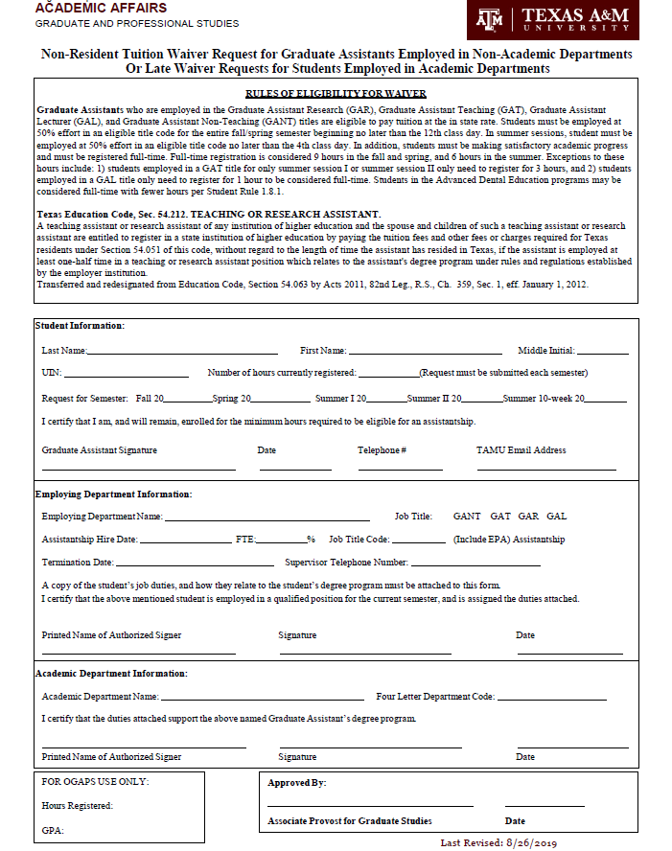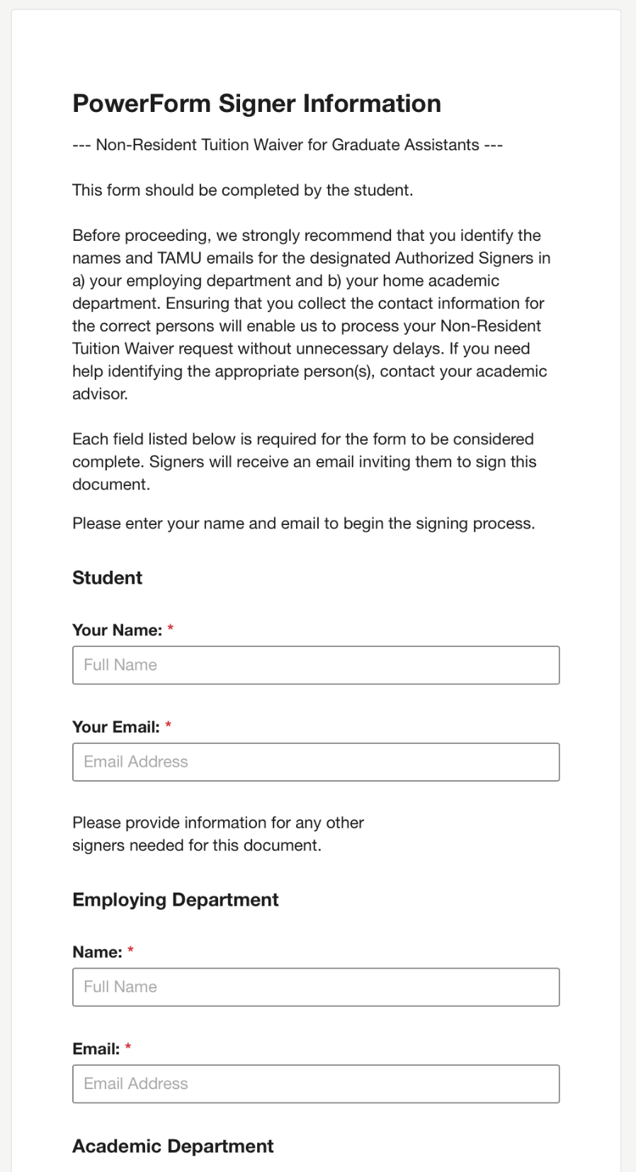
The steps to fill out a Spouse/Dependent Non-Resident Tuition Waiver Request are below:
- Fill out the information for the Spouse/Dependent Section.
- The spouse/dependent’s name should be listed exactly as it appears in Compass. Include the UIN of the spouse/dependent.
- List the number of hours for which the spouse/dependent is currently registered.
- Indicate the semester for which the request is being made. Requests must be submitted every semester.
- Attach formal proof of marriage/dependency.
- The spouse/dependent should sign and date the form, provide a contact phone number, and provide their TAMU email address.
- Fill out the information for the Graduate Assistant Section.
- The GA’s name should be listed exactly as it appears in Compass. Include the UIN of the student.
- Enter the number of hours for which the student is currently registered. Graduate Assistants must be enrolled full time to hold an assistantship. No waivers will be processed until a student is enrolled in the required number of hours.
- The GA should sign and date the form, provide a contact phone number, and provide their TAMU email address.
- Fill out the employing department name.
- Indicate the Graduate Assistant’s job title (Graduate Assistant Non-Teaching, Graduate Assistant Teaching, Graduate Assistant Research, etc.)
- An authorized signer from the employing department should sign this section verifying that the student is employed in an eligible position for the semester.
- Fill out the academic department name and four-letter department code.

A Non-Resident Tuition Waiver Request for the Spouse/Dependents of Graduate Assistants can be accessed on the Graduate and Professional School NRTW webpage. An example of this form is shown on the following page.

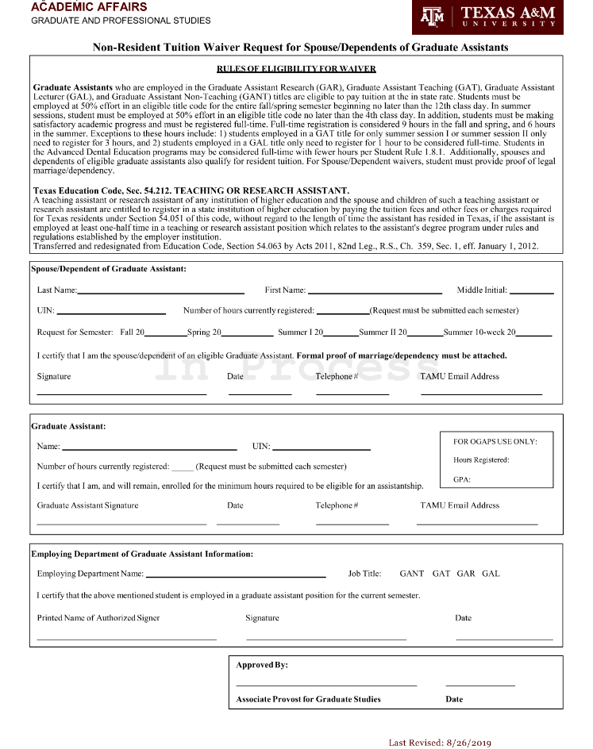
Common reasons the Non-Resident Tuition Waiver may be returned include:
- Unauthorized signers from the Employing Academic Units
- Graduate Assistant is not meeting the minimum registration requirements
- NRTW request form is missing employment information such as pay title and position type

Thesis / Dissertation – Approval of Written Thesis Form
The Written Approval Form should be initiated by the student in the Academic Requirements Completion System (ARCS) section of the Howdy portal.
For additional information regarding thesis submittal and review, contact the Thesis and Dissertation Services team at 979-845-3631 or thesis@tamu.edu.

Thesis / Dissertation – Copyright and Availability Form
The Copyright and Availability Form should be initiated by the student in the Academic Requirements Completion System (ARCS) section of the Howdy portal. The student must complete the student information section, including the student’s name, UIN, degree, and month/year of graduation.
- The student should read and understand the Texas A&M University Copyright agreement.
- The student should read and acknowledge his/her responsibility for the content found in this ETD, in regard to accuracy, copyright, Institutional Review Board, and other applicable laws/requirements.
- After consulting with the committee chair), the student should select the appropriate availability option.
- If the Full Record Hold or Document Only Hold are chosen, the student will need to provide written justification for their selection in the space provided.
- The chair should approve the form, indicating their acknowledgement of the availability option selected.

NOTE: This form must be received by Thesis and Dissertation Services in order for the student to receive clearance.

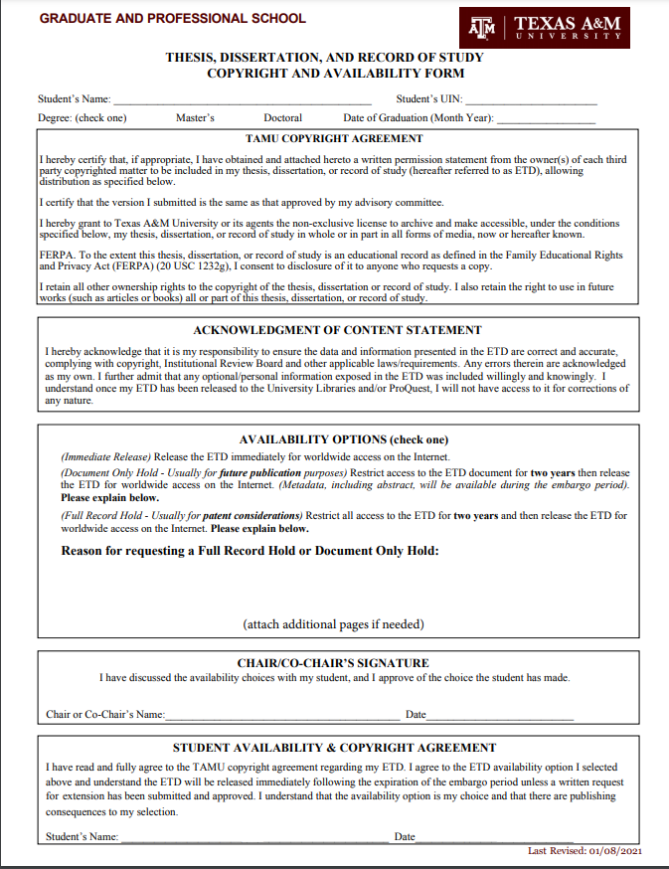
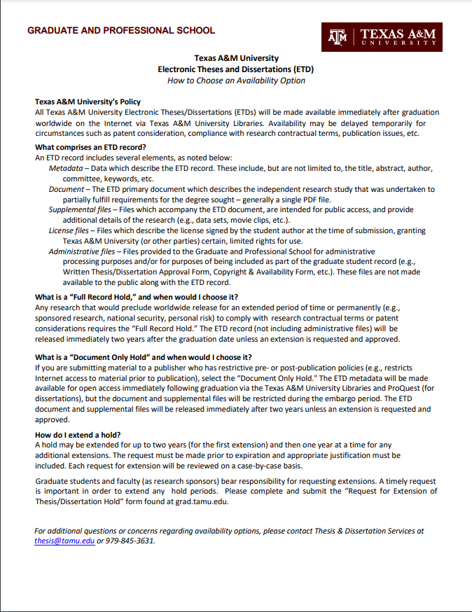

Graduate Student Research and Presentation Travel Award Application Form
The Graduate Student Research and Presentation Travel Award Application Form is now an online process through the Graduate and Professional School Award Portal, grad-rap-portal.tamu.edu. Information on the application process, including instructions, Frequently Asked Questions and access to the Graduate and Professional School Award Portal can be found at https://grad.tamu.edu/funding-your-education/travel-awards. Please email grad-travel-award@tamu.edu with any questions.
Required information includes:
- An itemized budget justification.
- List of any other funding sources the applicant have applied to or received.
- All travel information.
- Location of travel.
- Dates of travel.
- Additional requirements including travel purpose and activities essay, screen shot of submitted G.R.A.D. Aggies reflection and Conference Presentation Acceptance or Submission confirmation (if applying for conference).
- Approvals by both the applicant’s committee chair and department head approver.

Graduate Student Research and Presentation Travel Award Reimbursement Form
The Graduate Student Research and Presentation Travel Award Reimbursement Form is now an online process through the Graduate and Professional School Award Portal, grad-rap-portal.tamu.edu. Information on the reimbursement process, including instructions, Frequently Asked Questions and access to the Graduate and Professional School Award Portal can be found at https://grad.tamu.edu/funding-your-education/travel-awards. Please email grad-travel-award@tamu.edu with any questions.
- Complete and submit the Reimbursement Form through the online portal at grad-rap-portal.tamu.edu. Reimbursement Forms must be submitted within 30 days of the travel return date.
- Required information includes:
  - Itemized Expense Report that includes all travel expenses associated with the trip
  - Total amount of other funds received to support the travel
  - Uploaded PDF that includes:
    - Itemized receipts for each expense
    - Two-page summary/reflection of the trip that includes the statement “I verify that this is an accurate representation of my accomplishments using these travel funds.” and the applicant’s signature.

Request for Fellowship Deferment
- Initiate the fellowship deferment form.
- The completed form will route to the student’s department and the Graduate and Professional School for approval of deferment.
- To reactivate your fellowship, you must submit a Request for Reinstatement form.
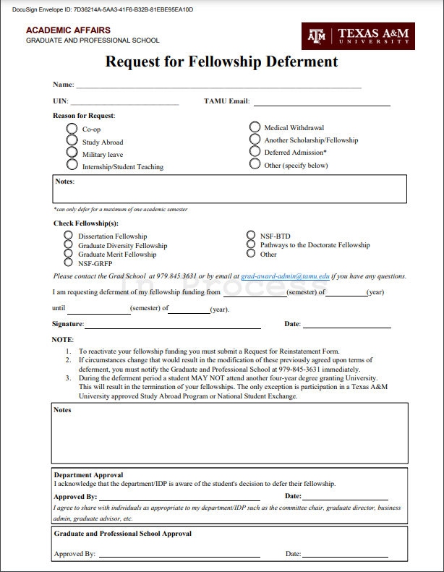

Request for fellowship reinstatement

- Initiate the fellowship reinstatement form.
- Students returning from an approved leave of absence should submit this form preferably six (6) weeks before the start of the semester in which they wish to return.
- The completed form will route to the department and Graduate and Professional School for approval.
- Students who have decided not to return from a leave of absence should select the appropriate box, indicating that they intend to withdraw from the University.

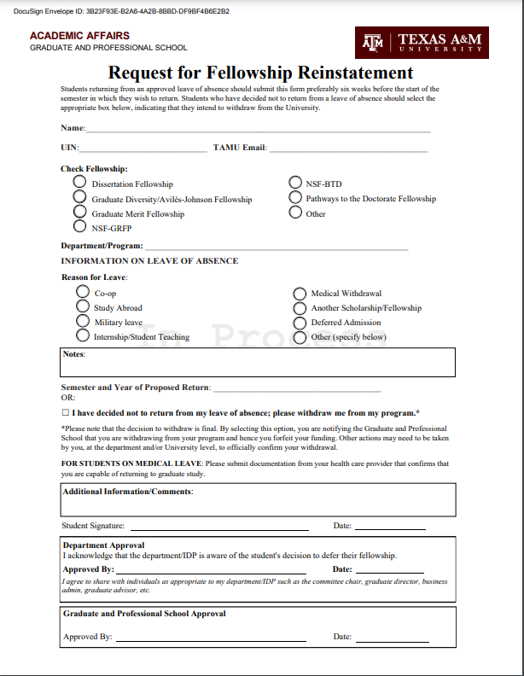

Graduate and Professional School - Faculty/Staff Forms

689 (Special Topics) Course Requests
689 (Special Topics) course requests are now submitted via the Registrar’s online Section Request System (SRS) at https://sectionrequest.tamu.edu/. For access to or questions about the system, please contact the Scheduling Office in the Office of the Registrar. All course requests should be approved by the college at least five (5) working days prior to the class schedule inclusion registration deadline published by the Office of the Registrar each semester.

For information on the SRS and submission of 689 requests, see the Regstrar’s User Guide (https://sectionrequest.tamu.edu/UserGuide/SRSUserGuide.pdf).

Contact: Graduate and Professional School – grad@tamu.edu or 979-845-3631
Office of the Registrar, Scheduling Office – scheduling@tamu.edu or 979-458-4950

Authorized Signers Forms
- Log in to Google Drive (https://drive.google.com/) with your TAMU NetID and password (ability to access and edit the Authorized Signers Form requires a TAMU email address and the Google Apps Account setting enabled in the “Email Settings” section on Aggie Account Gateway (https://gateway.tamu.edu/settings/email/)).
- Each college/school, department, and IDP will need to provide the following information on their Authorized Signers Form:
- The full names of all the unit’s relevant faculty leadership and position titles (Dean, Department Head, or Program Chair; Associate Dean(s), Assistant Department Head(s), Program Co-Chair(s); Graduate Instruction Committee Chair; Graduate Operations Committee Dean; etc.)
- The full names of all the unit’s relevant staff and position titles (Administrative Assistant(s), Program Coordinator(s), Graduate Advisor(s), etc.)
- The University Identification Number (UIN) of all authorized faculty signers and staff
- The TAMU email addresses of all authorized faculty signers and staff
- The NetID of all authorized faculty signers and staff
- The phone number of all authorized faculty signers and staff
- The Authorized Signers Form should designate
- faculty and/or staff authorized to enter and view nominations in the Graduate Committee Faculty Portal (GradCom);
- faculty authorized to approve nominations in GradCom;
- faculty and/or staff as Pre-Committee Staff Approvers for student documents in the Document Processing Submission System (DPSS);
- faculty authorized to approve student documents in DPSS;
- faculty and/or staff authorized to enter and view nominations for Fellowships and Awards in InfoReady;
- faculty authorized to approve nominations for Fellowships and Awards;
- faculty and/or staff as Pre-Committee Staff Approvers in DocuSign;
- faculty authorized to approve student documents in DocuSign;
- access for user of ImageNow and the Doctoral Student Profile System;
- point(s) of contact regarding graduate student documents;
- faculty and/or staff authorized to submit non-resident tuition waivers; and
- faculty authorized to approve non-resident tuition waivers.

College/School Authorized Signers Form

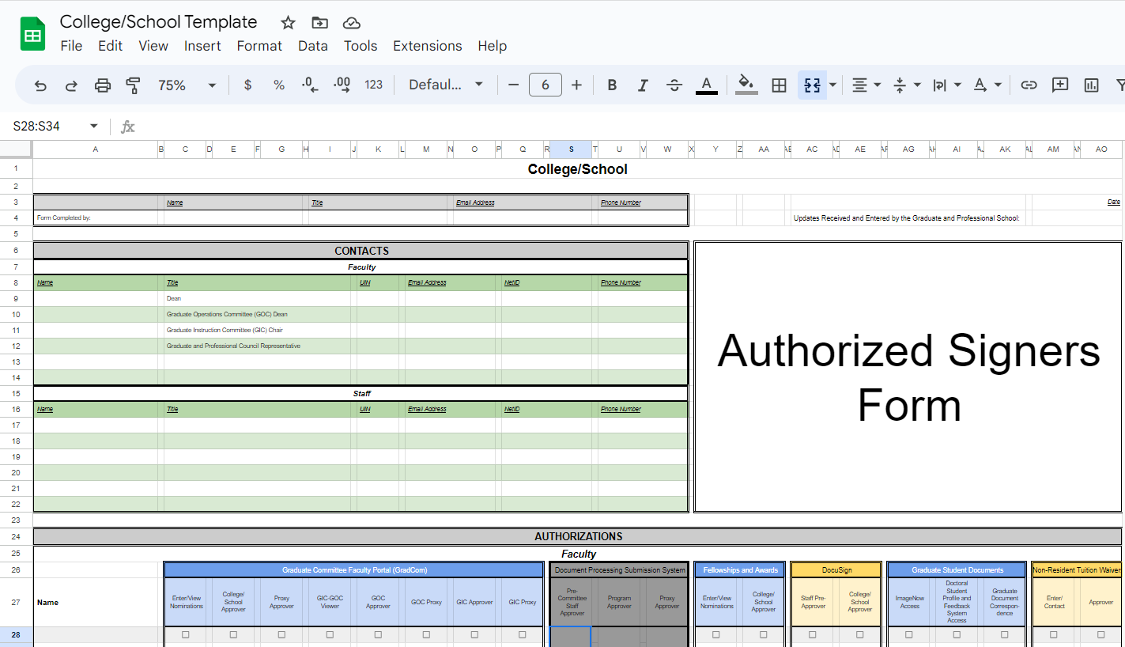

Department Authorized Signers Form

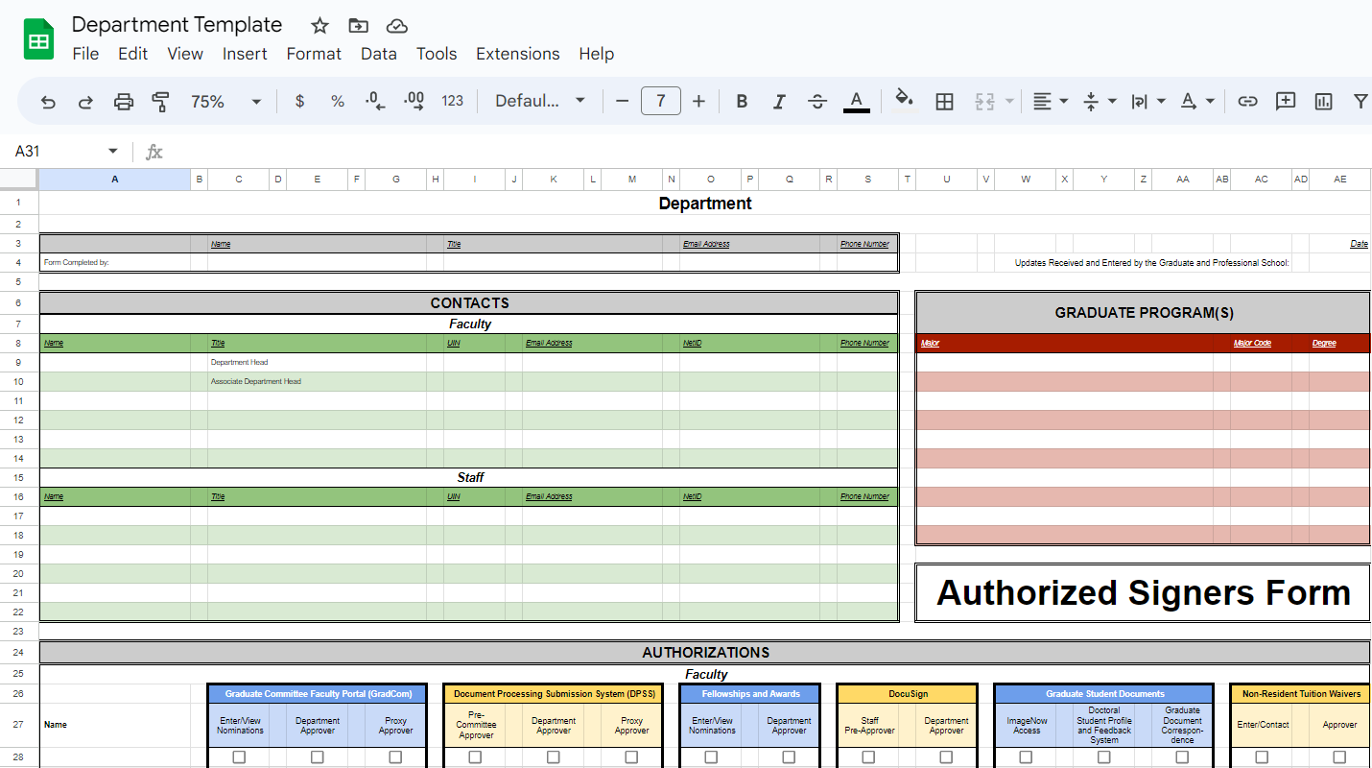

Interdisciplinary Degree Program Authorized Signers Form

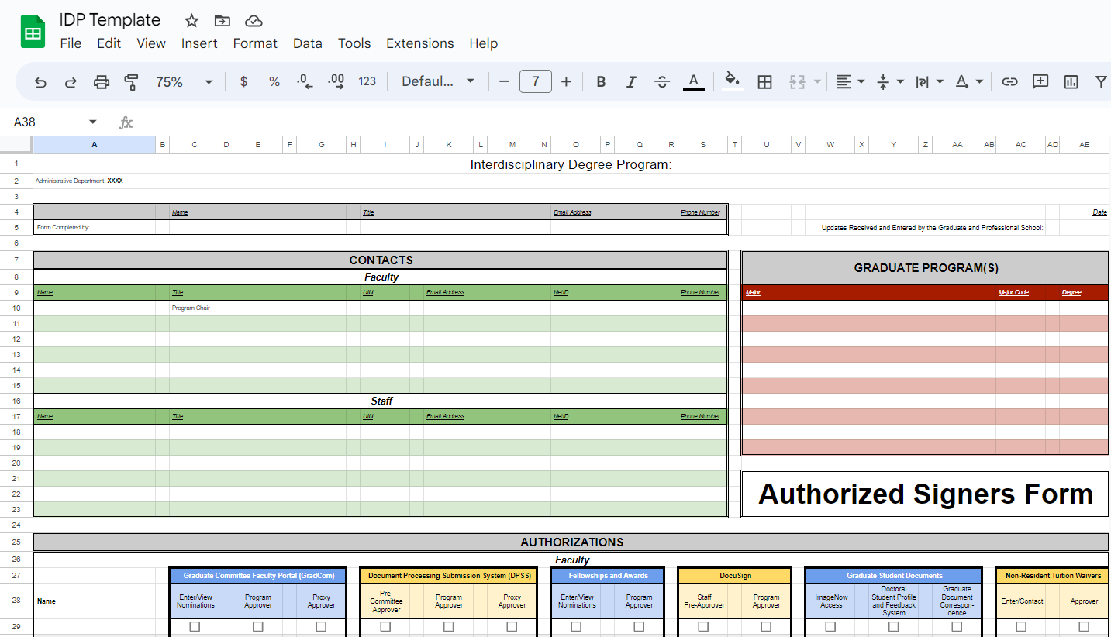

Contact: Graduate Committee Faculty Administrative Coordinator – gradcom@tamu.edu or 979-845-3631

English Language Proficiency – Alternative Verification Form
- Complete the student’s name and UIN.
- The Department Head must sign the form.
- If selecting option two, please attach all justification and documentation to support the request, such as transcripts associated with training or courses completed for English oral skills at a university and/or institution other than Texas A&M University.

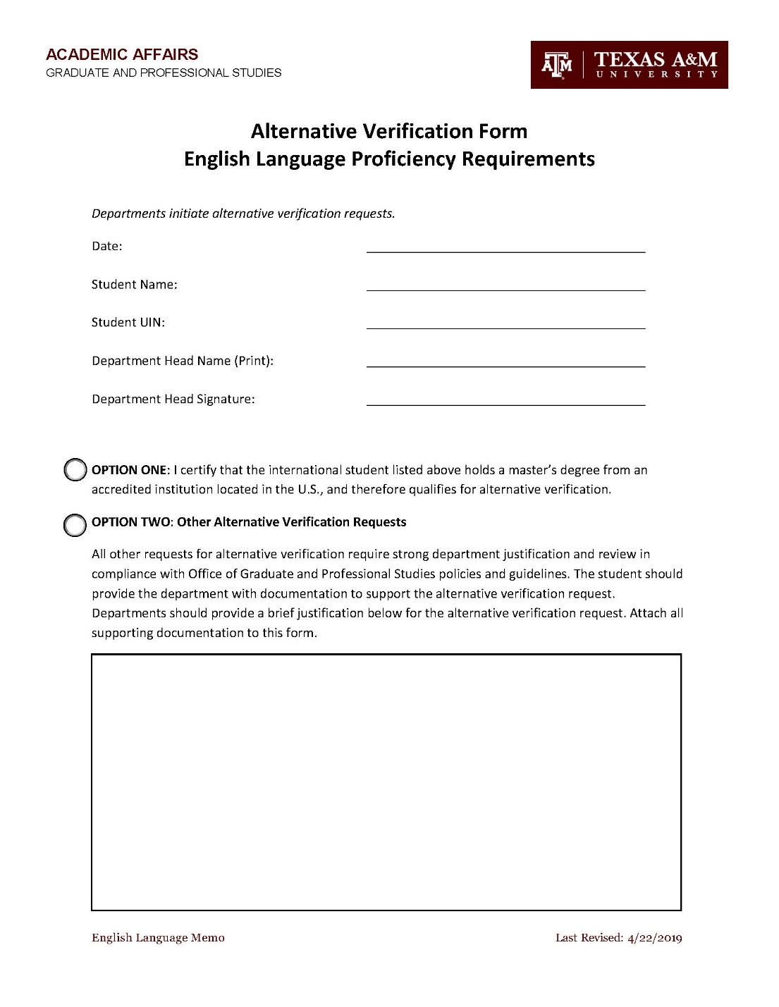

English Language Proficiency – Alternative Certification Form
- Include the student’s name and UIN.
- A designated department or program approver must sign the form and include the date on which it was signed.
- Select one of the three justification options available. If selecting Option Two, please provide a statement of justification in the space provided and attach relevant documentation to support the request(e.g. transcripts associated with training, courses completed for English oral skills at a university and/or institution other than Texas A&M University, etc.).

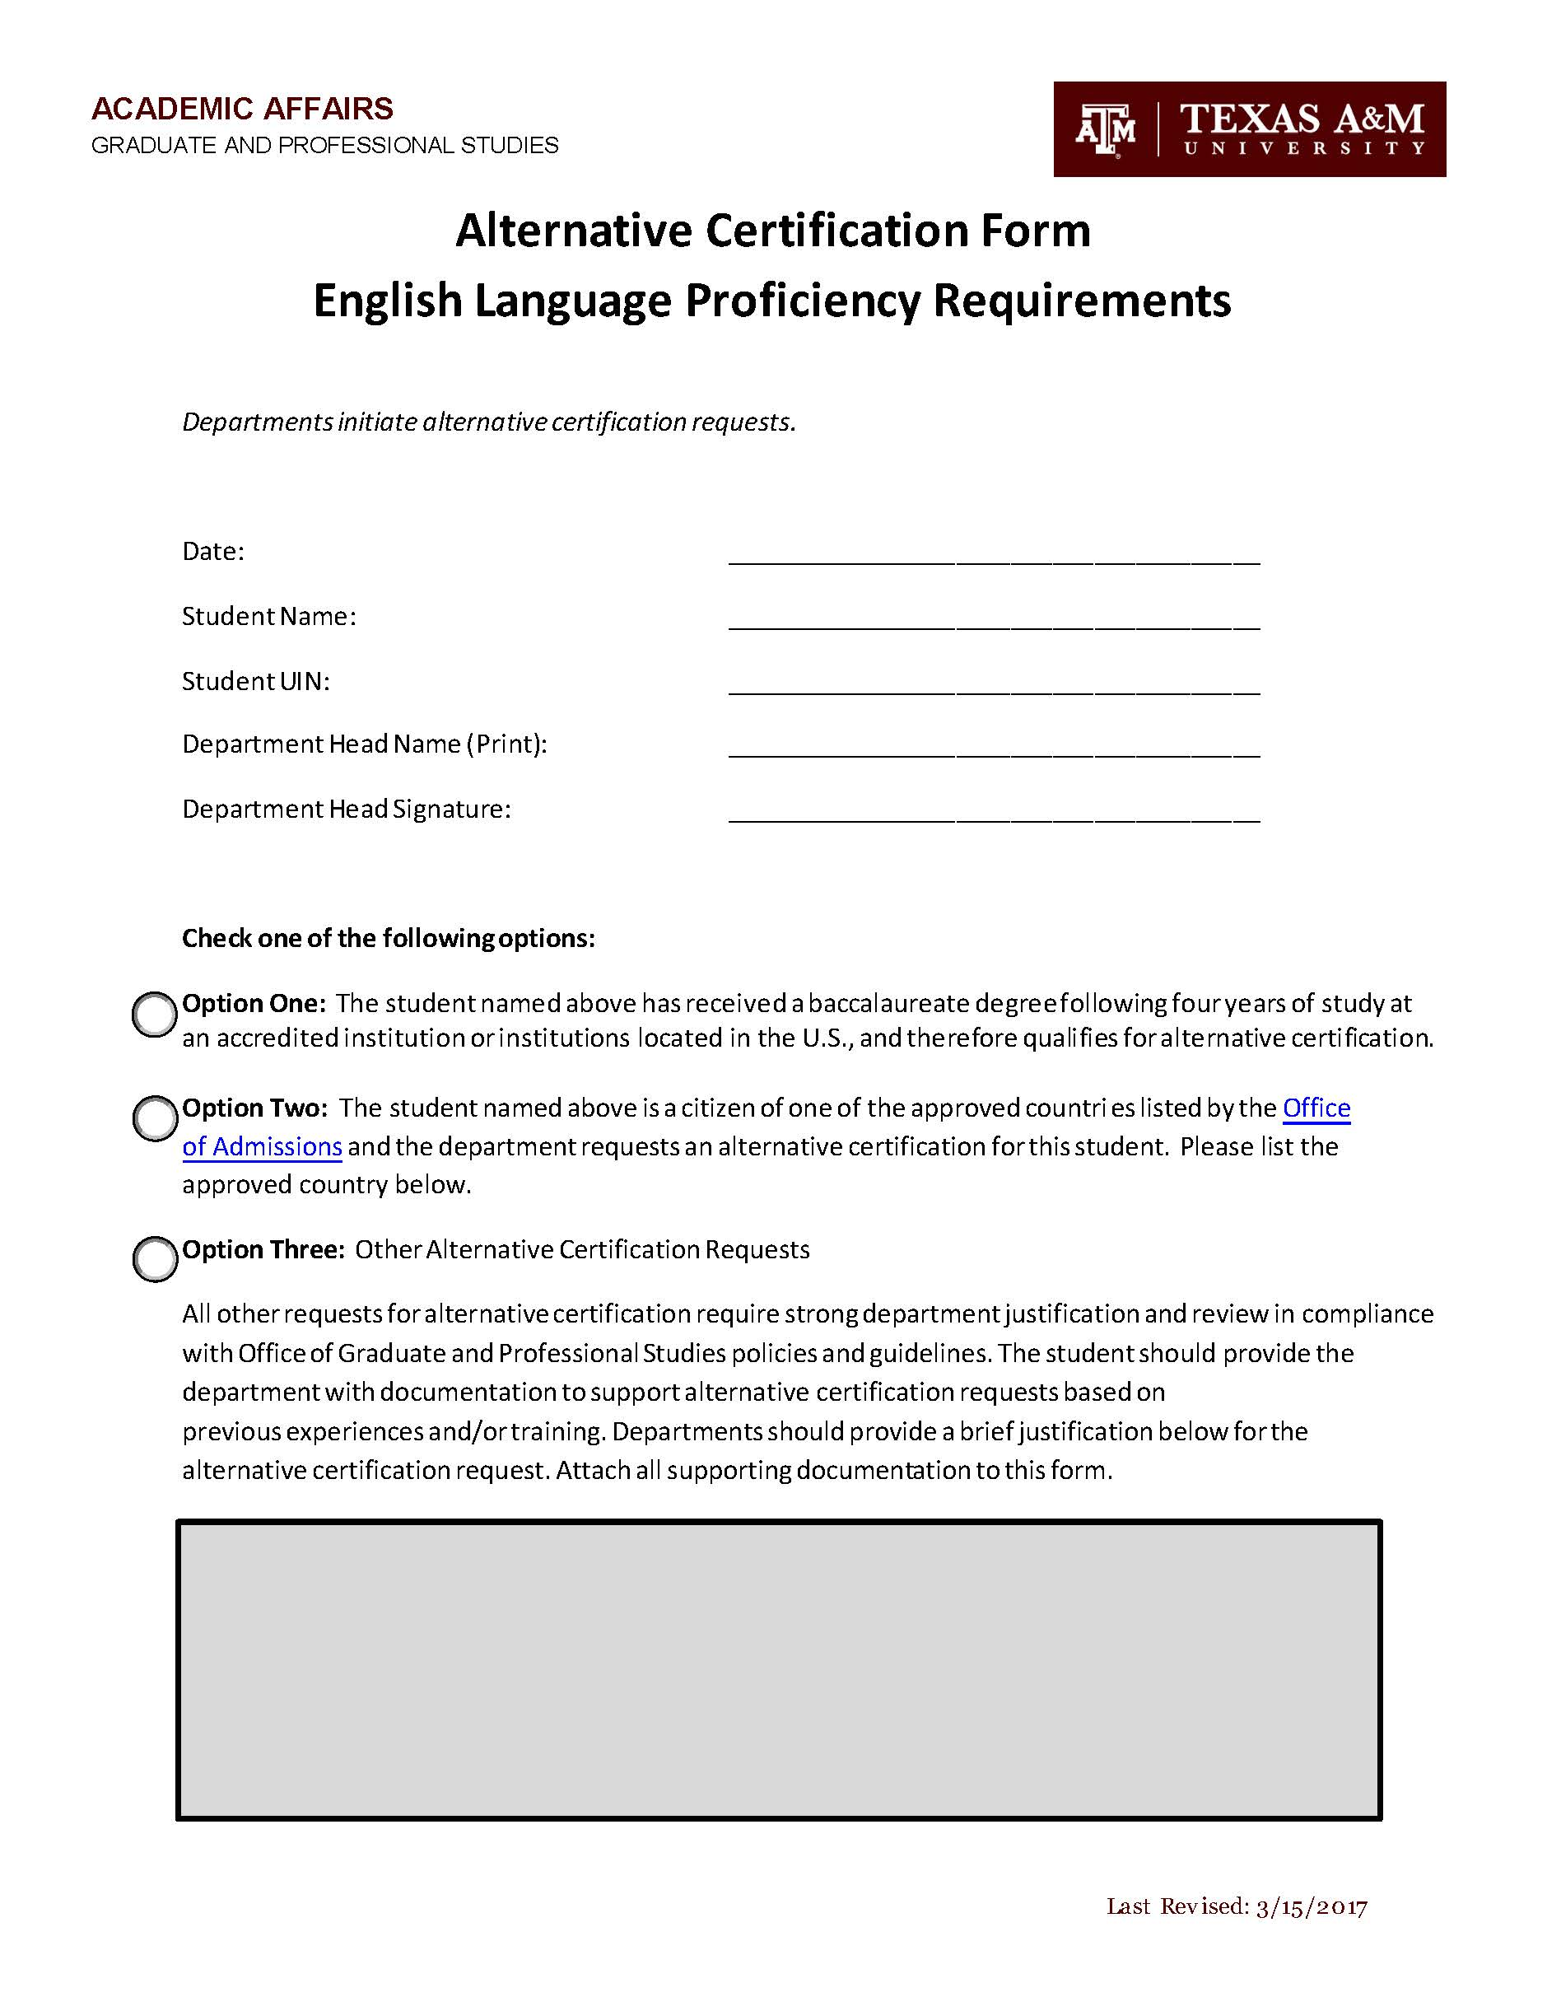

English Language Proficiency – Emergency Deferral Request Form
- Include the student’s name and UIN.
- Indicate the semester for which the Emergency Deferral is being requested.
- Select one of the three justification options included. Provide a brief explanation in support of the option selected (please note: inability to schedule TOEFL, IELTS, or ELPE is no longer considered as an acceptable justification for Option Three).
- The supervising faculty member must sign the form and include the date on which it was signed.
- The student must provide the date on which a CTE-ELP Intake Assessment has been scheduled and include a copy of the confirmation.
- The designated department or program approver and appropriate Graduate Operations Committee Dean must sign the form and include the date on which it was signed.
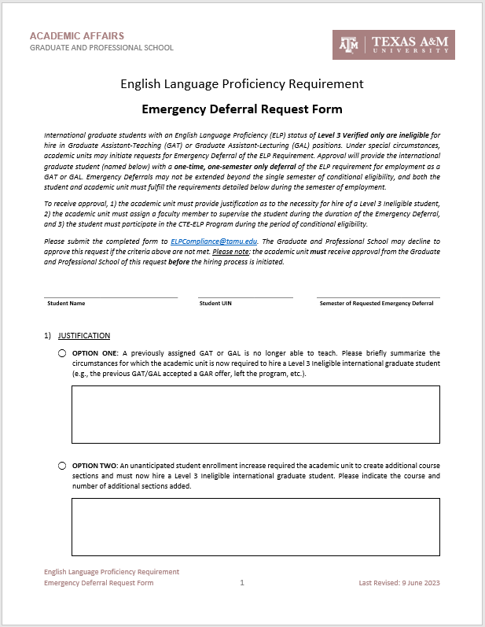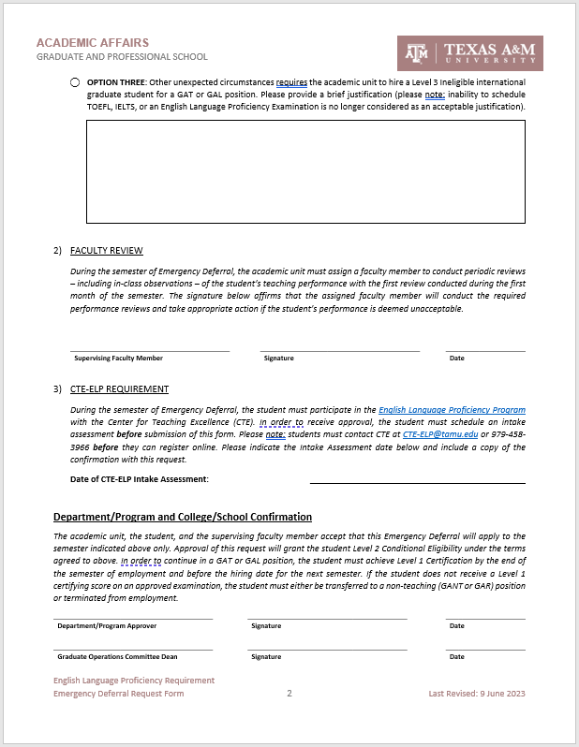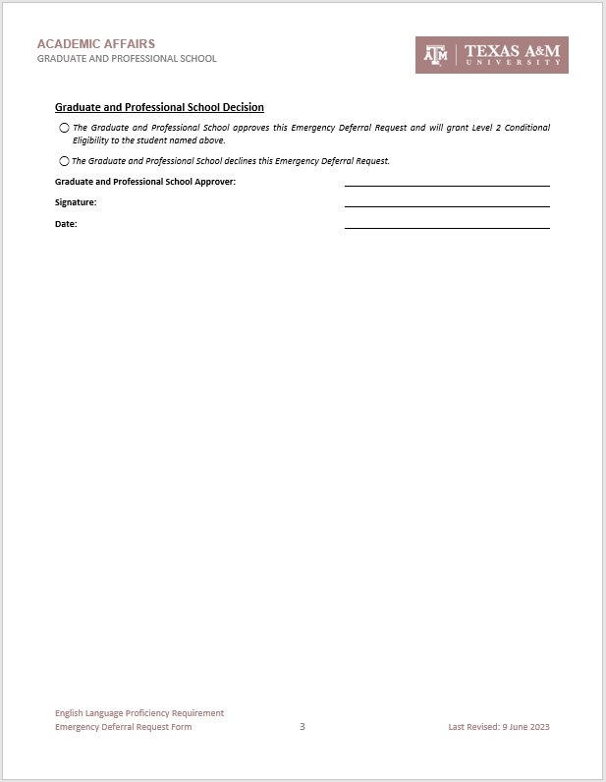

Academic Department Approval For Graduate Assistant To Work >50% Effort

- HROE, AgriLife, and Engineering Grad Partner(s) process the Academic Department Request for a Graduate Assistant to work greater than 50% FTE (20 hours per week) for their respective employees.
  - The graduate student must meet Graduate Assistantship registration requirements.
  - The form can only be submitted for one semester at a time.
- The student’s name and UIN must be listed as they appear in COMPASS.
- The form must note if the student status is F1 or J1
- Academic Term of Request: provide the semester that the work is being completed (e.g. Fall 2016).
- List the Department Point of Contact information for the primary appointment, including email and phone number, usually the business administrator or individual in the department who manages graduate assistant payroll/benefits.
- Summary of Duties: A description of duties for each position is required.
- Provide information regarding the student’s additional appointment or increased effort.
- List the Department Point of Contact for the additional appointment; include email and phone number.
- The department head from the student’s academic home department or their committee chair (if they have an approved degree plan on file with the Graduate and Professional School) must approve the form.
- If the student’s academic home is in Texas A&M Galveston, AgriLife, or the College of Engineering, the GOC Dean’s signature is also required.
Once the form has been completed and signatures obtained, the form should be returned to the employing department to be uploaded with the associated Workday request. Common reasons the form may be returned:
- The student is not registered for the semester that the work is being completed
- The student is an F1 or J1 student request to work greater than 20 hours per week during a fall or spring term when classes are in session
- The student is not meeting Graduate Assistant Registration requirements for the semester that the work is being completed
- The form lacks required information
- The form lacks a required signature
- The form is submitted for more than one semester
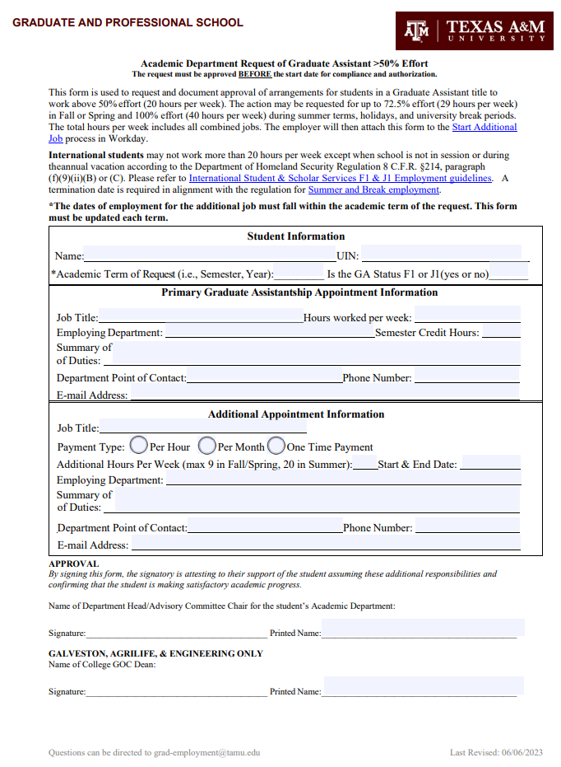

Request for Doctoral Student to Add a Secondary Master’s Degree Program
- This is completed in AdobeSign.
  - This can be found on the Graduate and Professional School website at https://grad.tamu.edu/knowledge-center/forms/request-to-add-secondary-curriculum.
- This completed form should be submitted by the doctoral department of the student.
- Student/department should indicate which circumstance they are requesting to add the secondary program.
- Student’s name should be listed exactly as it appears in Compass. Include UIN.
- Check the appropriate box for the current doctoral program, or for option 3, the doctoral program the student is moving into. Write out the department name or code and major.
- Check the appropriate box for the proposed secondary master’s program. Write out the department name or code and major.
- Please provide the expected semester and year of graduation for the master’s degree.
- Student’s name should be listed exactly as it appears in Compass.
- Please indicate whether the doctoral department will allow filing of 64-hour degree plan with completion of master’s degree by checking yes or no.
- Department should specify any stipulations for either the doctoral or master’s programs related to the addition of the secondary degree program.
- Student should sign and date the form.
- Both department heads are required to sign the form. If the student currently has a committee for either degree program, that committee is also required to sign the form.

